# Introduction in Machine Learning | Machine Learning

**Machine Learning:** Machine Learning is a method of teaching machines/computers to make a prediction based on some data and experience. It is applied in an incredibly wide variety of application areas. In briefly, Machine learning is an application of artificial intelligence that automates analytical model building by using an algorithm that iteratively learns from data without being explicitly programmed. A system to ask questions and answers.

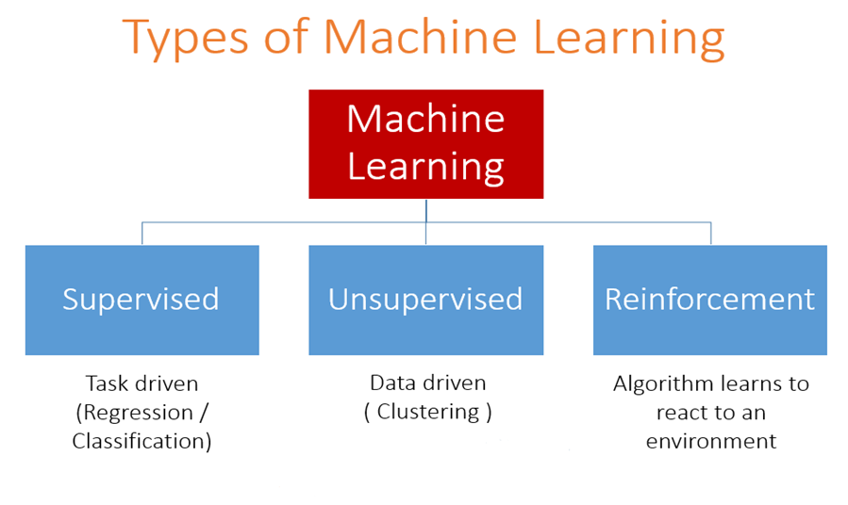

**Supervised Learning:** Supervised learning is concerned with teaching the model with knowledge and allow it to understand and then predict the future instances using that knowledge. It deals with labeled data. The model is trained using labeled data so it can predict the future outcome with respect to the sample data.

**Unsupervised Learning:** Unsupervised learning uses a machine learning algorithm that draws the conclusion on unlabeled data.

It has more difficult algorithm because we have very low information of data since we don't know what kind of data we are dealing with.

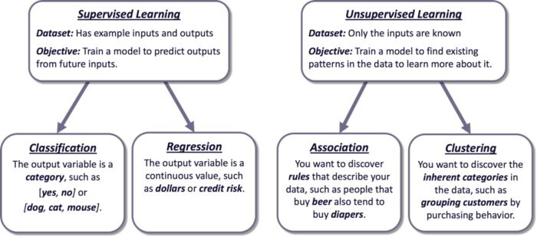

**Reinforcement Learning:**Reinforcement learning is an area of machine learning, where an agent learn how to behave in an environment by performing an action and seeing the results.

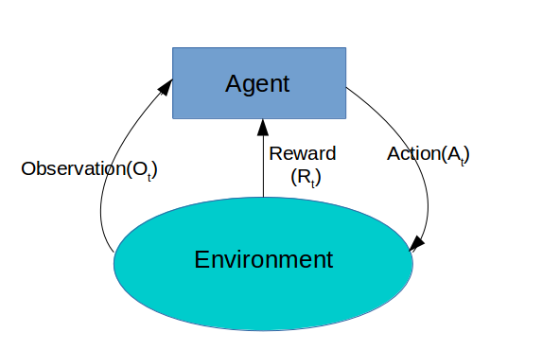

# Data Pre-processing | Machine Learning

**Data Pre-processing:** Data Prepossessing is the first stage of building a machine learning model. It involves transforming raw data into an understandable format for the analysis by a machine learning model. It is a crucial stage and should be done properly. A well-prepared dataset will give the best prediction by the model.

**Why Data Pre-processing is so important?**

* Raw data may contain improper values or in an incorrect format.
* Making the dataset feasible for the analysis.
* For achieving the best result from a dataset.
* Quality result depends on quality data. I.e. improper or missing data can lead a model to give confusing output

**Major tasks in Data Pre-processing:** The major tasks in Data Pre-processing are given below:

**1.Data cleaning:** Fill in missing values, smooth noisy data, identify or remove outliers, and resolve inconsistencies.

**2.Data Integration:** Integration of multiple databases, data cubes, or files.

**3.Data Transformation:** Normalization and aggregation.

**4.Data reduction:** Reduced representation in volume but produces the same or similar analytical results.

**5.Data discretization:** Part of data reduction but with particular importance, especially for numerical data.

Important: We will use the Spyder IDE from Anaconda for executing the codes. To start with executing the following codes in Spyder, first, you need to set the folder where you keep this dataset as the working directory. To do so, you need to go to the file explorer of your Spyder IDE and set the folder as the working directory.

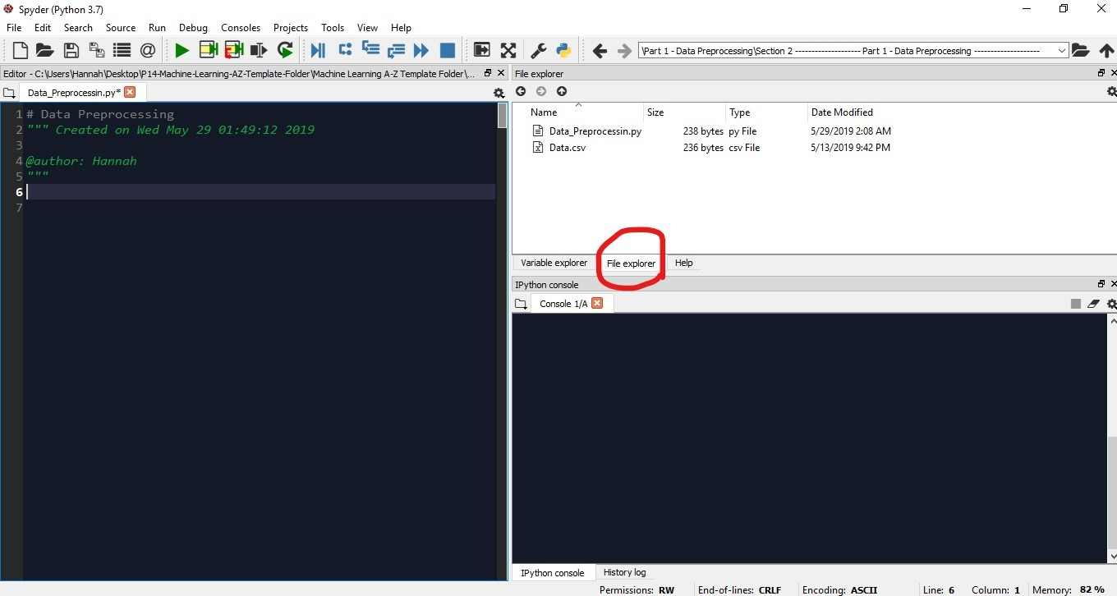

Then for executing the code given here, you need to write them on the Spyder editor. After that, you need to select all the code and press ctrl+enter(in windows). Then you will see the output on the IPython console.

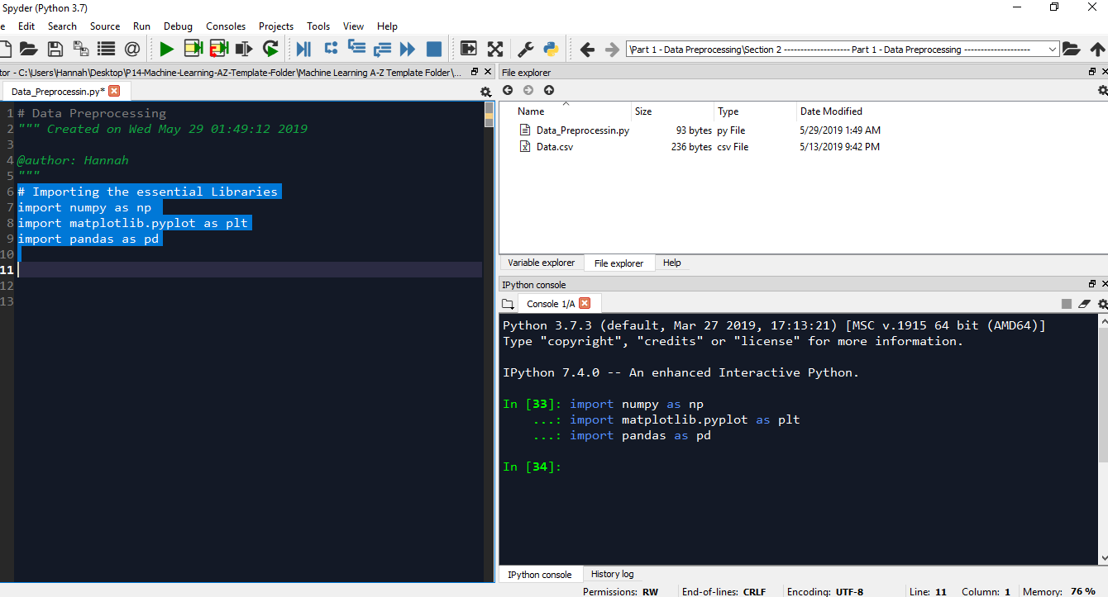

You can see the variables from the variable explorer.

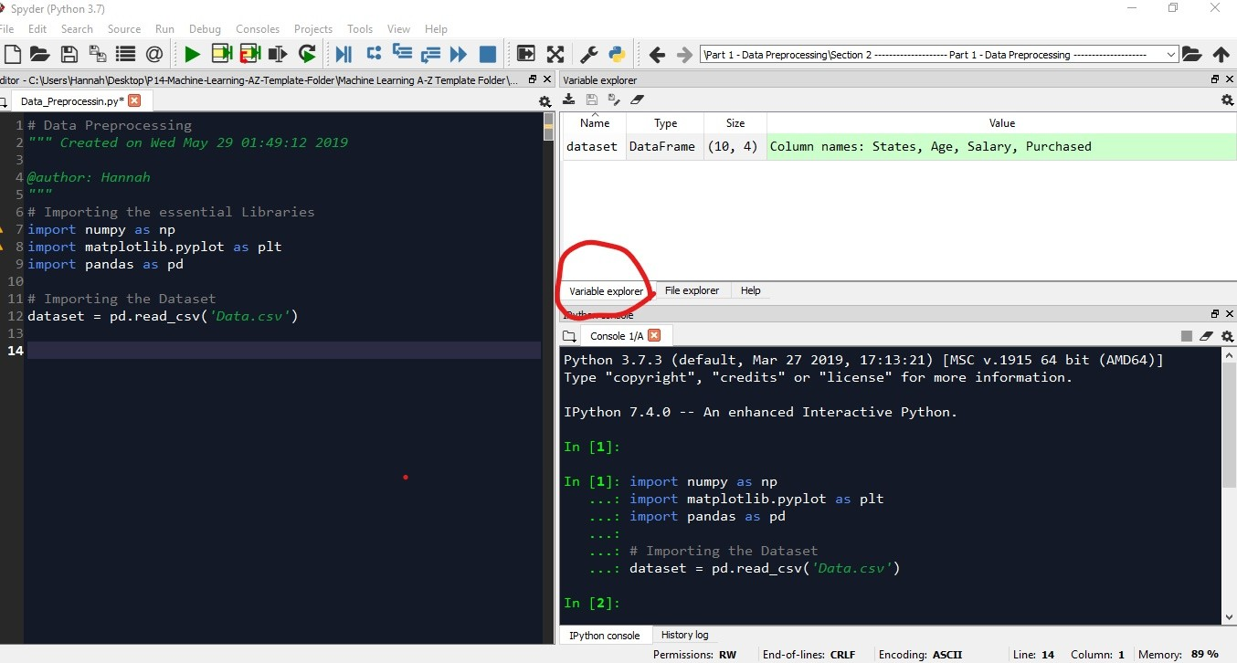

In this tutorial, I will show you how to pre-process your data using several techniques.

**Getting the Dataset:** There are several places from where you can download standard datasets. Kaggle is the best place for that. You can also get data from UCI machine learning database, data.gov, and google public dataset. For this tutorial, I used this dataset named Data.csv.   
You can download it from [**here**](https://www.dropbox.com/s/1gx66hwxih5xy13/Data.csv?dl=0).

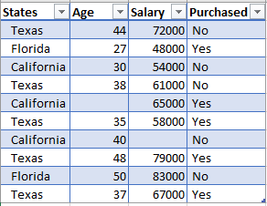

**Importing the Libraries:** Libraries are tools in python that we can use to make a specific job. And what's cool about these libraries is that you just have to give some inputs and the library will do the rest of the job. For making our models we are going to use a lot of libraries but there are three most common libraries that are used in every program. So, first of all, we will import those libraries. Now let's get into the work

import numpy as np   
import matplotlib.pyplot as plt  
import pandas as pd

Here, the library numpy contains lots of predefined tools to do mathematical and scientific operations on the data. matpolotlib.pyplot is the library to plot the data in charts. And the last one, pandas provides tools to read and import the dataset.

**Importing the Dataset:** First, we import the dataset from our working directory. For this, we need to do the following:

dataset = pd.read_csv('Data.csv')

**Note:** The dataset must be in CSV format.

There is something you must understand in machine learning is that in Python, we need to distinguish the matrix of feature and the dependent variable vector in our dataset. The independent variables which are used to predict the value of the dependent variable are contained in the Feature Matrix. The dependent variable is kept in the dependent variable vector. If you look back into the dataset you can see that the first three columns- *States, Age, Salary*are independent variables which we must take in the feature matrix. Let's denote it as X. And then we take the*Purchased* column in the dependent variable matrix, denoting y. The codes are as follows:

X = dataset.iloc[:, [0,1,2]].values

y = dataset.iloc[:, 3].values

The output for X should be like this:

array([['Texas', 44.0, 72000.0],  
 ['Florida', 27.0, 48000.0],  
 ['California', 30.0, 54000.0],  
 ['Texas', 38.0, 61000.0],  
 ['California', nan, 65000.0],  
 ['Texas', 35.0, 58000.0],  
 ['California', 40.0, nan],  
 ['Texas', 48.0, 79000.0],  
 ['Florida', 50.0, 83000.0],  
 ['Texas', 37.0, 67000.0]], dtype=object)

And for y it will be:

array(['No', 'Yes', 'No', 'No', 'Yes', 'Yes', 'No', 'Yes', 'No', 'Yes'], dtype=object)

**Handle the Missing Data:** If you look into the dataset you should find that there are some missing values in age and salary columns(actually it's two, one in the*Age*column and another in *Salary* column). This missing data will cause irregularities to our machine learning model. So we need to handle these missing data. For this, we use *Imputer* class from the Scikit-learn library of Python. There are many strategies to handle missing data, we can take the average or median or mean of the column. Here we will take the median value.

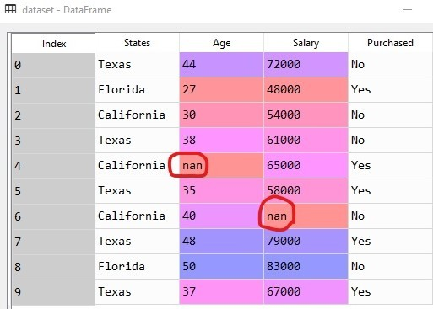

Handling the missing values

from sklearn.Pre-processing import Imputer

imputer = Imputer(missing_values = 'NaN', strategy = 'mean', axis = 0)

imputer.fit(X[:, 1:3])

X[:, 1:3] = imputer.transform(X[:, 1:3])

Note: Python uses 'NaN' to represent missing values.

The output should look like this:

array([['Texas', 44.0, 72000.0],

['Florida', 27.0, 48000.0],

['California', 30.0, 54000.0],

['Texas', 38.0, 61000.0],

['California', 38.77777777777778, 65000.0],

['Texas', 35.0, 58000.0],

['California', 40.0, 65222.22222222222],

['Texas', 48.0, 79000.0],

['Florida', 50.0, 83000.0],

['Texas', 37.0, 67000.0]], dtype=object)

Here the missing values are replaced by the mean of the respective column values(highlighted in yellow).

**Categorical Data:** In our dataset, we have two columns- *States*and *Purchased*, both containing categorical data. These two variables are categorical variables because simply they contain categories(i.e. name of a state, or yes/no values). Since machine learning models are based on mathematical equations, you can intuitively understand that it would not fit in our model well. So, we can not keep the categorical variables because we only can use numbers in the equations.

That's why we need to encode the categorical variables.

#Encoding the categorical variables

from sklearn.Pre-processing import LabelEncoder

labelencoder_X = LabelEncoder()

X[:, 0] = labelencoder_X.fit_transform(X[:, 0])

labelencoder_y = LabelEncoder()

y = labelencoder_y.fit_transform(Y)

Note: here, *LabelEncoder* converts the categorical values into numbers so that they could be used in the machine learning equation.

The outputs are-

**For X:**

array([[2, 44.0, 72000.0],

[1, 27.0, 48000.0],

[0, 30.0, 54000.0],

[2, 38.0, 61000.0],

[0, 38.77777777777778, 65000.0],

[2, 35.0, 58000.0],

[0, 40.0, 65222.22222222222],

[2, 48.0, 79000.0],

[1, 50.0, 83000.0],

[2, 37.0, 67000.0]], dtype=object)

**For y:**

array([0, 1, 0, 0, 1, 1, 0, 1, 0, 1])

 At the output, for X the values for *States* column and for y, the values for the*Purchased* column are replaced by numbers.

**Note:** Though categorical values are converted to numbers, they will still cause a problem. You can observe that the encoding has made one state having a higher or lower value than others. As a machine learning model is based on equations, the numbers denoting the states will have some effect on the equation(i.e. persons from a higher/lower value state may be predicted having a higher/lower salary than persons from other states). But this is not the thing we wanted, these are actually categorical data with no relational order between them. To solve this problem, we need to make dummy variables so that our machine learning model does not confuse with the weight of the categorical values. The following code will generate a dummy variable for each of the three states contained in our dataset.

#Creating dummy variables for the encoded categorical values

from sklearn.Pre-processing import OneHotEncoder

onehotencoder = OneHotEncoder(categorical_features = [0])

X = onehotencode.fit_transform(X).toarray()

After creating dummy variables the X dataset should look like:

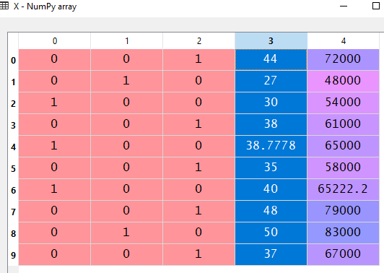

Here columns 0, 1, and 2 represent dummy variables for the three categorical values.

We need not make dummy variables for y dataset. Since this is the dependent variable and our machine learning model know it is a category and that there is no order between the two(yes/no) values. So, LabelEncoder will do good enough for the y dataset.

**Splitting the dataset:** Now, we need to split the dataset into training and test dataset. The training dataset is used to train the machine learning model and test dataset is to test the model.

#Splitting the datasets

from sklearn.model_selection import train_test_split

X_train, X_test, y_train, y_test = train_test_split(X, y, test_size = 0.2, random_state = 0 )

**Note:** Here, **test_size = 0.2**means we take 20% of our data to the test set, and the remaining 80% will be in the training set. **random_state = 0**is to ensure that after splitting, your datasets and our dataset look become the same.

After splitting the dataset should look like this:

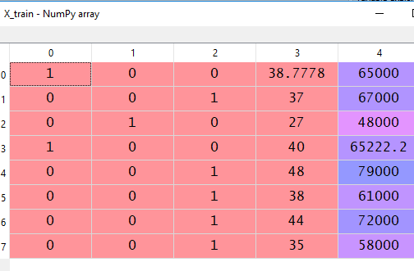

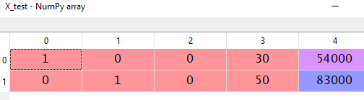

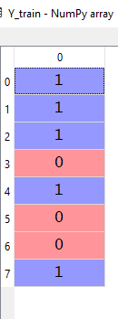                               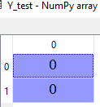

**Feature Scaling:** Now, we come to the last part of Pre-processing. Let's explain what is features scaling and why we need to do it.

If you look at the dataset again, you can see the two columns namely Age and Salary contain numerical data. You should notice that the variables are not on the same scale. The Age is going from 27 to 50 while the Salary has a range of 48000 to 83000. And there is no distinguished linear relationship between these two columns.  This will cause inaccurate prediction by our model. So we need to scale them to get a more accurate prediction from the model.

# Feature Scaling

from sklearn.Pre-processing import StandardScaler

sc_X = StandardScaler()

X_train = sc_X.fit_transform(X_train)

X_test = sc_X.transform(X_test)

sc_y = StandardScaler()

y_train = sc_y.fit_transform(y_train)

 After feature scaling the dataset will look like the following:

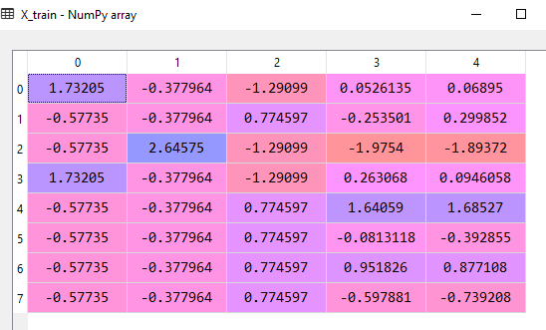

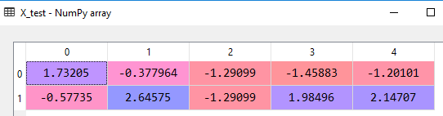

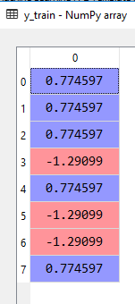

Data Pre-processing is the fundamental step to start creating a model, we will go further and see how the machine learning model is built using various algorithms and techniques in the following articles.

# Regression | Machine Learning

**Regression:** Basically, Regression is a statistical approach to find the correlations between variables (dependent and independent).

In the context of machine learning, Regression is an algorithm or technique that is applied to a certain dataset to find the correlation between the independent and dependent variables and with that, predicts the outcome of an unknown value.

For example, if you have a dataset that contains the salary of a certain number of employees according to their experience, your model will find the correlation between the experience and salary from that dataset. And with that correlation, it predicts the unknown salary of employees from their experience.

**How Does It Work?**

Let's take an example of a regression task. Assume that we have a dataset that contains the price(in dollars) of houses according to their area(in meter squared) of the town Branalle. The plot for price vs area data of the town Branalle is depicted below:

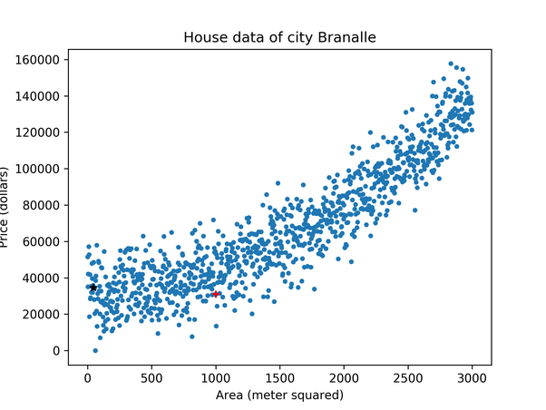

Here the value of area on the X-axis is the independent variable, and on the Y-axis, the value of the price is the dependent variable.

Now if we build a regression model based on this data, our model will try to find the correlation between the area and the price. And from that correlation, the outcome of the model will be a simple line(linear or nonlinear based on the chosen algorithm) on the graph. The line will be the prediction line of the model, upon which it will predict the unknown price according to the given area of a house.

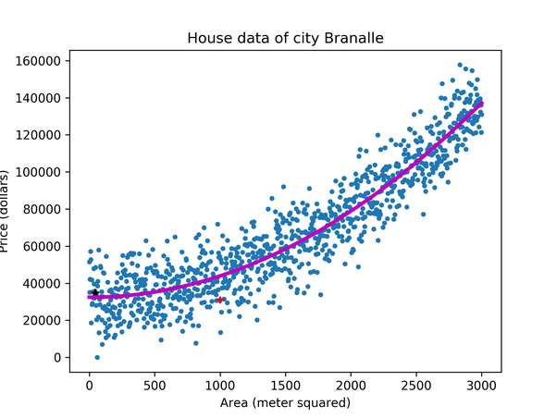

Here the line is the prediction line constructed by the regression model. This prediction line will be used as a reference to predict an unknown value that is the price of a house.

**How to Understand a Regression Task?**

Regression algorithms give you a continuous output. That means if you are asked to build a model that predicts the future outcome where the output will be continuous. Then you must choose one of the Regression algorithms to build your model.

For example, if you are provided with a dataset about houses, and asked to predict their prices, that is a regression task because the price will be a continuous output.

**Classification of Regression:**

There are several types of Regression models. They are as follows:

* [Simple Linear Regression](http://www.aionlinecourse.com/tutorial/machine-learning/simple-linear-regression)
* [Multiple Linear Regression](http://www.aionlinecourse.com/tutorial/machine-learning/multiple-linear-regression)
* [Polynomial Regression](http://www.aionlinecourse.com/tutorial/machine-learning/polynomial-regression)
* [Support Vector Regression](http://www.aionlinecourse.com/tutorial/machine-learning/support-vector-regression)
* [Decision Tree Regression](http://www.aionlinecourse.com/tutorial/machine-learning/decision-tree-intuition)
* [Random Forest Regression](http://www.aionlinecourse.com/tutorial/machine-learning/random-forest-regression)

In the following articles, we will understand these models in detail and learn how to implement them in Python.

# Simple Linear Regression | Machine Learning

**Simple Linear Regression:** It is a linear regression model that uses two-dimensional sample points with one independent and one dependent variable (conventionally, the x and y coordinates). Then it tries to fit them in a linear function as follows-

y = b0 +b1x

With this function, a simple linear regression model will predict the dependent variable (denoted y) values as a function of the independent variables (denoted x). Basically, this function generates a straight line in the Cartesian coordinate system. This straight line is the prediction line for the simple linear regression model which tries to predict the dependent values as accurately as possible.

Let's take an example of simple linear regression.

Suppose we have a dataset (Salary_Data.csv) that contains the salary of a certain number of employees according to their years of experience.

You can download the dataset from [here](https://www.dropbox.com/s/kquu5kzrqt9gtz7/Salary_Data.csv?dl=0).

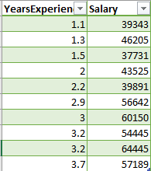

Let's plot the data in a graph.

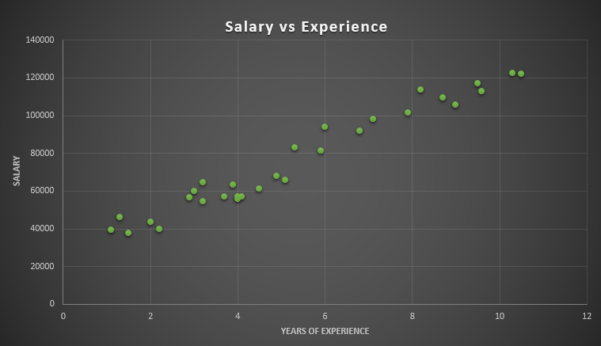

Here the plot shows the correlation between the Experience (in years) and Salary in our dataset. From this correlation, a simple linear regression model will try to find a straight line that best fits the data.

Now let's build a simple linear regression model with this dataset.

The first step will be Pre-processing the dataset. As this model deals with just two variables, we can take the Experience column as the independent variable in the feature matrix X, and the Salary column as a dependent variable in the dependent variable vector y.

#Simple Linear Regression

# Importing the essential libraries

import numpy as np

import matplotlib.pyplot as plt

import pandas as pd

# Importing the dataset

dataset = pd.read_csv('Salary_Data.csv')

X = dataset.iloc[:, 0].values

y = dataset.iloc[:, 1].values

Now, we will split the dataset between training and test sets. The training set will contain two third of the data and the test set will have one-third of the data. You can try taking arbitrary size for training and test sets. But keep in mind that the size of your datasets will make the model predict different outcomes. So, try to split the dataset in a way that helps the model to predict the best outcome.

# Splitting the dataset into the Training set and Test set

from sklearn.model_selection import train_test_split

X_train, X_test, y_train, y_test = train_test_split(X, y, test_size = 1/3, random_state = 0)

Note: Here, random_state = 0 is used to ensure that when you run this code, the output will be the same as us. You could run your code perfectly without this parameter. Though the training data set and test data set may not look exactly like ours, still it will be fine.

After Pre-processing the data, now we will build our simple linear regression model. To fit the model to our training set, we just need to use the linear regression class from the Scikit-Learn library. The code in Python is as follows:

# Fitting Simple Linear Regression to the Training set

from sklearn.linear_model import LinearRegression

regressor = LinearRegression()

regressor.fit(X_train, y_train)

Now we have come to the final part. Our model is ready and we can predict the outcome! The code for this is as follows:

# Predicting the Test set results

y_pred = regressor.predict(X_test)

To plot our regression model outcome, we need the following lines of code:

To visualize the training set results:

# Visualising the Training set results

plt.scatter(X_train, y_train, color = 'red')

plt.plot(X_train, regressor.predict(X_train), color = 'blue')

plt.title('Salary vs Experience (Training set)')

plt.xlabel('Years of Experience')

plt.ylabel('Salary')

plt.show()

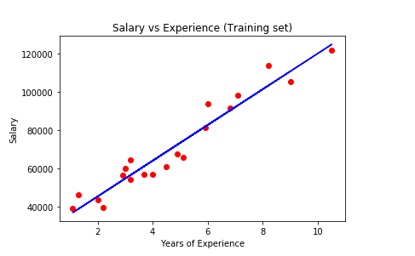

Here the graph represents the linear regression line(the blue straight line) for the training set data. The algorithm tries to find the best fit line for our dataset. So this line is the best fit line the algorithm could find for our data.

Now it is time to see how our model predicts on the test data:

# Visualising the Test set results

plt.scatter(X_test, y_test, color = 'red')

plt.plot(X_train, regressor.predict(X_train), color = 'blue')

plt.title('Salary vs Experience (Test set)')

plt.xlabel('Years of Experience')

plt.ylabel('Salary')

plt.show()

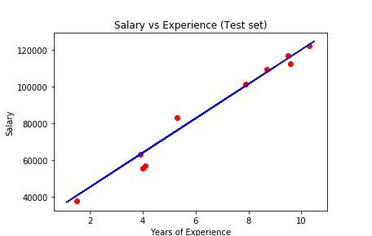

The above graph shows the predictions made by our simple linear regression model. The red dots are the test data and the blue line represents the predictions made by our model. If you look at the graph, our model made some close prediction for our test data (the dots on the line). Though the prediction is no accurate for some values (the dots far from the line), still it is a good simple linear regression model.

This is the simplest of all the regression models. In the following articles, we will see other complex regression models.

# Multiple Linear Regression | Machine Learning

In this tutorial, we are going to understand the Multiple Linear Regression Algorithm and implement the algorithm with Python.

**Multiple Linear Regression:** Multiple Linear Regression is closely related to a [simple linear regression model](http://www.aionlinecourse.com/tutorial/machine-learning/simple-linear-regression) with the difference in the number of the independent variables. Whereas the simple linear regression model predicts the value of a dependent variable based on the value of a single independent variable, in Multiple Linear Regression, the value of a dependent variable is predicted based on more than one independent variables. The concept of multiple linear regression can be understood by the following formula-

y = b0+b1*x1+b2*x2+..........+bn*xn

In the equation, y is the single dependent variable value of which depends on more than one independent variables(i.e. x1,x2,...,xn).

For example, you can predict the performance of students in an exam based on their revision time, class attendance, previous results, test anxiety, and gender. Here the dependent variable(Exam performance) can be calculated by using more than one independent variables. So, this the kind of task where you can use a Multiple Linear Regression model.

Now, let's do it together. We have a dataset(Startups.csv) that contains the Profits earned by 50 startups and their several expenditure values. Les have a glimpse of some of the values of that dataset-

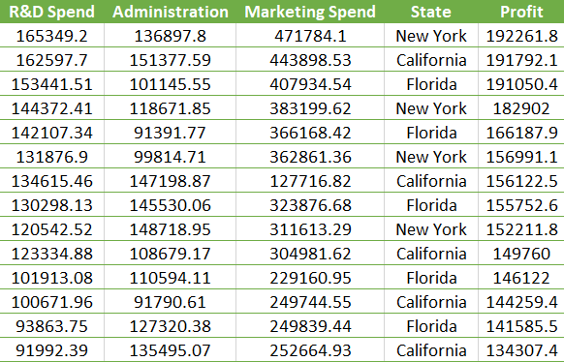

**Note:** this is not the whole dataset. You can download the dataset from [here](https://www.dropbox.com/s/z2ue4a1ogefcuo3/50_Startups.csv?dl=0).

From this dataset, we are required to build a model that would predict the Profits earned by a startup and their various expenditures like R & D Spend, Administration Spend, and Marketing Spend. Clearly, we can understand that it is a multiple linear regression problem, as the independent variables are more than one.

Let's take Profit as a dependent variable and put it in the equation as y and put other attributes as the independent variables-

**Profit = b0 + b1*(R & D Spend) + b2*(Administration) + b3*(Marketing Spend)**

From this equation, hope you can understand the regression process a bit clearer.

Now, let's jump to build the model, first the data preprocessing step. Here we will take Profit as in the dependent variable vector y, and other independent variables in feature matrix X.

# Multiple Linear Regression

# Importing the essential librariesimport numpy as np

import matplotlib.pyplot as plt

import pandas as pd

#Importing the dataset dataset = pd.read_csv('50_Startups.csv')

X = dataset.iloc[:, [0,1,2,3]].values

y = dataset.iloc[:, 4].values

The dataset contains one categorical variable. So we need to encode or make dummy variables for that.

#Encoding categorical data from sklearn.preprocessing import LabelEncoder, OneHotEncoder

labelencoder = LabelEncoder()

X[:, 3] = labelencoder.fit_transform(X[:, 3])

onehotencoder = OneHotEncoder(categorical_features = [3])

X = onehotencoder.fit_transform(X).toarray()

**Dummy Variable Trap:** Above code will make two dummy variables(as the categorical variable has two variations). And obviously, our linear equation will use both dummy variables. But this will make a problem. Here both dummy variables are correlated to some extent(that means ones value can be predicted by the other)  which causes multicollinearity, a phenomenon where an independent variable can be predicted from one or more than one independent variables. When multicollinearity exists, the model cannot distinguish the variables properly, therefore predicts improper outcomes. This problem is identified as the Dummy Variable Trap.

To solve this problem, you should always take all dummy variables except one form the dummy variable set.

#Avoiding the Dummy Variable Trap

X = X[:, 1:]

Now split the dataset in training set and test set

#Splitting the dataset into the Training set and Test set  
from sklearn.model_selection import train_test_split  
X_train, X_test, y_train, y_test = train_test_split(X, y, train_size = 0.8, test_size = 0.2, random_state = 0)

Its time to fit Multiple Linear Regression to the training set.

# Fitting Multiple Linear Regression to the Training set

from sklearn.linear_model import LinearRegression

regressor = LinearRegression()

regressor.fit(X_train, y_train)

Let's evaluate our model how it predicts the outcome according to the test data.

#Predicting the Test set result

y_pred = regressor.predict(X_test)

Let's compare the test set values with the prediction values

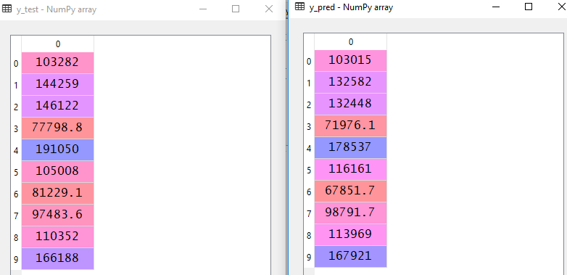

Here you can see our model has made some close predictions and some bad predictions also. But you can improve the quality of the prediction by choosing other Multiple Linear Regression techniques such as Backward Elimination, Forward Selection etc. which we will discuss in other tutorials.

# Polynomial Regression | Machine Learning

**Polynomial Regression:**Polynomial regression is a form of regression analysis in which the relationship between the independent variable x and dependent variable y is modelled as an nth degree polynomial of x. That is, if your dataset holds the characteristic of being curved when plotted in the graph, then you should go with a polynomial regression model instead of [Simple Linear](http://www.aionlinecourse.com/tutorial/machine-learning/simple-linear-regression) or [Multiple Linear regression](http://www.aionlinecourse.com/tutorial/machine-learning/multiple-linear-regression).

The equation for Polynomial Regression looks very similar to that of Multiple Linear Regression.

y=b0+b1*x1+b2*(x1)2+....+bn*(x1)n

The main difference is that in Multiple Linear Regression, there are several variables with the same degree but here the single variable has different powers.

**Why Polynomial Regression?**

Let’s say you have a dataset and fit both Simple and Polynomial Regression to that data.

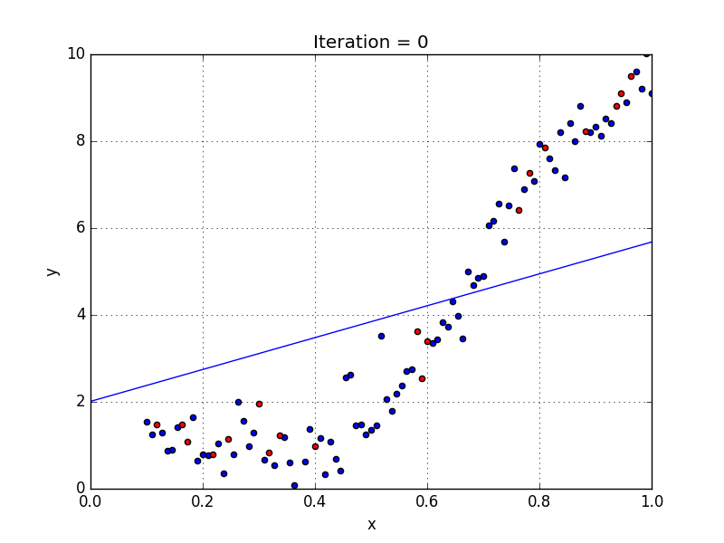

                              Plotted with a linear regression model

Here you can see the data has a tendency to grow in a non-linear fashion. Hence a simple linear model could not find the most optimal line that can fit the data well and has a very poor accuracy level.

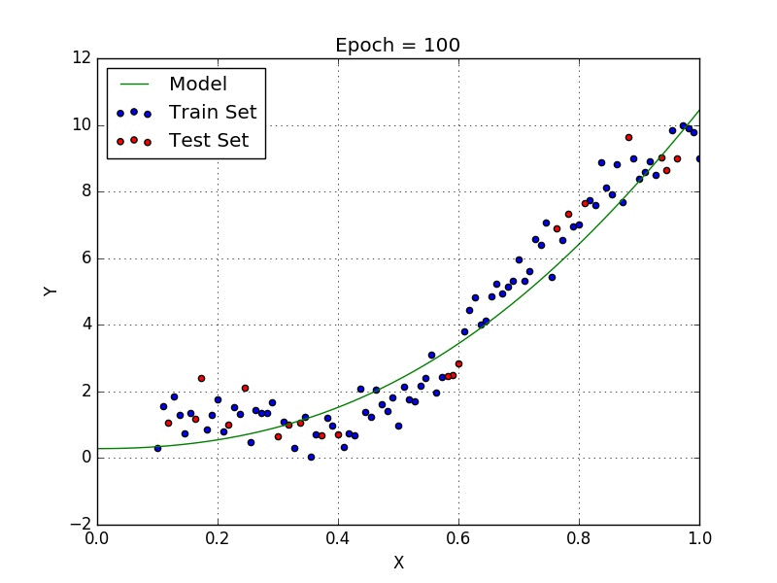

                                             Plotted with a polynomial regression model

Now if you look at the Polynomial Regression, you will clearly see the difference. The Polynomial model has fitted the dataset well with a higher accuracy rate than that of a simple linear model.

There are many cases where you will find great uses of Polynomial Regression. For example, if you want to discover how diseases spread, how a pandemic or epidemic spread over a continent and so on. It completely depends on your data. And based on the non-linear characteristics of your data, you should use Polynomial Regression.

Now we will jump into a dataset and implement this idea.

Suppose we have a dataset(Salary_data.csv) which contains the salaries of employees of different positions based on their Level. Let’s have a look at the dataset.

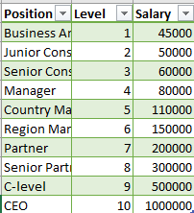

You can download the dataset from [here](https://www.dropbox.com/s/ecwhriu55lx0xd6/Position_Salaries.csv?dl=0).

If we plot the above data in a graph, it would look like this-

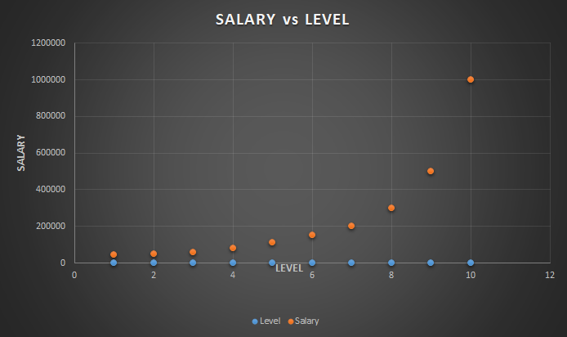

Here, you can observe that our data has a tendency of growing non linearly. So we are required to use a Polynomial Regression for this case.

The dataset contains just three columns. We will take the second column, Level as our independent variable in feature matrix, X and the Salary column as the dependent variable in the dependent variable vector, y.

We start by preprocessing the data. For this use this following codes-

# Polynomial Regression

# Importing the Essential Libraries

import numpy as np

import matplotlib.pyplot as plt import pandas as pd

# Importing the dataset

dataset = pd.read_csv('Position_Salaries.csv')

X = dataset.iloc[:, 1].values

y = dataset.iloc[:, 2].values

We skip the splitting part as the dataset contains only 10 values. So Let’s fit polynomial regression to our whole dataset and for this you should write the following code-

# Fitting Polynomial Regression to the dataset

from sklearn.preprocessing import PolynomialFeatures

poly_reg = PolynomialFeatures(degree = 4)

X_poly = poly_reg.fit_transform(X)

poly_reg.fit(X_poly, y)

lin_reg_2 = LinearRegression()

lin_reg_2.fit(X_poly, y)

Note: Here, I use degree = 4, you should try with different values for this parameter and watch how your model works. For this dataset, a value of degree 4 just works fine!

Well, we have fitted our model to the dataset. Now, its time to plot and see how it works.

# Visualising the Polynomial Regression results

X_grid = np.arange(min(X), max(X), 0.1)

X_grid = X_grid.reshape((len(X_grid), 1))

plt.scatter(X, y, color = 'red')

plt.plot(X_grid, lin_reg_2.predict(poly_reg.fit_transform(X_grid)), color = 'blue')

plt.title('Truth or Bluff (Polynomial Regression)')

plt.xlabel('Position level')

plt.ylabel('Salary')

plt.show()

The plot should look like this-

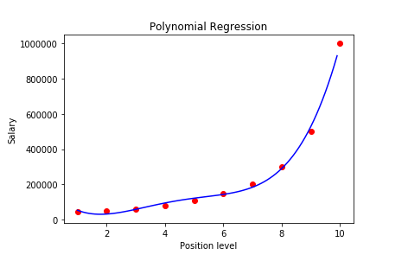

With a 4-degree polynomial regression, we obtained a model that has closely predicted the Salary values. If we used a simple linear regression instead, we could not obtain this level of accuracy.

So now we can use our model to learn how it predicts for an unknown value.

# Predicting an unknown value with Polynomial Regression model

y_pred = lin_reg_2.predict(poly_reg.fit_transform([[6.5]]))

For a level value of 6.5, it predicts: 158862

We put the same dataset in a simple linear regression model. And for the same level value of 6.5, it gave us the outcome: 330378.78!

If you compare both the value with the first SALARY vs LEVEL graph, you must discover that our polynomial model has predicted a way better than that of a simple linear regression model.

# Support Vector Regression | Machine Learning

**Support Vector Regression:** Support Vector Regression(SVR) is quite different than other Regression models. It uses the Support Vector Machine(SVM, a classification algorithm) algorithm to predict a continuous variable. While other linear regression models try to minimize the error between the predicted and the actual value, Support Vector Regression tries to fit the best line within a predefined or threshold error value. What SVR does in this sense, it tries to classify all the prediction lines in two types, ones that pass through the error boundary( space separated by two parallel lines) and ones that don’t. Those lines which do not pass the error boundary are not considered as the difference between the predicted value and the actual value has exceeded the error threshold, (epsilon). The lines that pass, are considered for a potential support vector to predict the value of an unknown. The following illustration will help you to grab this concept.

.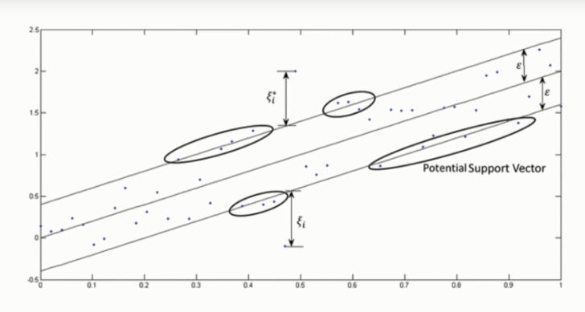

To understand the above image, you first need to learn some important definitions.

1. Kernel: Kernel is a function that is used to map a lower-dimensional data points into higher dimensional data points. As SVR performs linear regression in a higher dimension, this function is crucial. There are many types of kernel such as Polynomial Kernel, Gaussian Kernel, Sigmoid Kernel, etc.
2. Hyper Plane: In Support Vector Machine, a hyperplane is a line used to separate two data classes in a higher dimension than the actual dimension. In SVR, a hyperplane is a line that is used to predict continuous value.
3. Boundary Line: Two parallel lines drawn to the two sides of Support Vector with the error threshold value, (epsilon) are known as the boundary line. These lines create a margin between the data points.
4. Support Vector: The line from which the distance is minimum or least from two boundary data points.

From the above illustration, you clearly can find the idea. The boundary is trying to fit as many instances as possible without violating the margin. The width of the boundary is controlled by the error threshold (epsilon). In classification, the support vector X is used to define the hyperplane that separated the two different classes. Here, these vectors are used to perform linear regression.

How Does SVR Works?

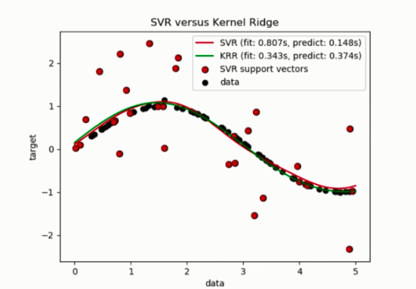

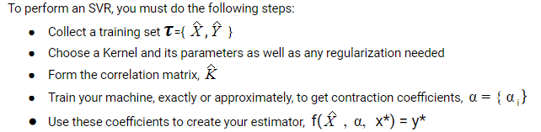

Let's do these steps one by one

Here we choose a Gaussian Kernel.

Now we come to the Correlation Matrix

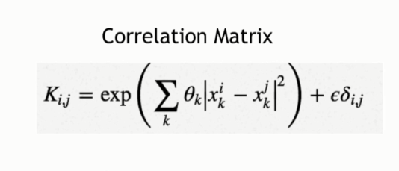

In the equation above, we are evaluating our kernel for all pairs of points in our training set and adding the regularizer resulting in the matrix.

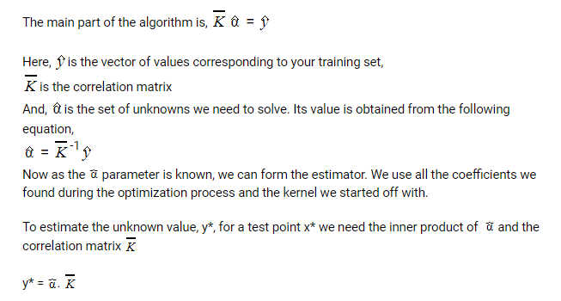

Then we estimate the elements of the coefficient matrix by the following:

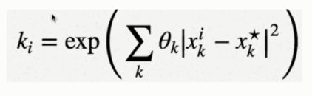

Overall, following all these steps, now our SVR model is ready to predict unknown values.

**Support Vector Regression in Python:** Now we are going to implement this idea into a workable code in Python. We are working with **Position_Salaries.csv** dataset. Let's have a look at the data-

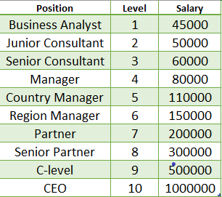

You can download the dataset from [here.](https://www.dropbox.com/s/ecwhriu55lx0xd6/Position_Salaries.csv?dl=0)

This dataset contains the position and level of some employees and according to this level, the salary is calculated. Let's check the graph of this dataset

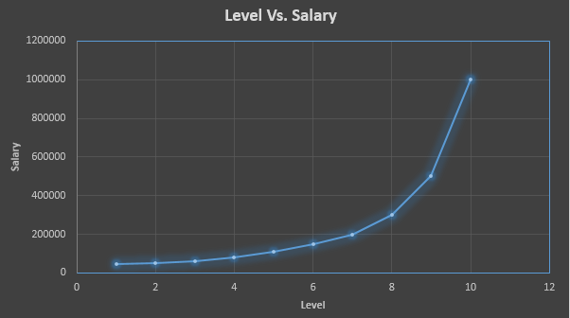

The graph shows that the data is non-linear. Now, what if we want to learn the salary for a level at 6.5. What would be that? To predict that, we will implement Support Vector Regression.

First of all, include the essential libraries

# Importing the libraries

import numpy as np

import matplotlib.pyplot as plt

import pandas as pd

Let's import the dataset and make the feature matrix and the dependent variable vector

# Importing the dataset

dataset = pd.read_csv('Position_Salaries.csv')

X = dataset.iloc[:, 1:2].values

y = dataset.iloc[:, 2].values

Now, we need to feature scale the data

# Feature Scaling

from sklearn.preprocessing import StandardScaler

sc_X = StandardScaler()

sc_y = StandardScaler()

X = sc_X.fit_transform(X)

y = sc_y.fit_transform(y)

Now, we need to feature scale the data

# Fitting SVR to the dataset

from sklearn.svm import SVR

regressor = SVR(kernel = 'rbf')

regressor.fit(X, y)

Fit the SVR algorithm to the dataset Let's predict the result

# Predicting a new result

y_pred = regressor.predict(6.5)

y_pred = sc_y.inverse_transform(y_pred)

Finally, we can now visualize what our model has done!

# Visualising the SVR results

plt.scatter(X, y, color = 'red')

plt.plot(X, regressor.predict(X), color = 'blue')

plt.xlabel('Position level')

plt.ylabel('Salary')

plt.show()

Let's have a look at the graph

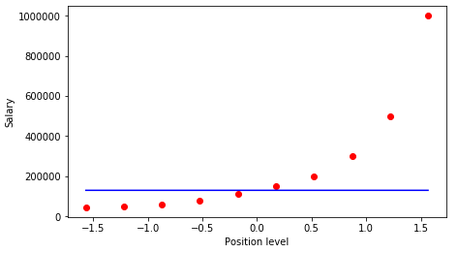

# Decision Tree Regression | Machine Learning

**Decision Tree Regression**: This Regression is based on the decision tree structure. A decision tree is a form of a tree or hierarchical structure that breaks down a dataset into smaller and smaller subsets. At the same time, an associated decision tree is incrementally developed. The tree contains **decision nodes** and **leaf nodes**. The **decision nodes**(e.g. Outlook) are those nodes represent the value of the input variable(x). It has two or more than two branches(e.g. Sunny, Overcast, Rainy). The **leaf nodes**(e.g. Hours Played) contains the decision or the output variable(y). The decision node that corresponds to the best predictor becomes the topmost node and called the **root node.**

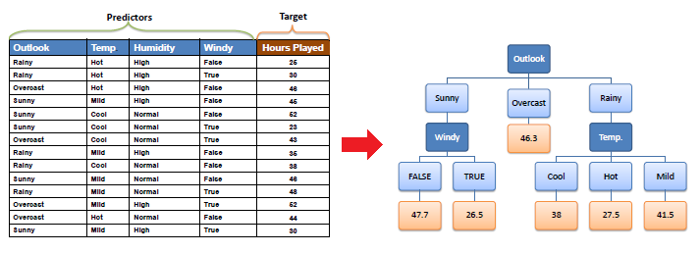

Decision Trees are used for both Classification and Regression tasks. In this tutorial, we will focus on Regression trees. Let’s consider scatter plot of some data set.

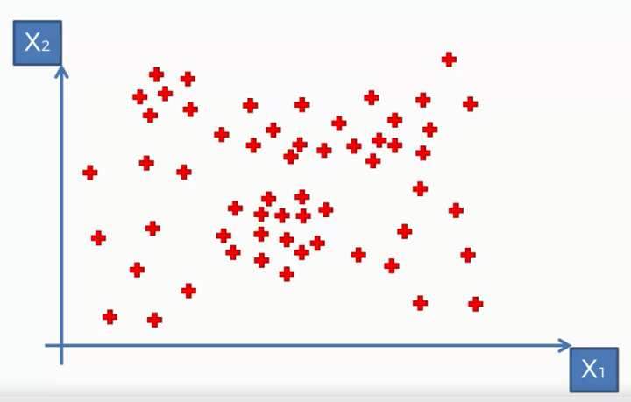

Here, we take a dataset that contains two independent variables X1, and X2 and we are predicting a third dependent variable y. You can not find it on the scatterplot as it has two dimensions. To visualize y, we need to add another dimension and after that, it would like the following:

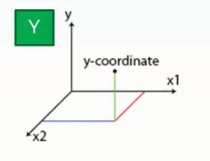

**How does a Decision Tree Work for Regression?**

Well, for this our decision tree would make some splits on the dataset based on information entropy (information entropy tells how much information there is in an event). This is basically dividing the points into some groups. The algorithm decides the optimal number of splits and splits the dataset accordingly. The figure will make it clear

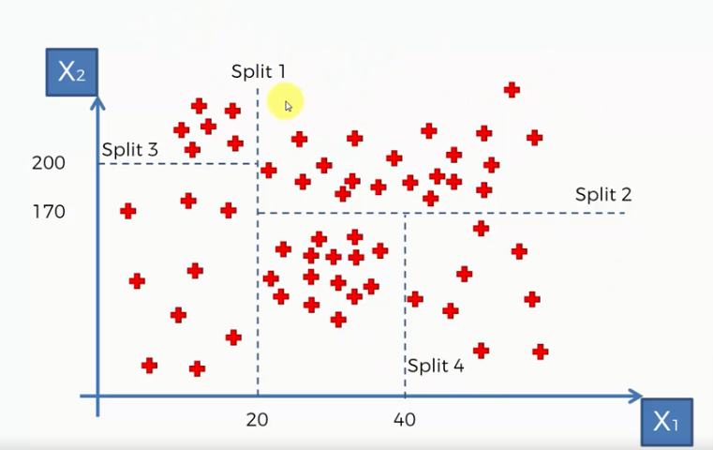

Here we can see the decision tree made four splits and divided the data points into five groups.

Now, this algorithm will take the average value of each group and based on that values it will build the decision tree for this dataset. The tree would look like the following:

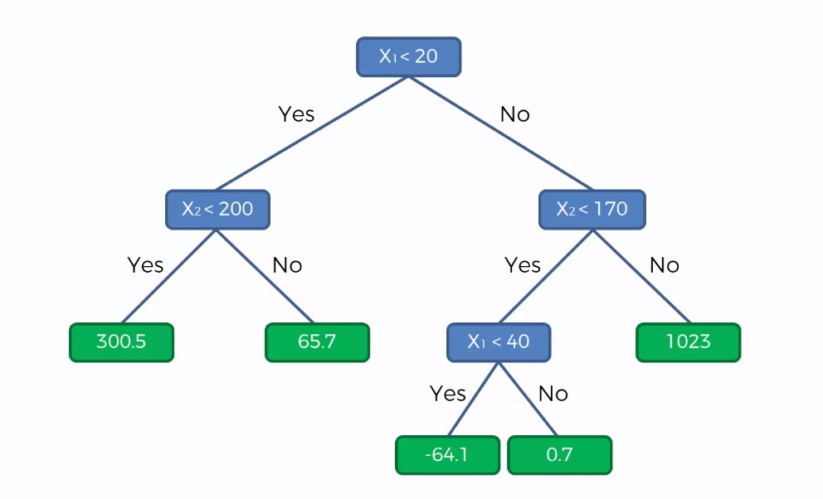

The decision tree above shows that whenever a value of y falls in one of the leaves, it will return the value of that leaf as the prediction for that y value.

**Decision Tree Regression in Python:** In this tutorial, we will implement Decision tree regression in Python. We will work on a dataset (Position_Salaries.csv) that contains the salaries of some employees according to their Position. Our task is to predict the salary of an employee according to an unknown level. So we will make a Regression model using Decision Tree for this task.

You can download the dataset from [here.](https://www.dropbox.com/s/ecwhriu55lx0xd6/Position_Salaries.csv?dl=0)

First of all, we will import the essential libraries.

# Importing the Essential Libraries

import numpy as np

import pandas as pd

import matplotlib.pyplot as plt

Then, we import our dataset.

# Importing the Dataset

dataset = pd.read_csv("Position_Salaries.csv")

After executing this code, the dataset will be imported to our program. Let's have a look on that dataset:

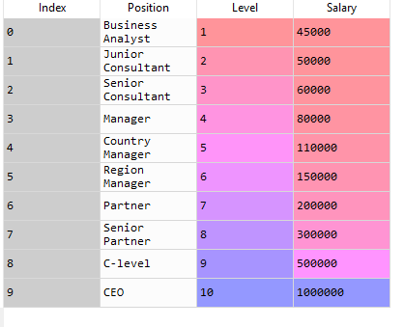

Now, we need to determine the dependent and independent variables. Here we can see the Level is an independent variable while *Salary* is dependent variable or target variable as we want to find out the salary of an employee according to his Level. So our feature matrix X will contain the *Level* column and the value of *Salary* is taken into the dependent variable vector, y.

# Creating Feature Matrix and Dependent Variable Vector

X = dataset.iloc[:, 1:2].values

y = dataset.iloc[:, 2].values

Now, we use **DecisionTreeRegressor** class from the **Scikit-learn** library and make an object of this class. Then we will fit the object to our dataset to make our model.

# Fitting Decision Tree Regression to the dataset

from sklearn.tree import DecisionTreeRegressor

regressor = DecisionTreeRegressor(random_state = 0)

regressor.fit(X, y)

Well, our model is ready!  Let's test our model to know how it predicts an unknown value.

# Predicting a new result

y_pred = regressor.predict([[6.5]])

We predict the result of 6.5 level salary. After executing the code, we get an output of $150k. To learn how closely our model predicted the value, let's visualize the training set.

# Visulizing the Training Set

X_grid = np.arange(min(X), max(X), 0.01)

X_grid = X_grid.reshape((len(X_grid), 1))

plt.scatter(X, y, color = 'red')

plt.plot(X_grid, regressor.predict(X_grid), color = 'blue')

plt.title('Decision Tree Regression')

plt.xlabel('Position level')

plt.ylabel('Salary')

plt.show()

The plot would look like this:

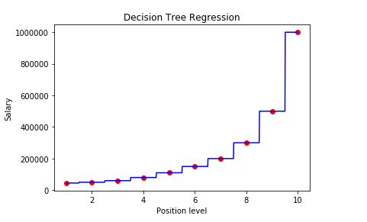

After executing the code, we can see a graph, where we plotting a prediction of  10 salary corresponding to 10 levels. It is nonlinear and non-continuous regression model. This graph does not look like the other linear regression models. Because the decision tree regression takes the average value of each group and assigns this value for any variable falls in that group. So the graph is not continuous rather it looks like a staircase.

From the graph, we see that the prediction for a 6.5 level is pretty close to the actual value (around $160k). So we can say it is a good regression model.

# Random Forest Regression | Machine Learning

**Random Forest Regression:** The basic idea behind Random Forest is that it combines multiple decision trees to determine the final output. That is it builds multiple decision trees and merge their predictions together to get a more accurate and stable prediction.

**How Does It Work?**

Random Forest is a supervised learning algorithm. It uses the ensemble learning technique (Ensemble learning is using multiple algorithms at a time or a single algorithm multiple times to make a model more powerful) to build several decision trees at random data points. Then their predictions are averaged. Taking the average value of predictions made by several decision trees is usually better than that of a single decision tree. Look at the following illustration of two trees (though the number of trees is much more!)

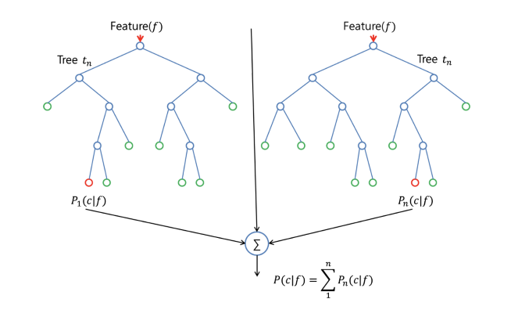

**Difference between Decision Trees and Random Forests:** Random Forest is a collection of Decision Trees, but there are some differences. If you input a training dataset with features and labels into a decision tree, it will formulate some set of rules, which will be used to make the predictions.

Another difference is that decision trees might suffer from **Overfitting**. Random Forest prevents overfitting most of the time, by creating random subsets of the features and building smaller trees using these subsets. Afterwards, it combines the subtrees. Note that this doesn't work every time and that it also makes the computation slower, depending on how many trees your random forest builds.

Random Forest is a flexible, easy to use machine learning algorithm that produces, even without hyper-parameter tuning, a great result most of the time. It is also one of the most used algorithms because it's simplicity and the fact that it can be used for both classification and regression tasks. In this post, you are going to learn, how the random forest algorithm works and several other important things about it.

**The Steps Required to Perform Random Forest Regression:**

**Step 1:** Pick at random k data point from the training set.

**Step 2:** Build the decision Tree associated with this K data point.

**Step 3:** Choose the number Ntree of trees you want to build and repeat STEPS 1 & 2.

**Step 4:** For a new data point, make each one of our Ntree trees predict the value of Y to for the data point in question and assign the new data point the average across all of the predicted Y values.

Now let’s do these steps in Python.

**Random forest regression in python:**

In this tutorial, we will implement Random Forest Regression in Python. We will work on a dataset (Position_Salaries.csv) that contains the salaries of some employees according to their Position. Our task is to predict the salary of an employee at an unknown level. So we will make a Regression model using Random Forest technique for this task.

You can download the dataset from [here.](https://www.dropbox.com/s/ecwhriu55lx0xd6/Position_Salaries.csv?dl=0)

First of all, we will import some essential libraries

# Importing the Essential Libraries

import numpy as np

import matplotlib.pyplot as plt import pandas as pd

Then we will import the dataset.

# Importing the Dataset

dataset = pd.read_csv("Position_Salaries.csv")

Now our dataset has imported to our program. Let’s check how it looks:



Now, we need to determine the dependent and independent variables. Here we can see the Level is an independent variable while Salary is dependent variable or target variable as we want to find out the salary of an employee according to his Level. So our feature matrix X will contain the Level column and the value of Salary is taken into the dependent variable vector, y.

# Creating Feature Matrix and Dependent Variable Vector

X = dataset.iloc[:, 1].values

y = dataset.iloc[:, 2].values

Well, we have come to the main part of the Regression. To implement Random Forest Regression, we need **RandomForestRegressor** class from **Scikit-Learn** library. Then we fit an object of that class to our dataset.

from sklearn.ensemble import RandomForestRegressor

regressor = RandomForestRegressor(n_estimators = 10, random_state = 0)

regressor.fit(X, y)

**Note:** Here, **n_estimators** is a parameter that sets the number of decision trees created for a random data point (the default value is 10, you can use a more number of trees). **random_state = 0**is used so that your code provides the same output as us. Our model is ready! Now, we will test our model for a new value of y.

# Predicting a New Value

y_pred = regressor.predict([[6.5]])

Our model predicted a value of $167k. Let’s compare this value with the actual value. For this, we will visualize our training set result.

# Visualizing the Training Set X_grid = np.arange(min(X), max(X), 0.01)

X_grid = X_grid.reshape((len(X_grid), 1))

plt.scatter(X, y, color = 'red')

plt.plot(X_grid, regressor.predict(X_grid), color = 'blue')

plt.title('Truth or Bluff (Random Forest Regression)')

plt.xlabel('Position level')

plt.ylabel('Salary')

plt.show()                                                        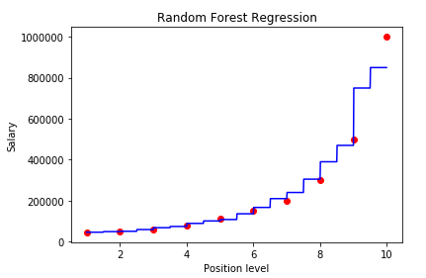

After executing the code, we can see a graph, which is pretty similar to that of a [Decision Tree Regression](http://www.aionlinecourse.com/tutorial/machine-learning/decision-tree-intuition). The main difference is that the lines are more discontinuous from the Decision Tree regression. This is because Random Forest uses a number of decision trees to predict the value of a data point.

From the graph, we see that the prediction for a 6.5 level is pretty close to the actual value (around $160k).

# Evaluating Regression Models performance | Machine Learning

The performance of a regression model can be understood by knowing the error rate of the predictions made by the model. You can also measure the performance by knowing how well your regression line fit the dataset.

In this post, we will try to understand how to measure the performance of regression models.

A good regression model is one where the difference between the actual or observed values and predicted values for the selected model is small and unbiased for train, validation and test data sets.

To measure the performance of your regression model, some statistical metrics are used. Here we will discuss four of the most popular metrics. They are-

* **Mean Absolute Error(MAE)**
* **Root Mean Square  Error(RMSE)**
* **Coefficient of determination or R2**
* **Adjusted R2**

**Mean Absolute Error (MAE)**

This is the simplest of all the metrics. It is measured by taking the average of the absolute difference between actual values and the predictions.

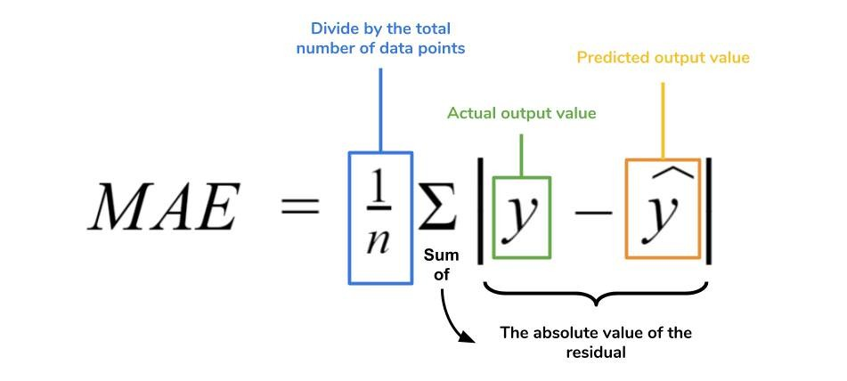

Suppose we have a model that predicted the salary of 4 employees which are $988, $1943, $1239, $2124 where the actual salaries were $1000, $1500, $2000. $2500 respectively.

If we take the absolute difference of the predictions and the actual values we get:

| 1000 - 988 | = 12

| 1500 - 1943 | = 443

| 2000 - 1239 | = 761

| 2500 - 2124 | = 376   
Now, MAE = (12 + 443 + 761 + 376) / 4

= 398

What does this MAE value mean? This value tells us that the model is predicting $398 more or less on average than the actual value.

**Note:**The less the value of MAE the better the performance of your model.

**Root Mean Square Error (RMSE)**

The Root Mean Square Error is measured by taking the square root of the average of the squared difference between the prediction and the actual value. It represents the sample standard deviation of the differences between predicted values and observed values (also called residuals). It is calculated using the following formula:

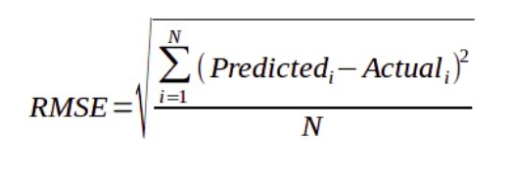

If we take our previous example again, then we have-

RMSE = sqrt((122 + 4432 + 7612 + 3762) / 4)

~478

*sqrt = Sqare Root

Here the RMSE value is greater than that of MAE. This is because RMSE takes the square of the differences between the predictions and the actual value, hence the value is greater the MAE value.

Both MAE and RMSE are in the same units as the dependent variable. As compared to MAE, RMSE will give higher weight to the errors and punish large error in the model. RMSE is the default metric of many models as the loss function defined in terms of RMSE is smoothly differentiable and makes it easier to perform mathematical operations.

**Note:** When you have more samples then reconstructing the error distribution using RMSE is more reliable. But RMSE is highly sensitive to outlier values(an outlier is a data point that differs significantly from other observations). Hence, prior to using this metric, you must remove the outliers from your data set.

**Coefficient of Determination or R^2**

It measures how well the actual outcomes are replicated by the regression line. It helps you to understand how well the independent variable adjusted with the variance in your model. That means how good is your model for a dataset. The mathematical representation for R^2 is-

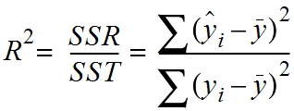

Here, SSR = Sum Square of Residuals (the squared difference between the predicted and the average value)

         SST = Sum Square of Total (the squared difference between the actual and average value)

The above equation can be easily understood by the following illustration:

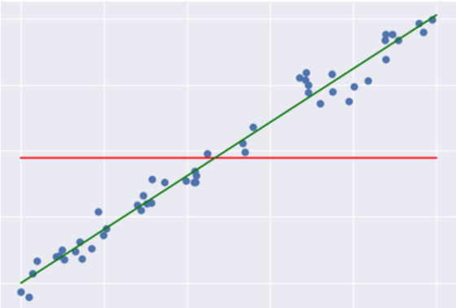

Here the green line represents the regression line and the red line represents the average line. The differences in data points from these lines are taken in the equation.

Usually, the value of R^2 lies between 0 to1 (it can be negative if the regression line somehow has a worse fit than the average!). The closer its value to one, the better your model is. This is because either your regression line has well fitted the dataset or the data points are distributed with low variance. Which lessens the value of the Sum of Residuals. Hence, the equation gets closer to one.

**Adjusted R-squared**

There is a drawback of R^2 that it improves every time when we add new variables in the model.

Think about it, whenever you add a new variable there can be two circumstances, either the new variable improves your model or not. When the new variable improves your model then it is ok. But what if it does not improve your model? Then the problem occurs. The value of  R^2 keeps on increasing with the addition of more independent variables even though they may not have a significant impact on the prediction.

To solve this pitfall, an Adjusted R^2 value is used instead of R^2 value. The mathematical representation for Adjusted R^2 is-

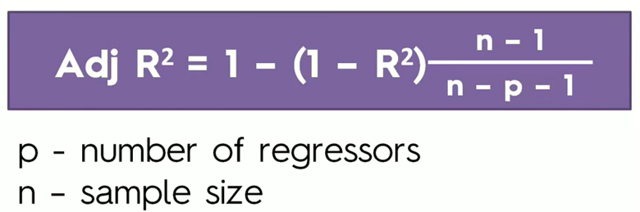

Adjusted R^2 will penalize the model whenever you add a new variable to it. From the equation, you can understand that clearly. Whenever you add a new variable, the value of  R^2  increases and it also increases the denominator( n - p - 1 ) on the left of the equation. As the denominator increases, it increases the value of 1 -  R^2 on the left of the equation. Which in turn decreases the value of Adjusted R^2. Hence, using an Adjusted R^2 value you can better understand the effect of the additional variables to your model.

**Note:** Adjusted  R^2 is greatly helpful when your dataset contains more features and you need to choose the most effective features to train your model.

**What Metric is the Best for Understanding the Performance of a Model?**

Well, this is subjective to your dataset and the model you choose. Each machine learning model solves a problem with a different objective using a different dataset. Hence, you must understand the context of using that model before choosing a metric.

# Classification | Machine Learning

**Classification:** Classification is machine learning task of predicting the value of a categorical variable (target or class). This is done by building a modal based on one or more numerical and categorical variables (predictors, attributes or features). It is considered an instance of supervised learning.

Classification is the problem of identifying to which of a set of categories a new observation belongs, on the basis of a training data containing observations. Classification models include linear models like Logistic Regression, SVM, and nonlinear ones like K-NN, Kernel SVM, and Random Forests.

Now, we will learn how to implement the following Machine Learning Classification models:

1. Logistic Regression
2. K-Nearest Neighbours (K-NN)
3. Support Vector Machine (SVM)
4. Kernel SVM

# Logistic Regression | Machine Learning

In this article, I will go you through the logistic regression, a simple classification algorithm. Then we will implement the algorithm in Python.

**Logistic Regression Intuition:**

Logistic Regression is the appropriate regression analysis to solve binary classification problems (problems with two class values yes/no or 0/1). This algorithm analyses the relationship between a dependent and independent variable and estimates the probability of an event to occur. Like other regression models, it is also a predictive model. But there is a slight difference. While other regression models provide continuous output, Logistic Regression is used to model the probability of a certain class or event existing such as pass/fail, win/lose, alive/dead or healthy/sick.

A good example can be finding the probability of getting cancer(yes/no) by a person for smoking for some years based on the dataset of people containing their smoking period, age, and the condition(having cancer or not).

**How this Algorithm Works?**

If you remember the regression, you can understand that in regression, we use a function to predict the probability of an event to occur. In logistic regression, the idea is the same but with that function, we combine another function named sigmoid or logistic function to find the probability. You can better understand from the following illustration-

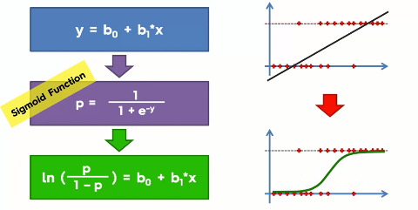

Top of the illustration you can see the original regression equation (at left) and the resulting regression line (at the right of the top). And when we combine it with the sigmoid function we get the logistic equation (in the green box at the bottom). And the resulting slope is shown at the bottom right.

Well, with this logistic function you will get the probability of an event to occur like the probability of buying a car by a person of a certain age.

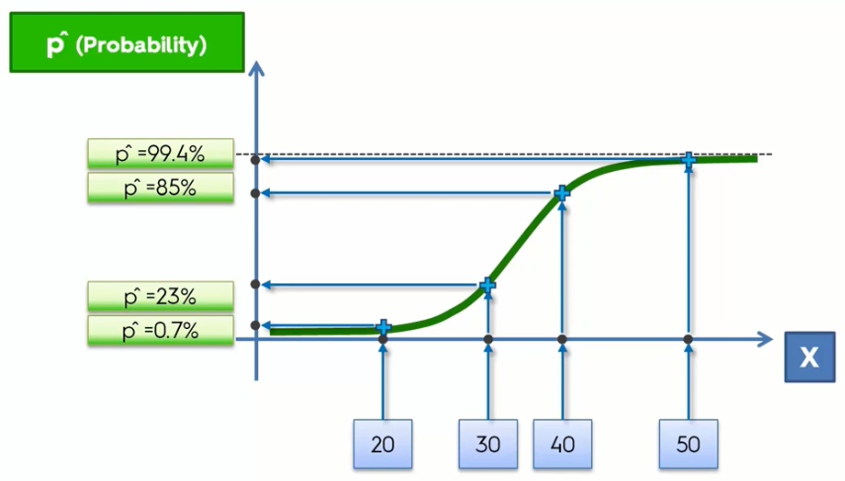

Here, you can see that the people of a lower age(between 20 to 30) are less likely to buy a car(between 0.7% to 23%) whereas people of higher ages have the more probability.

But wait! We are doing classification and we want the probability of people buying a car or not(yes/no values) but here we get a continuous probability. So what would we do is that we will take a threshold point(like 50% or 0.5) in the graph and based on that line we will calculate the probability.

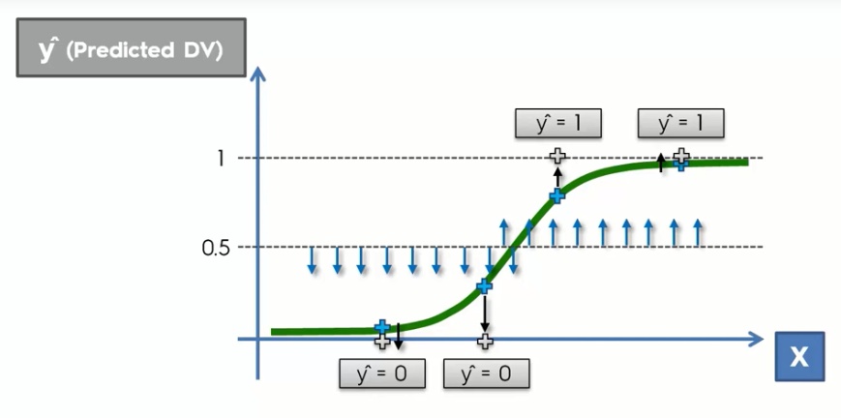

Here you can see we take a threshold point(50% or 0.5) where anything under that probability classified as a 0 or no value and above that line the probability is classified as 1 or yes.

This way we can use a regression function to solve classification problems.

**Logistic Regression in Python:**   
Now we will implement this algorithm in Python. Here we take a dataset containing the Age, Salary, and Action(yes/no value) of purchasing a car. Now our task is to classify a person in terms of his Age and Salary whether he/she is supposed to buy the car.

You can download the dataset from [**here.**](https://www.dropbox.com/s/sj2r3og9br7z08j/Social_Network_Ads.csv?dl=0)

First of all, we import essential libraries.

# Importing Essential Libraries import numpy as np

import matplotlib.pyplot as plt

import pandas as pd

Now, we will import the dataset to our program.

# Importing the Dataset

dataset = pd.read_csv('Social_Network_Ads.csv')

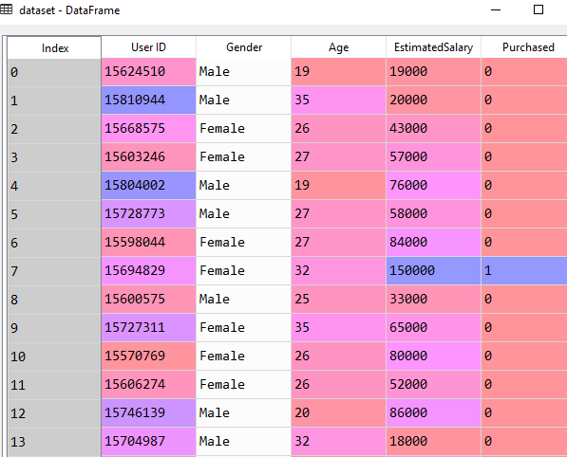

In this dataset, the *Age* and *EstimatedSalary* column are independent variables and the last column *Purchased* is the dependent variable. The last column contains the values 0 or 1. It means it provides the output like yes or no.

Now we take the indexes of *Age* and *EstimatedSalary* as our independent variable matrix. And take the *Purchased* column in the dependent variable vector.

X = dataset.iloc[:, [2, 3]].values

y = dataset.iloc[:, 4].values

Now we split the dataset into a training set and a test set. For this, we take the test size=0.25%. And execute it. After execution, we get 300 training set and 100 test set.

# Splitting the Dataset into Training and Test Set

from sklearn.model_selection import train_test_split

X_train, X_test, y_train, y_test = train_test_split(X, y, test_size = 0.25, random_state = 0)

Now, we will do feature scaling. To transform the x_train matrix object to scale, we use the **fit_transform** method.

# Scaling the Datasets

from sklearn.preprocessing import StandardScaler

sc = StandardScaler()

X_train = sc.fit_transform(X_train)

X_test = sc.transform(X_test)

Now, we fit a logistic regression to the training set. We use the linear model library to import the class **LogisticRegression**. Then we create the classifier object and call that object.

# Fitting the Datataset with Regression Class

from sklearn.linear_model import LogisticRegression

classifier = LogisticRegression(random_state = 0)

classifier.fit(X_train, y_train)

**Note:** Here we set the **random_state** to zero so that the result in our program and yours remain the same.

Well, we have come to the final part of the algorithm. Let's create a variable to predict the result.

# Predicting the output

y_pred = classifier.predict(X_test)

Now, we will see how good our model is to predict the values. Let's evaluate our model using the confusion matrix.

# Building the Confusion Matrix

from sklearn.metrics import confusion_matrix

cm = confusion_matrix(y_test, y_pred)

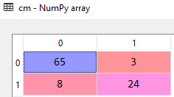

Here the output shows us that the model predicted 73(65+8) correct and 27(3+24) incorrect values. So the accuracy of the model is 73%, pretty impressive!

Now we will visualize the result of our model.

# Visualising the Test set results  
from matplotlib.colors import ListedColormap  
X_set, y_set = X_test, y_test  
X1, X2 = np.meshgrid(np.arange(start = X_set[:, 0].min() - 1, stop = X_set[:, 0].max() + 1, step = 0.01),  
                     np.arange(start = X_set[:, 1].min() - 1, stop = X_set[:, 1].max() + 1, step = 0.01))  
plt.contourf(X1, X2, classifier.predict(np.array([X1.ravel(), X2.ravel()]).T).reshape(X1.shape),  
             alpha = 0.75, cmap = ListedColormap(('red', 'green')))  
plt.xlim(X1.min(), X1.max())  
plt.ylim(X2.min(), X2.max())  
for i, j in enumerate(np.unique(y_set)):  
    plt.scatter(X_set[y_set == j, 0], X_set[y_set == j, 1],  
                c = ListedColormap(('red', 'green'))(i), label = j)  
plt.title('Logistic Regression (Test set)')  
plt.xlabel('Age')  
plt.ylabel('Estimated Salary')  
plt.legend()  
plt.show()

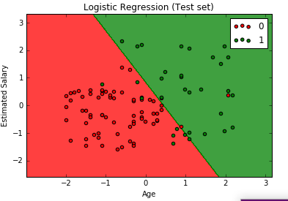

Here the graph shows us the classification of purchasing a car or not based on various *Age* and *Estimated Salary.*

# K-Nearest Neighbour | Machine Learning

In this tutorial, I am going to explain to you the K-Nearest Neighbour(KNN) algorithm and how to implement this algorithm in Python.

**K-Nearest Neighbour Intuition:** K-nearest Neighbour is a non-parametric lazy learning algorithm, used for both classification and regression. KNN stores all available cases and classifies new cases based on a similarity measure. The KNN algorithm assumes that similar things exist in close proximity. In other words, similar things are near to each other. When a new situation occurs, it scans through all past experiences and looks up the k closest experiences. Those experiences (or: data points) are what we call the k nearest Neighbours.

**How This Algorithm Works?**Let's take an example where we have some data points of two different classes. Now our task is to determine the position of a new data point whether it falls in the red category or the green category.

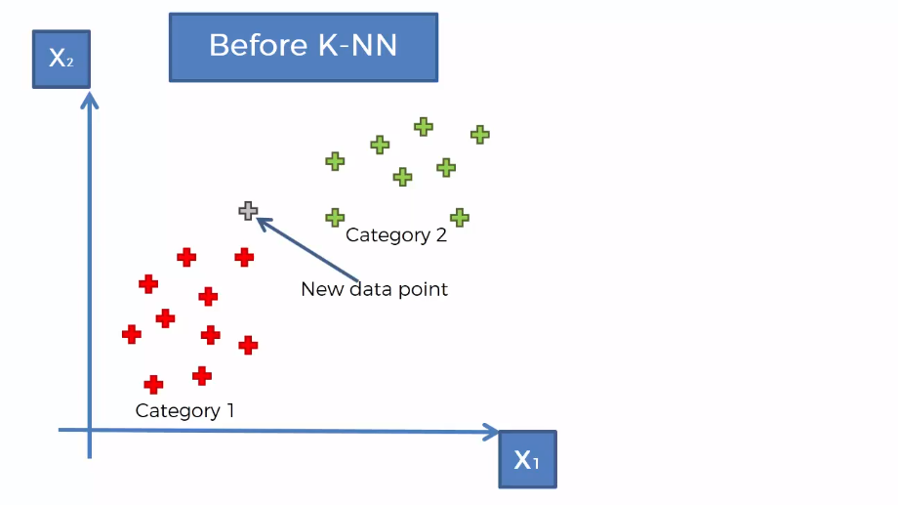

Here where KNN algorithm comes into action. Now let's understand the whole algorithm step by step.  
  
                                  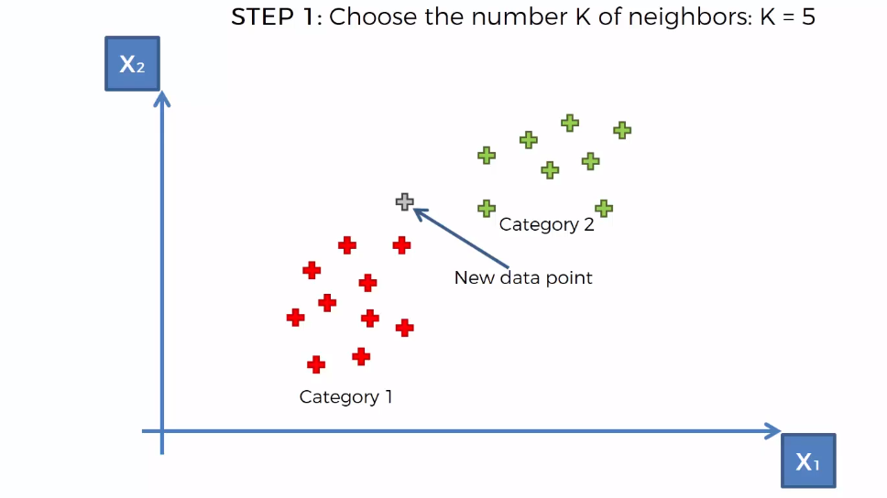

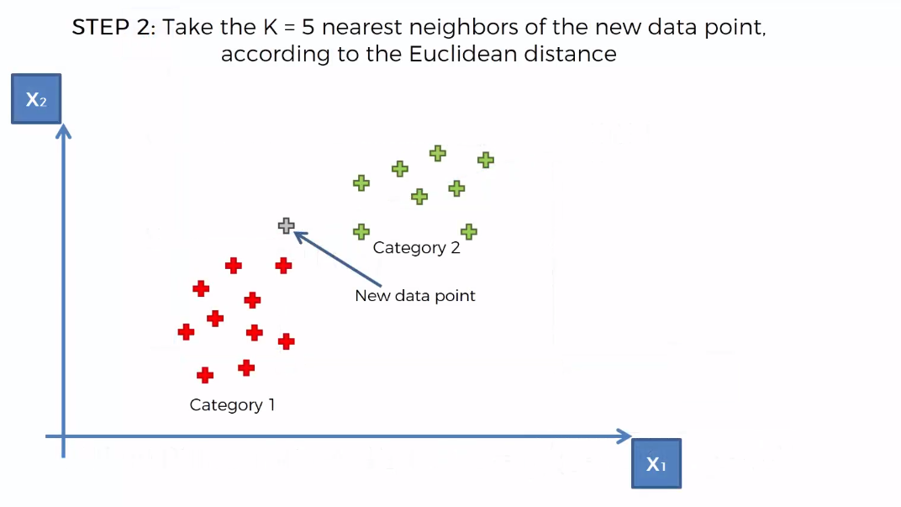

**Euclidean distance:** Euclidean distance is a basic type of distance that we define in geometry. The distance between two points is measured according to this formula.

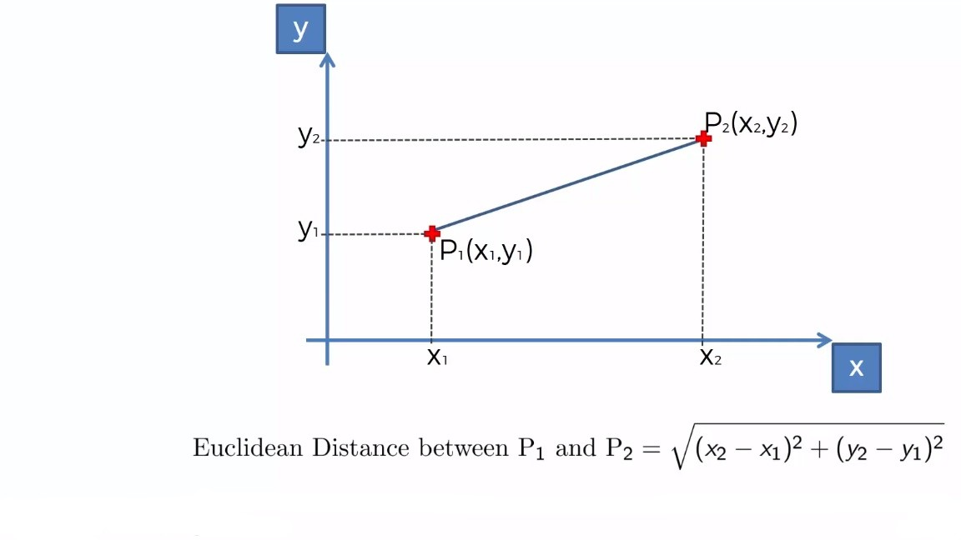

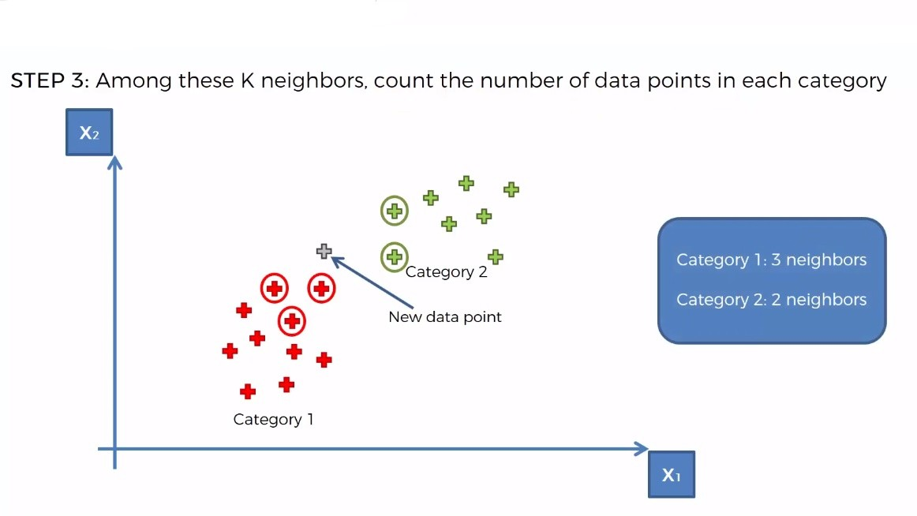

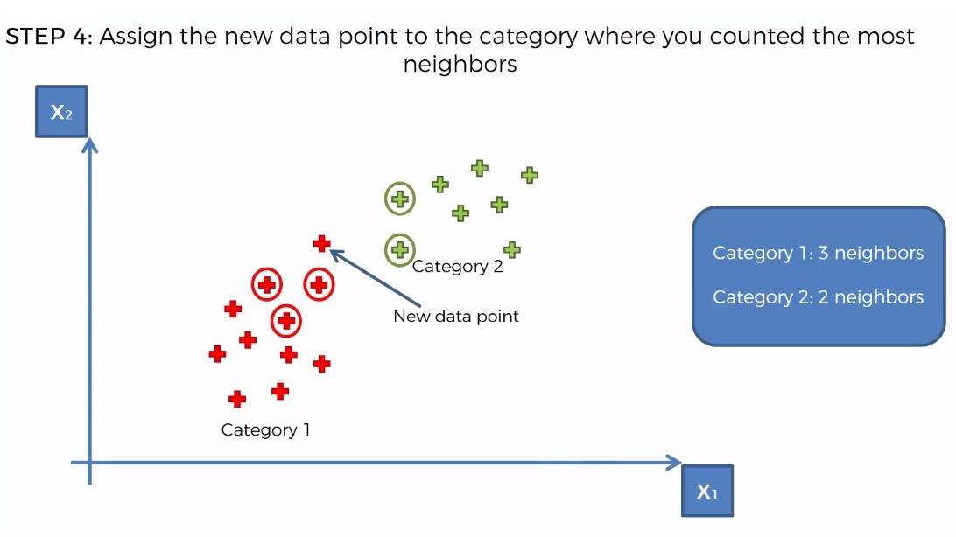

**K-NN in python:**

Now we will implement the KNN algorithm in Python. We will use the dataset Social_Network_Ads.csv

You can download the dataset from [here.](https://www.dropbox.com/s/sj2r3og9br7z08j/Social_Network_Ads.csv?dl=0)

First of all, we will import all the essential libraries.

import numpy as np

import matplotlib.pyplot as plt

import pandas as pd

Now, let's import our dataset.

dataset = pd.read_csv('Social_Network_Ads.csv')

Let's have a look on our dataset.  
                    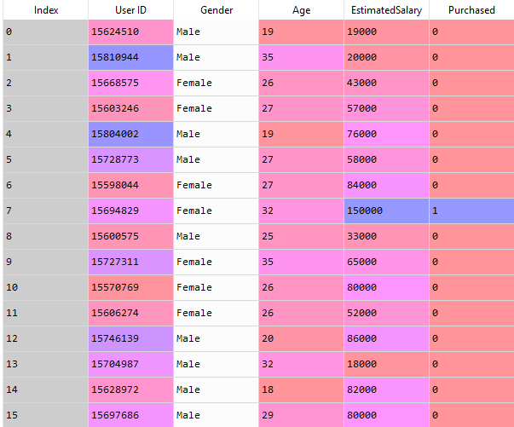

Here you can see that the *Age* and *EstimatedSalary*columns are independent variables and the *Purchased* column is the dependent variable. So we will take the *Age* and *EstimatedSalary*in the independent variable matrix and the *Purchased*column in the dependent variable vector.

X = dataset.iloc[:, [2, 3]].values  
y = dataset.iloc[:, 4].values

Now, we will split our dataset into train and test sets.

from sklearn.model_selection import train_test_split  
X_train, X_test, y_train, y_test = train_test_split(X, y, test_size = 0.25, random_state = 0)

**Note:**Here random_state parameter is set to zero so that your result and our result remain the same.

We need to scale our training and test set to make sure that they have a standard difference in them.

from sklearn.preprocessing import StandardScaler

sc = StandardScaler()

X_train = sc.fit_transform(X_train)

X_test = sc.transform(X_test)

It's time to make a classifier of KNN algorithm. To do so we need the following code.

from sklearn.Neighbours import KNeighboursClassifier

classifier = KNeighboursClassifier(n_Neighbours = 5, metric = 'minkowski', p = 2)

classifier.fit(X_train, y_train)

We have come to the final part of our program, Let’s take a variable to predict the outcome from our model.

y_pred = classifier.predict(X_test)

Now, we use the confusion metrics to find the correct and incorrect prediction.

from sklearn.metrics import confusion_matrix  
cm = confusion_matrix(y_test, y_pred)

Let's execute the code.

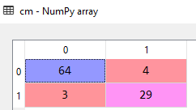

After executing the code, we get 64+29= 93 correct predictions and 3+4=7 incorrect prediction. The correctness of the model is 93% quite impressive!

Well, it's time to look at the result whether it is linear or non-linear.  If it is linear we get a straight line and if it is non-linear we get the curve shape. Let's visualize the outcome.

First, we will visualize our training set.

# Visualising the Training set results

from matplotlib.colors import ListedColormap

X_set, y_set = X_train, y_train

X1, X2 = np.meshgrid(np.arange(start = X_set[:, 0].min() - 1, stop = X_set[:, 0].max() + 1, step = 0.01),

np.arange(start = X_set[:, 1].min() - 1, stop = X_set[:, 1].max() + 1, step = 0.01))

plt.contourf(X1, X2, classifier.predict(np.array([X1.ravel(), X2.ravel()]).T).reshape(X1.shape),

alpha = 0.75, cmap = ListedColormap(('red', 'green')))

plt.xlim(X1.min(), X1.max())

plt.ylim(X2.min(), X2.max())

for i, j in enumerate(np.unique(y_set)):

plt.scatter(X_set[y_set == j, 0], X_set[y_set == j, 1],

c = ListedColormap(('red', 'green'))(i), label = j)

plt.title('K-NN (Training set)')

plt.xlabel('Age')

plt.ylabel('Estimated Salary')

plt.legend()

plt.show()

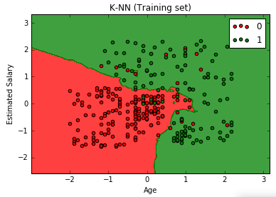

From the above graph, we can see that KNN is a nonlinear classifier.

Now, we visualize the result for the test set.

# Visualising the Test set results

from matplotlib.colors import ListedColormap

X_set, y_set = X_test, y_test

X1, X2 = np.meshgrid(np.arange(start = X_set[:, 0].min() - 1, stop = X_set[:, 0].max() + 1, step = 0.01),

np.arange(start = X_set[:, 1].min() - 1, stop = X_set[:, 1].max() + 1, step = 0.01))

plt.contourf(X1, X2, classifier.predict(np.array([X1.ravel(), X2.ravel()]).T).reshape(X1.shape),

alpha = 0.75, cmap = ListedColormap(('red', 'green')))

plt.xlim(X1.min(), X1.max())

plt.ylim(X2.min(), X2.max())

for i, j in enumerate(np.unique(y_set)):

plt.scatter(X_set[y_set == j, 0], X_set[y_set == j, 1],

c = ListedColormap(('red', 'green'))(i), label = j)

plt.title('K-NN (Test set)')

plt.xlabel('Age')

plt.ylabel('Estimated Salary')

plt.legend()

plt.show()

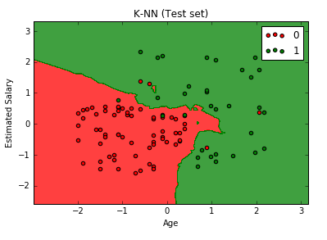

After executing this code, we can see that these regions are perfectly fitted to the test observation. We can see that the real observation point is in the right region.

# Support Vector Machine | Machine Learning

In this tutorial, we will learn the Support Vector Machine algorithm and implement it in Python.

**Support Vector Machine:** Support Vector Machine is a discriminative classifier which finds the optimal hyperplane that distinctly classifies the data points in an N-dimensional space(N - the number of features). In a two dimensional space, a hyperplane is a line that optimally divides the data points into two different classes.

**How the Algorithm Works:**

Let's say you need to classify two different classes of data points in a two-dimensional space. Look at the following illustration.

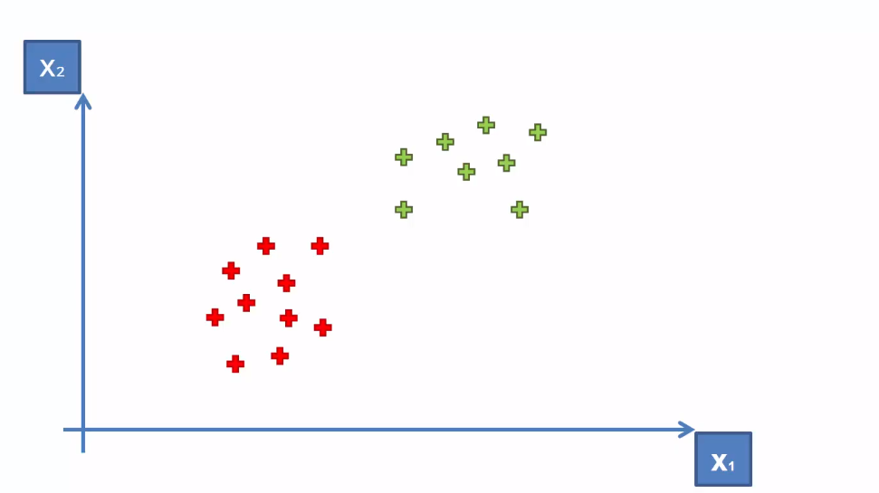

Here we see two classes of data points, one in the red and other in green. Now, what can we do to separate these classes? We can simply draw a line that separates them. This line could be drawn anywhere in the plane.

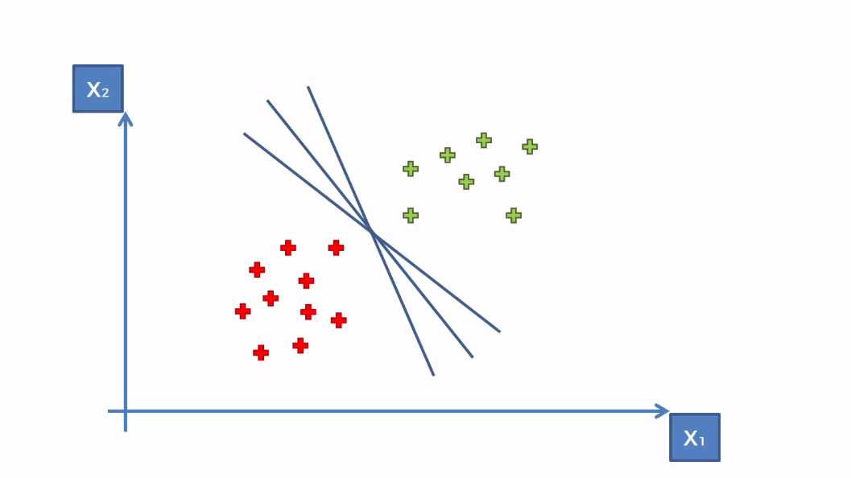

Here, any of the lines can separate the classes. But our task is to find the best fit or optimal line that classifies the data points most accurately. Here the Support vector machine can help us to do so. This algorithm finds us the optimal line/hyperplane. It does so by finding the line with the maximum margin (i.e. the highest distance between data points of both classes).

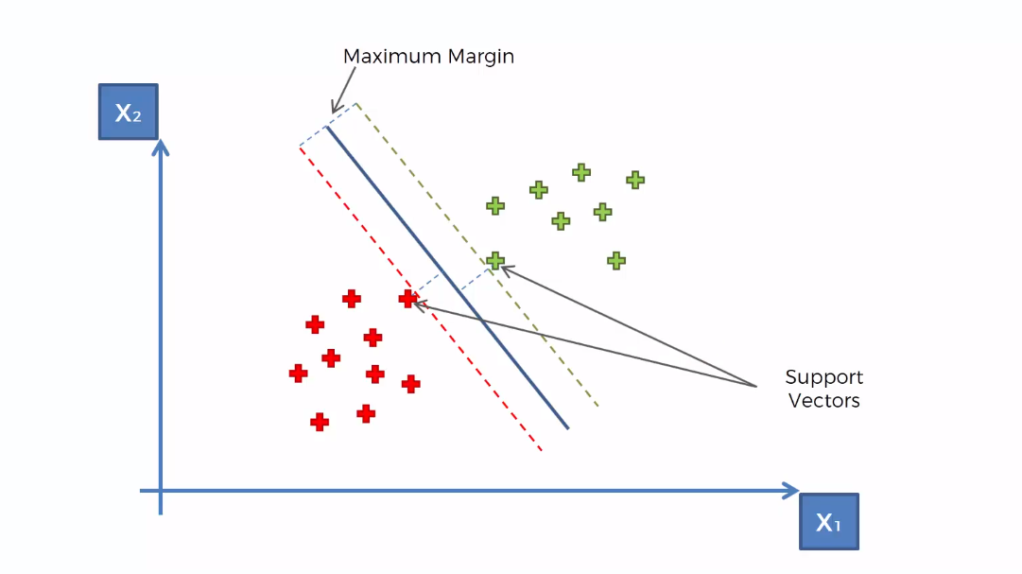

Here support vectors are those two data points that are supporting the decision boundary(the data points which have the maximum margin from the hyperplane). ThatÃƒÆ’Ã‚Â¢ÃƒÂ¢Ã¢â‚¬Å¡Ã‚Â¬ÃƒÂ¢Ã¢â‚¬Å¾Ã‚Â¢s why this algorithm is called support vector machine.

Note: In higher dimensional space(more than two dimensions), the classes cannot be represented as single data points, so they are represented as vectors.

This is one of the simplest but yet a powerful algorithm to solve classification problems.

SVM in python: Now we will implement this algorithm in Python. For this task, we will use the dataset Social_Network_Ads.csv. Let's have a glimpse of that dataset.

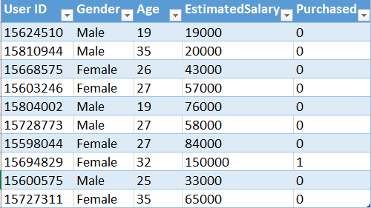

This dataset contains the buying decision of a customer based on gender, age and salary. Now, using SVM, we need to classify this dataset to predict the decision for unknown data points.

You can download the whole dataset from [here.](https://www.dropbox.com/s/sj2r3og9br7z08j/Social_Network_Ads.csv?dl=0)

First of all, we need to import the essential libraries to our program.

import numpy as np

import matplotlib.pyplot as plt

import pandas as pd

Now, Let’s import the datset.

dataset = pd.read_csv('Social_Network_Ads.csv')

In the dataset, the *Age* and *EstimatedSalary*columns are independent and the *Purchased*column is dependent. So we will take both the *Age* and *EstimatedSalary*in our feature matrix and the *Purchased* column in the dependent variable vector.

X = dataset.iloc[:, [2, 3]].values

y = dataset.iloc[:, 4].values

Now, we will split our dataset in training and test sets.

from sklearn.model_selection import train_test_split

X_train, X_test, y_train, y_test = train_test_split(X, y, test_size = 0.25, random_state = 0)

We need to scale our dataset for getting a more accurate prediction.

from sklearn.preprocessing import StandardScaler

sc = StandardScaler()

X_train = sc.fit_transform(X_train)

X_test = sc.transform(X_test)

Well, its time to fit the SVM algorithm to our training set. For this, we use the SVC class from the ScikiLearn library.

from sklearn.svm import SVC

classifier = SVC(kernel = 'linear', random_state = 0)

classifier.fit(X_train, y_train)

Note: Here kernel specifies the type of algorithm we are using. You will know about it in detail in our [Kernel SVM](http://www.aionlinecourse.com/tutorial/machine-learning/kernel-svm) tutorial. For simplicity, here we choose the linear kernel.

Our model is ready. Now, let's see how it predicts for our test set.

y_pred = classifier.predict(X_test)

To see how good is our SVM model is, let's calculate the predictions made by it using the confusion matrix.

from sklearn.metrics import confusion_matrix  
cm = confusion_matrix(y_test, y_pred)

The output of the confusion matrix will be

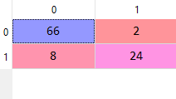

Now, let's visualize our test set result.

# Visualising the Test set results  
from matplotlib.colors import ListedColormap  
X_set, y_set = X_test, y_test  
X1, X2 = np.meshgrid(np.arange(start = X_set[:, 0].min() - 1, stop = X_set[:, 0].max() + 1, step = 0.01),  
                     np.arange(start = X_set[:, 1].min() - 1, stop = X_set[:, 1].max() + 1, step = 0.01))  
plt.contourf(X1, X2, classifier.predict(np.array([X1.ravel(), X2.ravel()]).T).reshape(X1.shape),  
             alpha = 0.75, cmap = ListedColormap(('red', 'green')))  
plt.xlim(X1.min(), X1.max())  
plt.ylim(X2.min(), X2.max())  
for i, j in enumerate(np.unique(y_set)):  
    plt.scatter(X_set[y_set == j, 0], X_set[y_set == j, 1],  
                c = ListedColormap(('red', 'green'))(i), label = j)  
plt.title('SVM (Test set)')  
plt.xlabel('Age')  
plt.ylabel('Estimated Salary')  
plt.legend()  
plt.show()

The graph will like the following

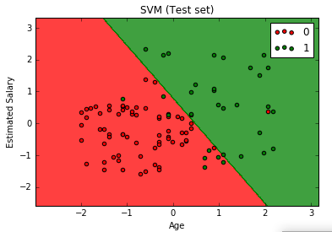

From the above graph, we can see that our model tries to find the optimal line that separates the data points accurately.

This tutorial only explains SVM in two-dimensional space, in the next tutorial we will see SVM in higher dimensional spaces.

# Kernel SVM | Machine Learning

In this tutorial, we are going to introduce to the Kernel Support Vector Machine and how to implement in Python.

**Kernel SVM Intuition:**  
In previous Support Vector Machine tutorial, we implemented SVM for the following scenario.



Here the data points are linearly separable. That means we can separate the data points with a straight line.



But what if we have data points like the following

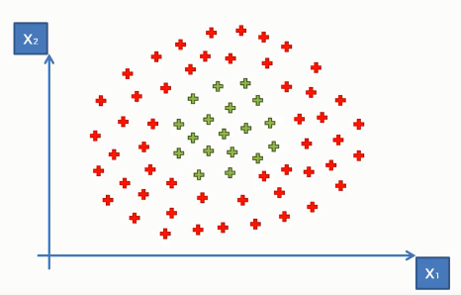

Here the data points do not look like the previous data points(though both in the same dimensional space). As we can see they can not be separated into two distinctive classes with a straight line. This is because these data points are not linearly separable.

So what can we do to make them linearly separable so that we can apply the SVM algorithm to the data point?

Well, we can do one thing, that is we can take the data points in a higher dimensional space where they become linearly separable. To get a clear idea of this concept, letÃƒÆ’Ã‚Â¢ÃƒÂ¢Ã¢â‚¬Å¡Ã‚Â¬ÃƒÂ¢Ã¢â‚¬Å¾Ã‚Â¢s look at the following illustration.

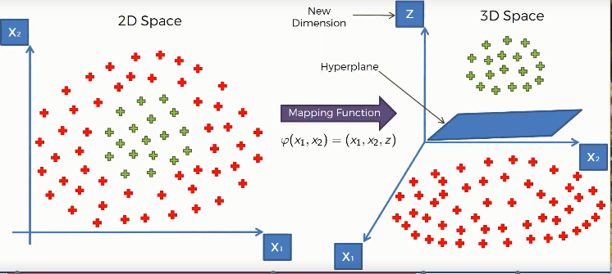

Here we used a mapping function(a function that maps the lower dimensional data points in a higher dimensional space), that elevates our data points into a higher dimensional space where they become linearly separable. And we find a hyperplane that classifies the data points into two distinctive classes.

Then we will project our data points to the initial dimensional space using another function.

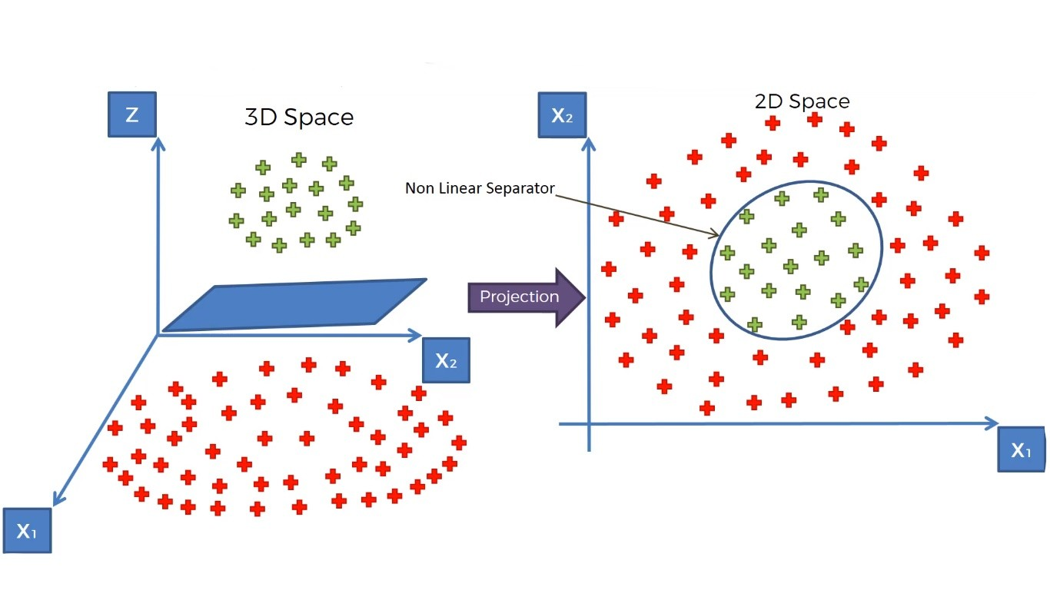

This is the whole idea of separating non-linear data points. In SVM, we do this by a special method or function called Kernel Trick.

In simple terms, Kernel Tricks are functions which apply some complex mathematical operations on the lower dimensional data points and convert them into higher dimensional space, then find out the process of separating the data points based on the labels and outputs you have defined.

There are many kernel tricks used in SVM. Some most used kernels are- the Gaussian RBF Kernel, Polynomial Kernel, Sigmoid Kernel etc.

Here we choose the Gaussian RBF Kernel.

**The Kernel trick:**Here we choose the Gaussian RBF Kernel function.

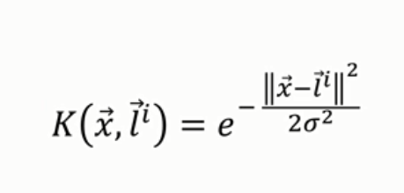

And using the simplified formula of this Kernel Function stated above, we can find the classification of data points like the following.

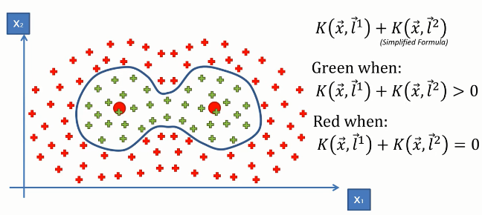

**Kernel SVM in python:** Now, we will implement this algorithm in Python. For this task, we will use the Social_Network_Ads.csv dataset. Let's have a glimpse of that dataset.                                      

This dataset contains the buying decision of a customer based on gender, age and salary. Now, using SVM, we need to classify this dataset to predict the decision for unknown data points.

You can download the whole dataset from [here.](https://www.dropbox.com/s/sj2r3og9br7z08j/Social_Network_Ads.csv?dl=0)

First of all, we need to import essential libraries.

import numpy as np

import matplotlib.pyplot as plt

import pandas as pd

Then we will import the dataset.

dataset = pd.read_csv('Social_Network_Ads.csv')

Now, let's divide the features of the dataset into feature matrix X and dependent variable vector y.

X = dataset.iloc[:, [2, 3]].values

y = dataset.iloc[:, 4].values

Then we will make training and test sets.

from sklearn.model_selection import train_test_split  
X_train, X_test, y_train, y_test = train_test_split(X, y, test_size = 0.25, random_state = 0)

Let's scale the training and test sets.

from sklearn.preprocessing import StandardScaler  
sc = StandardScaler()  
X_train = sc.fit_transform(X_train)  
X_test = sc.transform(X_test)

It's time to fit SVC to our model. For this, we will use the SVC class from ScikitLearn library.

from sklearn.svm import SVC

classifier = SVC(kernel = 'rdf', random_state = 0)

classifier.fit(X_train, y_train)

We have built our model. Let's say how it predicts on the test set.

y_pred = classifier.predict(X_test)

We are going to visualize the predicted result.

# Visualising the Test set results  
from matplotlib.colors import ListedColormap  
X_set, y_set = X_test, y_test  
X1, X2 = np.meshgrid(np.arange(start = X_set[:, 0].min() - 1, stop = X_set[:, 0].max() + 1, step = 0.01),  
                     np.arange(start = X_set[:, 1].min() - 1, stop = X_set[:, 1].max() + 1, step = 0.01))  
plt.contourf(X1, X2, classifier.predict(np.array([X1.ravel(), X2.ravel()]).T).reshape(X1.shape),  
             alpha = 0.75, cmap = ListedColormap(('red', 'green')))  
plt.xlim(X1.min(), X1.max())  
plt.ylim(X2.min(), X2.max())  
for i, j in enumerate(np.unique(y_set)):  
    plt.scatter(X_set[y_set == j, 0], X_set[y_set == j, 1],  
                c = ListedColormap(('red', 'green'))(i), label = j)  
plt.title('Kernel SVM (Test set)')  
plt.xlabel('Age')  
plt.ylabel('Estimated Salary')  
plt.legend()  
plt.show()

  The above code will generate the following graph.

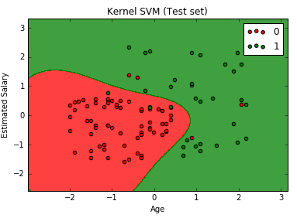

We can see that the graph looks different than that of the previous SVM result. This is because we modelled the data points in a higher dimensional space.

# Naive Bayes Classification | Machine Learning

In this tutorial, we are going to learn the intuition behind the Naive Bayes classification algorithm and implement it in Python.

**Naive Bayes Intuition:**It is a classification technique based on Bayes Theorem. In simple terms, it is a probabilistic classifier which assumes that the presence of a particular feature in a class is not related to the presence of other features. It calculates the Posterior probability of all the events using the Bayes Theorem. Then it takes the event that has the maximum posterior probability.

To clear the idea, Let’s have a look at the Bayes Theorem.

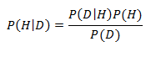

Here,  
P (H | D) = The conditional probability for event H to occur given that event D has occurred. This is known as the Posterior probability.

P (H) and P (D) = The probability of event H and D to occur without depending on each other.

P (D | H) = The probability of event D to occur given that even H has occurred. It is also known as the likelihood of the event.

Now Let’s get into work. We will apply this Bayes Theorem to make our Naive Bayes classifier. Let’s take an example.

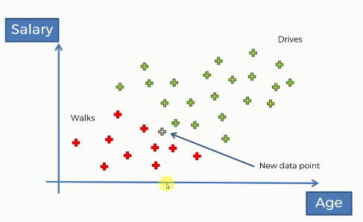

Here we have 30 data points(excluding the grey one) of people with two features Salary and Age, and their choice whether they walk or drive based on these two distinctive features. Now, for a new data point(the grey data point), we need to classify which class does it belong. That means we should find whether this new person walks or drive. For this, we will apply the Naive Bayes technique to take the decision.

First of all, we will apply Bayes Theorem to calculate the posterior probability of walking for this new data point based on the given features X. That is how likely the person walks.

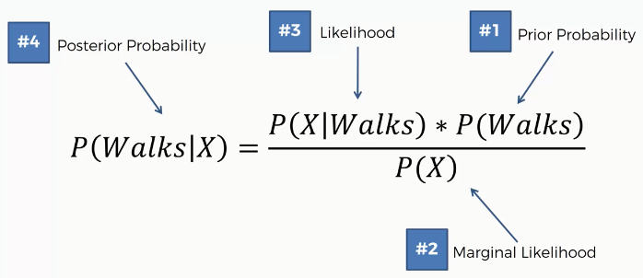

In the same way, we will calculate the probability of driving

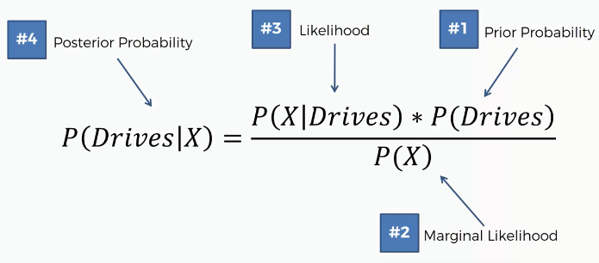

After calculating both the probabilities, the algorithm will compare them, and take the one that has the highest value.

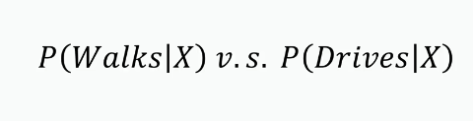

Step 1: Now we will calculate all the prior probability, marginal likelihood, likelihood, and posterior probability of a person likely to walk.

The prior probability, P(Walks) is simply the probability of the persons who walk among all the people.                                     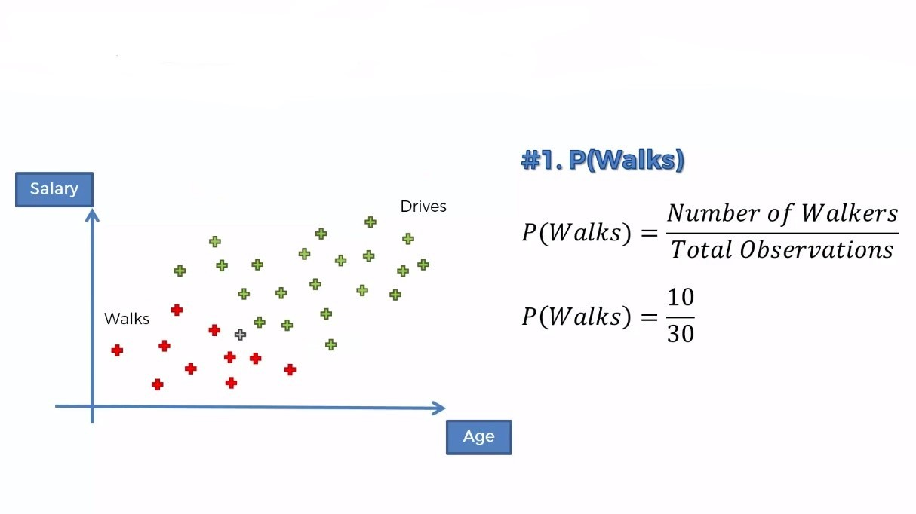

For marginal likelihood, P(X), we will make a circle around the new data point and calculate all the observations (including red and green). The radius of the circle depends upon you. That means you can take different radii depending on the algorithm.             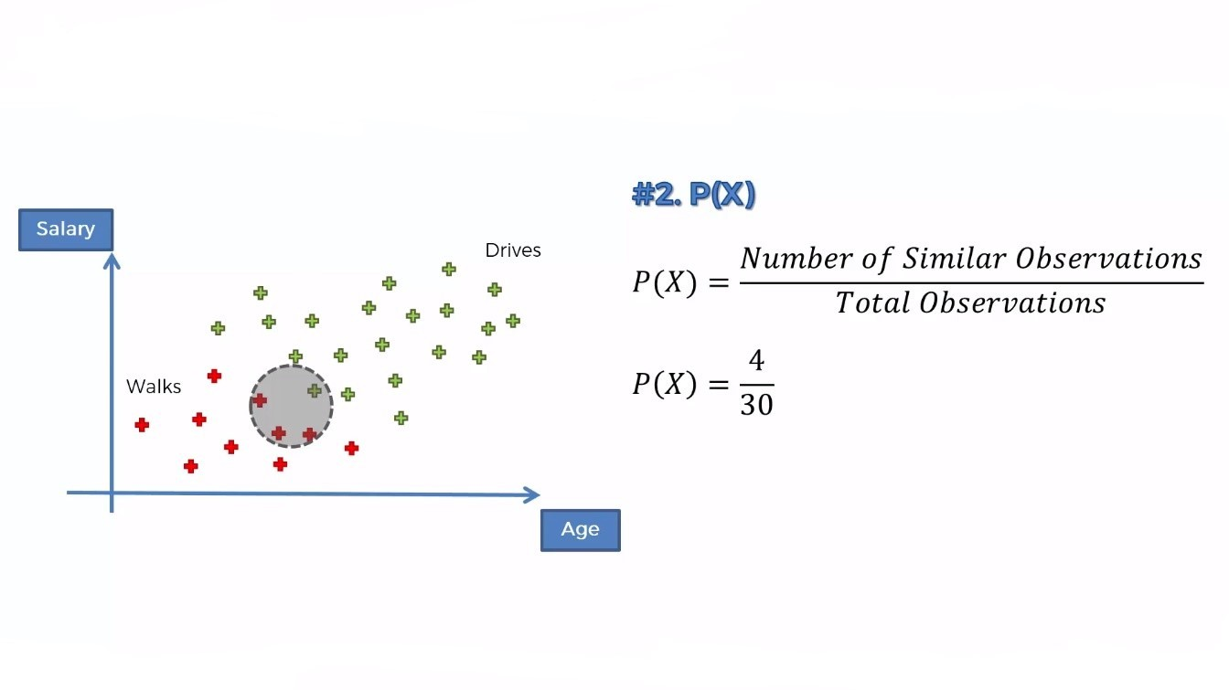

The likelihood is the probability of such persons who walk to work. So, here we are concerned only with the red dots.                           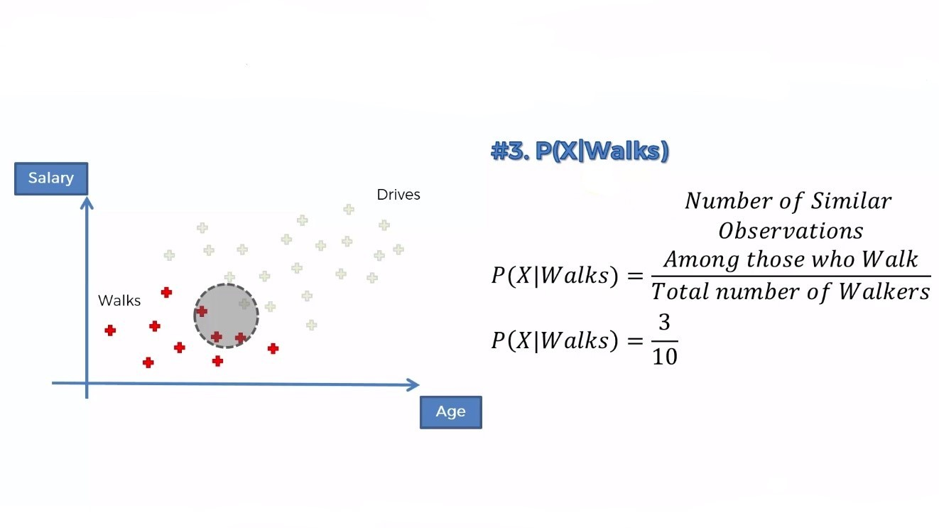

After calculating all these, now we can put them into the Bayes' Theorem

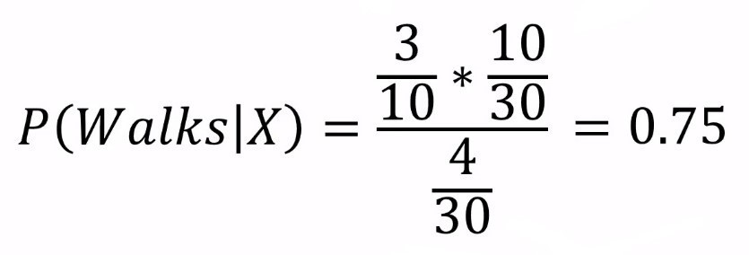

**Step 2:** Now, we will do similar calculations for P(Drives | X)

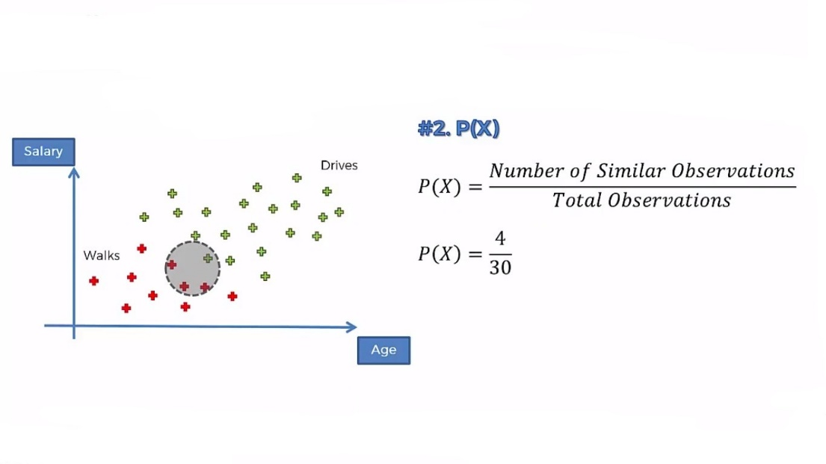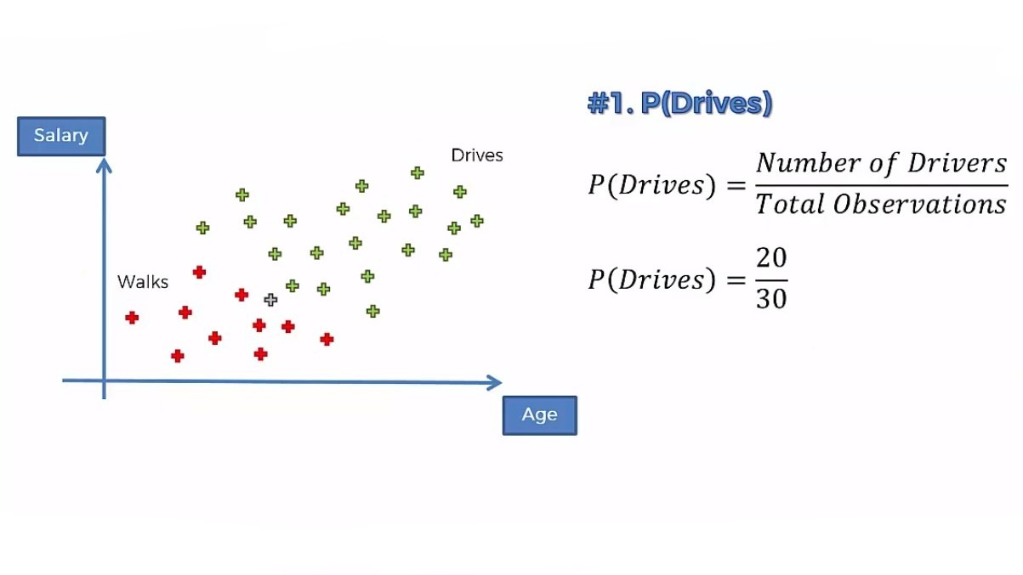

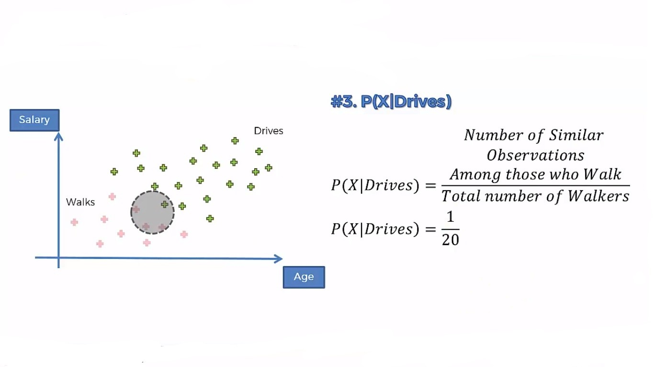

Putting all these together, we get

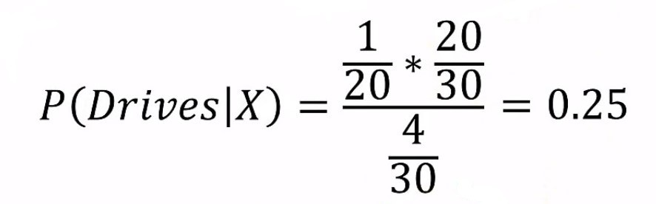

Step 3: Now we will compare both the probabilities. Then we will take the higher probability value as the output.

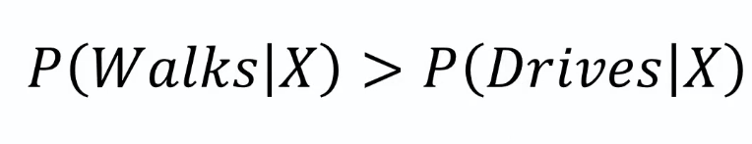

Here we can see the probability of a person likely to walk is greater than the probability for a person to drive. So we say that our new point falls into the category of people who walks.

**Naive Bayes in Python:** Now, we will implement the algorithm in Python. For this task, we will use the *Social_Network_Ads.csv*dataset. Let’s have a glimpse of that dataset-



You can download the whole dataset from [here](https://www.dropbox.com/s/sj2r3og9br7z08j/Social_Network_Ads.csv?dl=0).

First of all, we will import all the essential libraries.

# Importing essential libraries

import numpy as np

import matplotlib.pyplot as plt

import pandas as pd

Now, we will import the dataset to our program

# Importing the dataset

dataset = pd.read_csv('Social_Network_Ads.csv')

From the dataset, we take the *Age* and *EstimatedSalary* columns in the Feature matrix as they are independent features and the *Purchased*column in the Dependent vector.

# Making the Feature matris and dependent vector

X = dataset.iloc[:, [2, 3]].values

y = dataset.iloc[:, 4].values

Now, we split our dataset into training and test sets.

# Splitting the dataset into the Training set and Test set

from sklearn.model_selection import train_test_split

X_train, X_test, y_train, y_test = train_test_split(X, y, test_size = 0.25, random_state = 0)

We need to scale the training and test sets to get a better prediction.

#Feature Scaling

from sklearn.preprocessing import StandardScaler

sc = StandardScaler()

X_train = sc.fit_transform(X_train)

X_test = sc.transform(X_test)

Now, we will fit the Naive Bayes algorithm to our dataset.

# Fitting Naive Bayes to the Training set

from sklearn.naive_bayes import GaussianNB

classifier = GaussianNB()

classifier.fit(X_train, y_train)

Its time to see how our model predicts the test set result.

# Predicting the Test set results

y_pred = classifier.predict(X_test)

We will see the performance of our model using the confusion matrix.

# Making the Confusion Matrix  
from sklearn.metrics import confusion_matrix  
cm = confusion_matrix(y_test, y_pred)

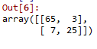

Now, we will visualize our model with the training set result.

# Visualising the Training set results

from matplotlib.colors import ListedColormap

X_set, y_set = X_train, y_train

X1, X2 = np.meshgrid(np.arange(start = X_set[:, 0].min() - 1, stop = X_set[:, 0].max() + 1, step = 0.01),

np.arange(start = X_set[:, 1].min() - 1, stop = X_set[:, 1].max() + 1, step = 0.01))

plt.contourf(X1, X2, classifier.predict(np.array([X1.ravel(), X2.ravel()]).T).reshape(X1.shape),

alpha = 0.75, cmap = ListedColormap(('red', 'green')))

plt.xlim(X1.min(), X1.max())

plt.ylim(X2.min(), X2.max())

for i, j in enumerate(np.unique(y_set)):

plt.scatter(X_set[y_set == j, 0], X_set[y_set == j, 1],

c = ListedColormap(('red', 'green'))(i), label = j)

plt.title('Naive Bayes (Training set)')

plt.xlabel('Age')

plt.ylabel('Estimated Salary')

plt.legend()

plt.show()

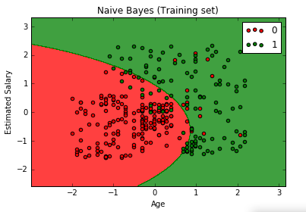

We will now see how it performs on our test set. Let’s visualize this.

# Visualising the Test set results

from matplotlib.colors import ListedColormap

X_set, y_set = X_test, y_test

X1, X2 = np.meshgrid(np.arange(start = X_set[:, 0].min() - 1, stop = X_set[:, 0].max() + 1, step = 0.01),

np.arange(start = X_set[:, 1].min() - 1, stop = X_set[:, 1].max() + 1, step = 0.01))

plt.contourf(X1, X2, classifier.predict(np.array([X1.ravel(), X2.ravel()]).T).reshape(X1.shape),

alpha = 0.75, cmap = ListedColormap(('red', 'green')))

plt.xlim(X1.min(), X1.max())

plt.ylim(X2.min(), X2.max())

for i, j in enumerate(np.unique(y_set)):

plt.scatter(X_set[y_set == j, 0], X_set[y_set == j, 1],

c = ListedColormap(('red', 'green'))(i), label = j)

plt.title('Naive Bayes (Test set)')

plt.xlabel('Age')

plt.ylabel('Estimated Salary')

plt.legend()

plt.show()

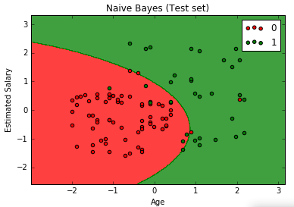

# Decision Tree Classification | Machine Learning

In this article, we are going to understand the concept of Decision Tree algorithm for classification and then we will implement it in Python.

**Decision Tree Classification:** This Classification is based on the decision tree structure. A decision tree is a form of a tree or hierarchical structure that breaks down a dataset into smaller and smaller subsets. At the same time, an associated decision tree is incrementally developed. The tree contains **decision nodes** and **leaf nodes**. The **decision nodes** are those nodes represent the value of the input variable(x). It has two or more than two branches. The **leaf nodes** contain the decision or the output variable(y). The decision node that corresponds to the best predictor becomes the topmost node and called the **root node.**

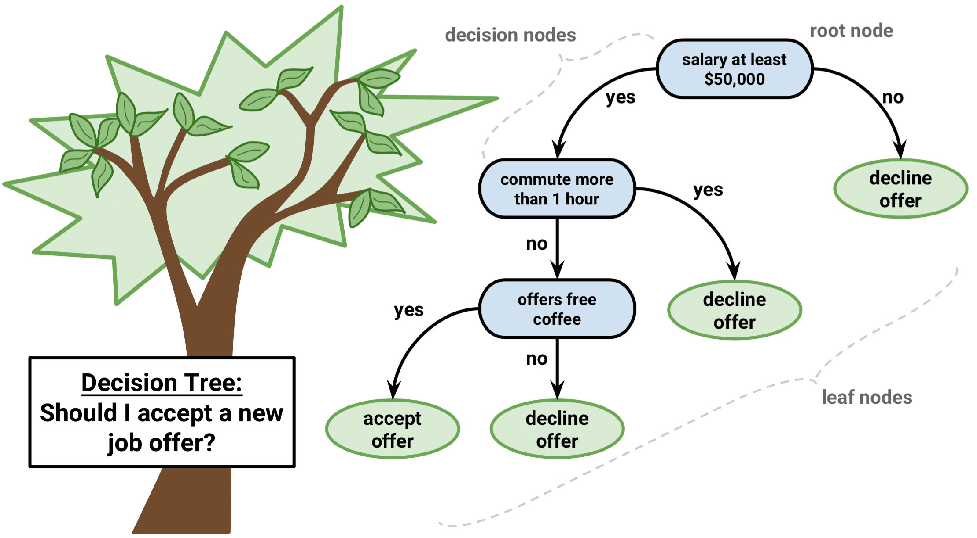

**When You Should Choose a Decision Tree?**

Assume you have a dataset where the data points are randomly distributed. Consider the following illustration.

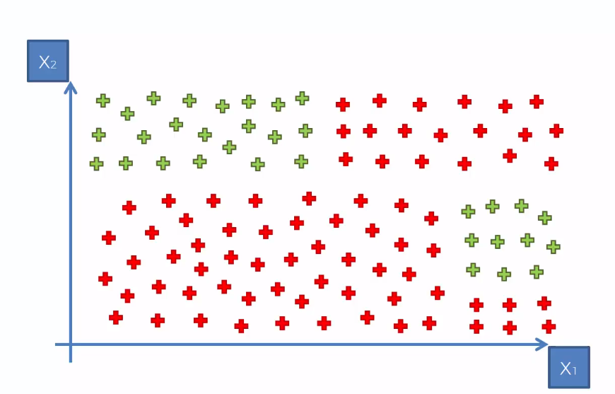

For a randomly distributed dataset like this, you should not go for the other classification algorithm like SVM, K-means, or Naive Bayes. As more randomness in data will create more entropy, you must choose an algorithm that minimizes the entropy and maximize the information gain. In that context, you should implement a Decision Tree for classification.

**Entropy** is the measure of randomness or impurity contained in a dataset.**Information gain** is the opposite of entropy that measures the decrease in entropy.

**How does the Algorithm Work?**

This algorithm works based on maximizing the information gain in the groups of data points. That means it splits the data points into optimal parts(subtree) in such a way that it contains as much as information and less randomness. It selects the best attributes using the Attribute Selection Measures to split the data. For the above data points, it would split them in the following way.

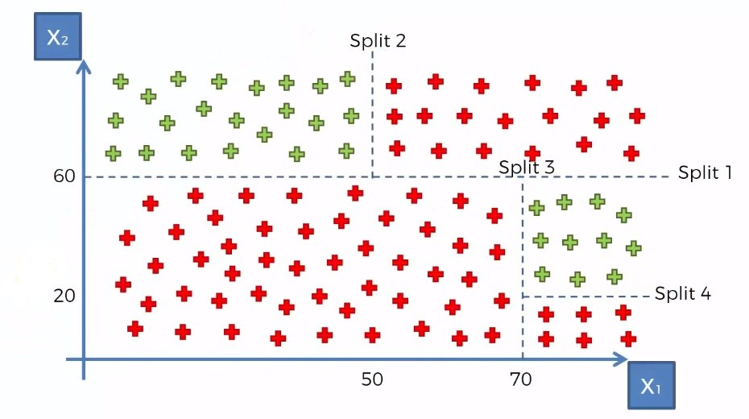

Then it makes the attribute a decision node and breaks the dataset into smaller subsets (subtree). It repeats the process recursively for each child node until there is no more remaining attributes or no more instances to add to the tree.

For the above dataset, it will make a tree like this.

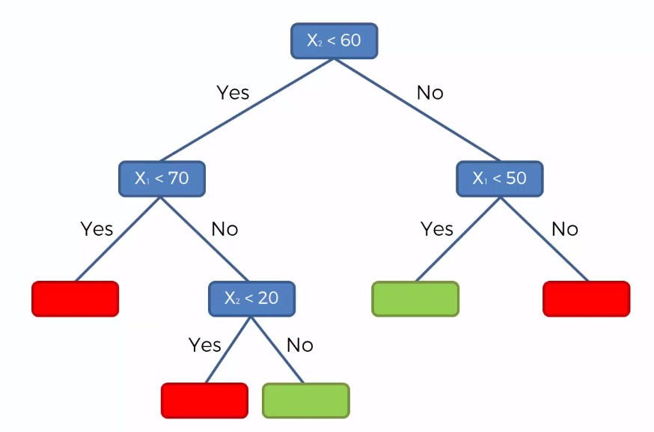

Then to classify a new data point, it will traverse the tree and try to match that point to one of the decision nodes. If it reaches that node, it returns the leaf node value for that data point.

It is quite a simple method but at the same time, it lies in the foundation of some of the more modern and powerful method of machine learning.

**Decision Tree Classification in python:**Now, we will implement the above algorithm in Python. For this task, we will use Social_Network_Ads.csv dataset. Let’s have a glimpse of that dataset.

o

You can download the whole dataset from [here.](https://www.dropbox.com/s/sj2r3og9br7z08j/Social_Network_Ads.csv?dl=0)

First of all, we will import the libraries.

import numpy as np

import matplotlib.pyplot as plt

import pandas as pd

Then we will import the dataset into our program and divide the attributes into Feature matrix and dependent variable vectors. Here the *Age*and *Estimated Salary*are the independent attributes, so we will put them into the Feature matrix and the *Purchased* column into the dependent variable vector.

# Importing the dataset

dataset = pd.read_csv('Social_Network_Ads.csv')

X = dataset.iloc[:, [2, 3]].values

y = dataset.iloc[:, 4].values

Now, we will split the dataset into training and test sets.

# Splitting the dataset into the Training set and Test set

from sklearn.model_selection import train_test_split

X_train, X_test, y_train, y_test = train_test_split(X, y, test_size = 0.25, random_state = 0)

We need to scale our dataset for a more accurate prediction.

# Feature Scaling

from sklearn.preprocessing import StandardScaler

sc = StandardScaler()

X_train = sc.fit_transform(X_train)

X_test = sc.transform(X_test)

It's time to fit the Decision tree algorithm to our dataset.

# Fitting Decision Tree Classification to the Training set

from sklearn.tree import DecisionTreeClassifier

classifier = DecisionTreeClassifier(criterion = 'entropy', random_state = 0)

classifier.fit(X_train, y_train)

**Note:**Here criterion is the parameter that measures the quality of a split. We choose 'entropy' for the information gain.

We have built our model. Now, we will predict the result.

# Predicting the Test set results

y_pred = classifier.predict(X_test)

To learn how our model performed on the dataset, we will build a confusion matrix.

# Making the Confusion Matrix

from sklearn.metrics import confusion_matrix

cm = confusion_matrix(y_test, y_pred)

After executing, the output of the confusion matrix would look like this.

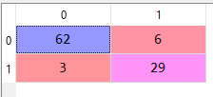

Now, we have come to the most fun and exciting part. We will visualize both the training set and test set results.

# Visualising the Training set results

from matplotlib.colors import ListedColormap

X_set, y_set = X_train, y_train

X1, X2 = np.meshgrid(np.arange(start = X_set[:, 0].min() - 1, stop = X_set[:, 0].max() + 1, step = 0.01),

np.arange(start = X_set[:, 1].min() - 1, stop = X_set[:, 1].max() + 1, step = 0.01))

plt.contourf(X1, X2, classifier.predict(np.array([X1.ravel(), X2.ravel()]).T).reshape(X1.shape),

alpha = 0.75, cmap = ListedColormap(('red', 'green')))

plt.xlim(X1.min(), X1.max())

plt.ylim(X2.min(), X2.max())

for i, j in enumerate(np.unique(y_set)):

plt.scatter(X_set[y_set == j, 0], X_set[y_set == j, 1],

c = ListedColormap(('red', 'green'))(i), label = j)

plt.title('Decision Tree Classification (Training set)')

plt.xlabel('Age')

plt.ylabel('Estimated Salary')

plt.legend()

plt.show()

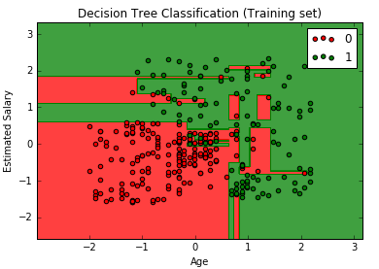

# Visualising the Test set results

from matplotlib.colors import ListedColormap

X_set, y_set = X_test, y_test

X1, X2 = np.meshgrid(np.arange(start = X_set[:, 0].min() - 1, stop = X_set[:, 0].max() + 1, step = 0.01),

np.arange(start = X_set[:, 1].min() - 1, stop = X_set[:, 1].max() + 1, step = 0.01))

plt.contourf(X1, X2, classifier.predict(np.array([X1.ravel(), X2.ravel()]).T).reshape(X1.shape),

alpha = 0.75, cmap = ListedColormap(('red', 'green')))

plt.xlim(X1.min(), X1.max())

plt.ylim(X2.min(), X2.max())

for i, j in enumerate(np.unique(y_set)):

plt.scatter(X_set[y_set == j, 0], X_set[y_set == j, 1],

c = ListedColormap(('red', 'green'))(i), label = j)

plt.title('Decision Tree Classification (Test set)')

plt.xlabel('Age')

plt.ylabel('Estimated Salary')

plt.legend()

plt.show()

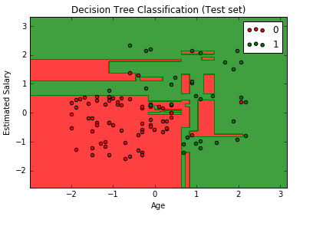

Though the Decision Tree algorithm is good for classification of random data, it is sensitive to noisy data and has a tendency to overfit data. Even the small variance in data can result in different Decision Trees. So it is

# Random forest Classification | Machine Learning

Random Forest is an ensemble learning technique. It builds a number of decision trees on the randomly selected data sample. Then it gets predictions from each tree and by means of majority voting, it selects the decision which gets the majority vote.                                     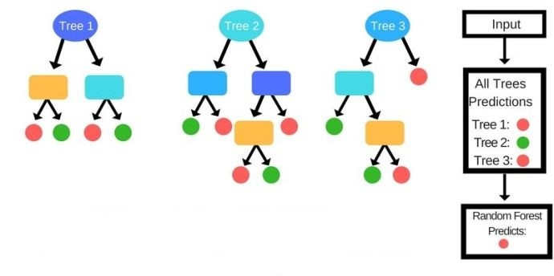

**How does the Algorithm work?**

As said earlier, this algorithm is based on decision trees. For a given dataset, it takes some random data points, builds decision trees one at a time around them. The number of trees is defined in the program. Then it comprises the predictions of all the decision trees. From the predictions, it chooses the best one which is predicted by the most number of trees.

The steps for Random Forest Algorithms are as follows-

STEP 1: Pick at random K data points from the Training set.

STEP 2: Build the Decision Tree associated with these K data points.

STEP 3: Choose the number Ntree of trees you want to build and repeat STEPS 1 & 2

STEP 4: For a new data point, make each one of your Ntree trees predict the category to which the data points belongs, and assign the new data point to the category that wins the majority vote.

This simple ensemble technique gives astonishingly accurate predictions. This is because one decision tree may provide wrong predictions, but aggregating the decisions of a large number of trees will reduce the wrong predictions leading to more accurate predictions.

Now, we will implement this algorithm in Python.

**Random Forest Classification in Python:**

For this task, we will use the dataset named Social_Network_Ads.csv. This dataset contains the age, salary, and buying choice for a specific product of a number of customers through social network ads. Our task is to classify what will be the buying choice of a future customer upon given these features. Let's have a glimpse of that dataset

.

You can download the whole dataset from [here.](https://www.dropbox.com/s/sj2r3og9br7z08j/Social_Network_Ads.csv?dl=0)

First of all, we will import the essential libraries to our program.

# Importing the libraries

import numpy as np

import matplotlib.pyplot as plt

import pandas as pd

Then we will import the dataset into our program and divide the attributes into Feature matrix and dependent variable vectors. Here the *Age*and *EstimatedSalary*are the independent attributes, so we will put them into the Feature matrix and the *Purchased*column into the dependent variable vector.

# Importing the dataset

dataset = pd.read_csv('Social_Network_Ads.csv')

X = dataset.iloc[:, [2, 3]].values

y = dataset.iloc[:, 4].values

Now, we will split the dataset into training and test sets. # Splitting the dataset into the Training set and Test set

from sklearn.model_selection import train_test_split

X_train, X_test, y_train, y_test = train_test_split(X, y, test_size = 0.25, random_state = 0)

We need to scale our dataset for a more accurate prediction.

# Feature Scaling

from sklearn.preprocessing import StandardScaler

sc = StandardScaler()

X_train = sc.fit_transform(X_train)

X_test = sc.transform(X_test)

It's time to fit the Random Forest algorithm to our dataset.

# Fitting Random Forest Classification to the Training set

from sklearn.ensemble import RandomForestClassifier

classifier = RandomForestClassifier(n_estimators = 10, criterion = 'entropy', random_state = 0)

classifier.fit(X_train, y_train)

Note: Here **n_estimators** defines the number of decision trees we want in our Random Forest.

We have built our model. Now, Let’s see how it predicts on the test set.

# Predicting the Test set results

y_pred = classifier.predict(X_test)

We could build the confusion matrix to see the accuracy of our model.

# Making the Confusion Matrix

from sklearn.metrics import confusion_matrix

cm = confusion_matrix(y_test, y_pred)

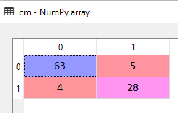

We have come to the most exciting and fun part. Let’s visualize the predictions of our model for training and test sets.

# Visualising the Training set results

from matplotlib.colors import ListedColormap

X_set, y_set = X_train, y_train

X1, X2 = np.meshgrid(np.arange(start = X_set[:, 0].min() - 1, stop = X_set[:, 0].max() + 1, step = 0.01),

np.arange(start = X_set[:, 1].min() - 1, stop = X_set[:, 1].max() + 1, step = 0.01))

plt.contourf(X1, X2, classifier.predict(np.array([X1.ravel(), X2.ravel()]).T).reshape(X1.shape),

alpha = 0.75, cmap = ListedColormap(('red', 'green')))

plt.xlim(X1.min(), X1.max())

plt.ylim(X2.min(), X2.max())

for i, j in enumerate(np.unique(y_set)):

plt.scatter(X_set[y_set == j, 0], X_set[y_set == j, 1],

c = ListedColormap(('red', 'green'))(i), label = j)

plt.title('Random Forest Classification (Training set)')

plt.xlabel('Age')

plt.ylabel('Estimated Salary')

plt.legend()

plt.show()

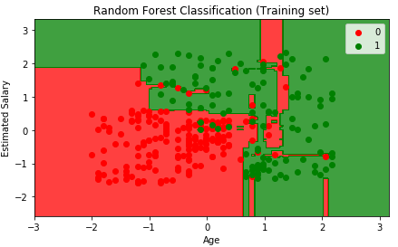

# Visualising the Test set results

from matplotlib.colors import ListedColormap

X_set, y_set = X_test, y_test

X1, X2 = np.meshgrid(np.arange(start = X_set[:, 0].min() - 1, stop = X_set[:, 0].max() + 1, step = 0.01),

np.arange(start = X_set[:, 1].min() - 1, stop = X_set[:, 1].max() + 1, step = 0.01))

plt.contourf(X1, X2, classifier.predict(np.array([X1.ravel(), X2.ravel()]).T).reshape(X1.shape),

alpha = 0.75, cmap = ListedColormap(('red', 'green')))

plt.xlim(X1.min(), X1.max())

plt.ylim(X2.min(), X2.max())

for i, j in enumerate(np.unique(y_set)):

plt.scatter(X_set[y_set == j, 0], X_set[y_set == j, 1],

c = ListedColormap(('red', 'green'))(i), label = j)

plt.title('Random Forest Classification (Test set)')

plt.xlabel('Age')

plt.ylabel('Estimated Salary')

plt.legend()

plt.show()

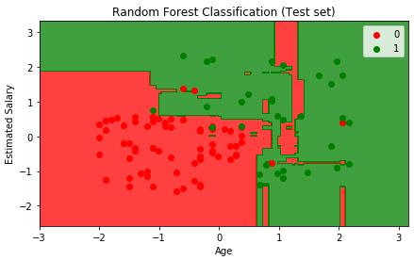

If you compare the results with a single [Decision Tree classifier](http://www.aionlinecourse.com/tutorial/machine-learning/decision-tree-classification), you must find that Random Forest tends to provide more accurate predictions.

# Evaluating Classification Model performance | Machine Learning

Through this post, you are going to understand different metrics for the evaluation of classification models.

**The Basics: False Positive and False Negative**

Suppose your classification model predicts the probability of a person having cancer based on various features. Here the outcome is binary, either Yes or No. That means the person has cancer or not. That's simple. Well, as your model is not absolutely correct every time (it doesn't provide 100% accuracy), it will misjudge some events and thus provide the wrong outcome. If your model predicts that the person has cancer but in reality, he doesn't, then the outcome is False Positive or Type I error. On the other hand, if the person does have cancer, but your model predicts No, then that is a False Negative or Type II error.

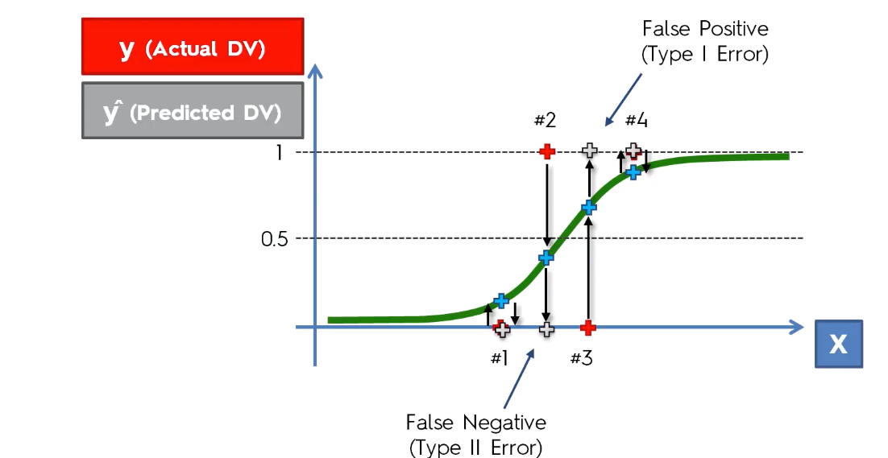

Here the red points are the actual outcomes and the grey points are predicted outcomes. False-positive errors are less impactful so as the False Negative errors. For example, if the model predicts the person doesn't have cancer while he actually has will have more impact than the prediction that tells the person has cancer but in reality does not.

**Confusion Matrix:**

Confusion Matrix is the most commonly used metric for evaluating the performance of a classification model. It shows the number of correct and incorrect predictions made by a model compared to the actual outcomes(target value). It is an NxN matrix, where N is the number of target classes. i.e. the number of labels for predictions. It shows the number of False Positive(FP) and False Negative(FN) in the NxN grid.

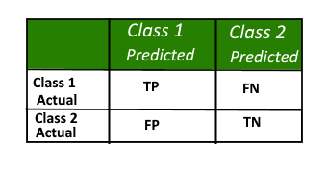                                                               Here

TP = True Positive, the actual and predicted outcomes are both positive

FP = False Positive, the predicted outcome is true but the target value is false

TN = True Negative, the actual and predicted outcome are both negative

FN = False Negative, the predicted outcome is negative but the target value is positive

Using the confusion matrix, we can calculate the accuracy rate of our models. Let's take an example.

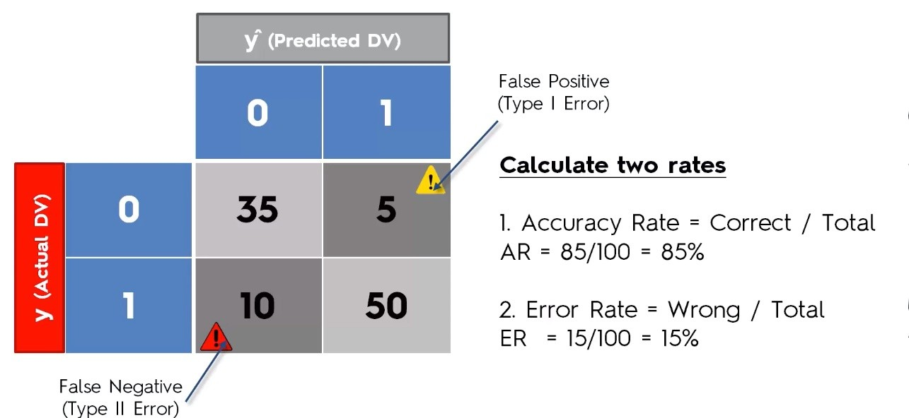

**Accuracy Paradox**

The confusion matrix may lead to the wrong evaluation of models. This is known as the accuracy paradox. It happens when you stop your model to predict logically, that means you stop the model to learn. For example, let's say we have a model with the following confusion matrix.

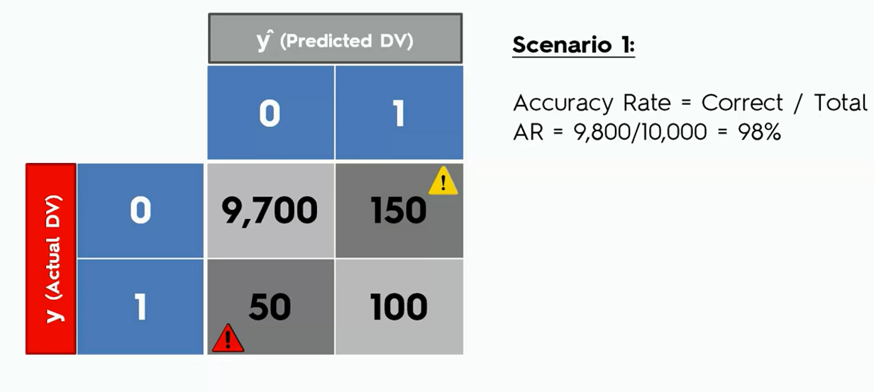

Let’s say from now on we ask our model to predict on only a false outcome that is a zero in the confusion matrix. Now see how the accuracy look like.

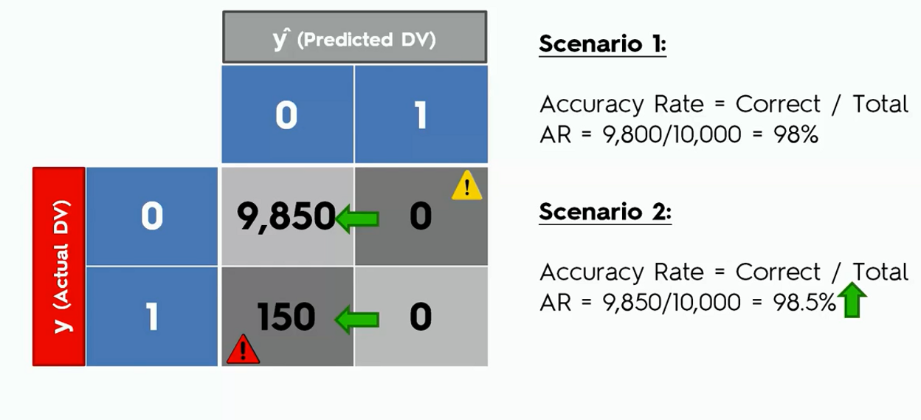

In the second case, we can see that the accuracy of the model went up though the model was not actually doing any logical predictions.

Though easy to understand but Confusion matrix is not a good metric for model evaluation.

**Cumulative Accuracy Profile (CAP) Curve**

The cumulative accuracy profile (CAP) is used in data science to visualize the discriminative power of a model. The CAP of a model represents the cumulative number of positive outcomes along the y-axis versus the corresponding cumulative number of a classifying parameter along the x-axis. The CAP is distinct from the receiver operating characteristic (ROC), which plots the true-positive rate against the false-positive rate.

Let's take an example say we are contacting customers to sell some products. And we know that among our customers, 10% of them will buy our product. Now, if we build a model that helps us to classify which of the customers will respond to us if conducted.

Now how could we say that ours one is a good model?

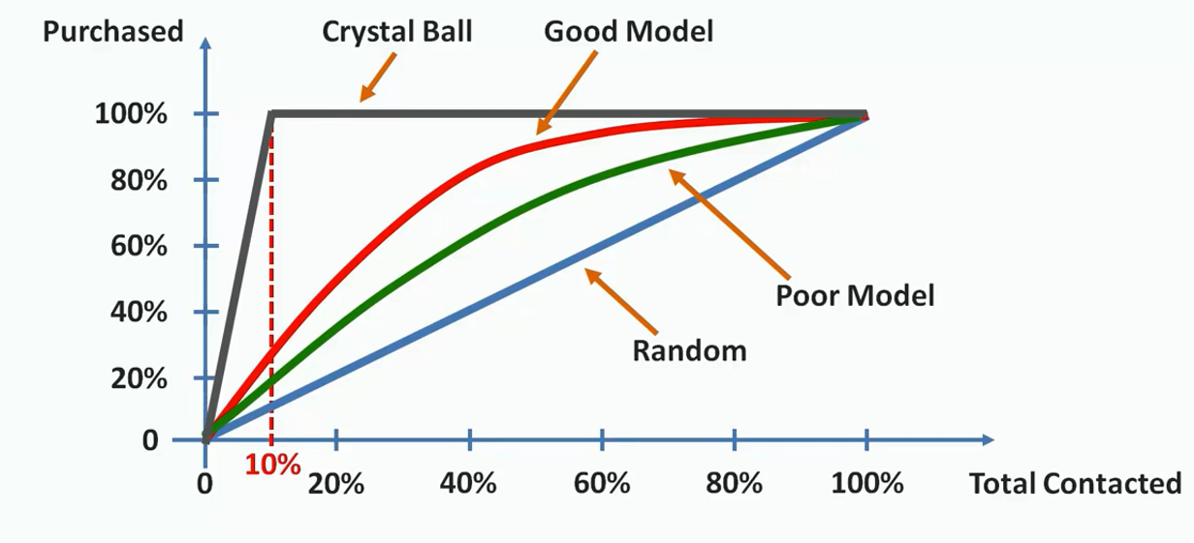

In the above illustration, we have plotted the scenario. First, we draw a random line from the probability we have known earlier( that 10% of our customers will respond). Now, if the area between the model's prediction line and the random line is substantially large, then we can say that this is a good model. If the area is small then the model should be considered as a poor model. Here the red line shows a good model comparable to the green line. The grey line above represents an ideal model. That is when we exactly know the customers who would buy our products.

**CAP Curve Analysis**

We can easily calculate the goodness of our model form the CAP curve. For this, we first calculate the area between the perfect model line and the random line(aP). We also find the area between the good model line and the random line(aR). Then we take their ratio.

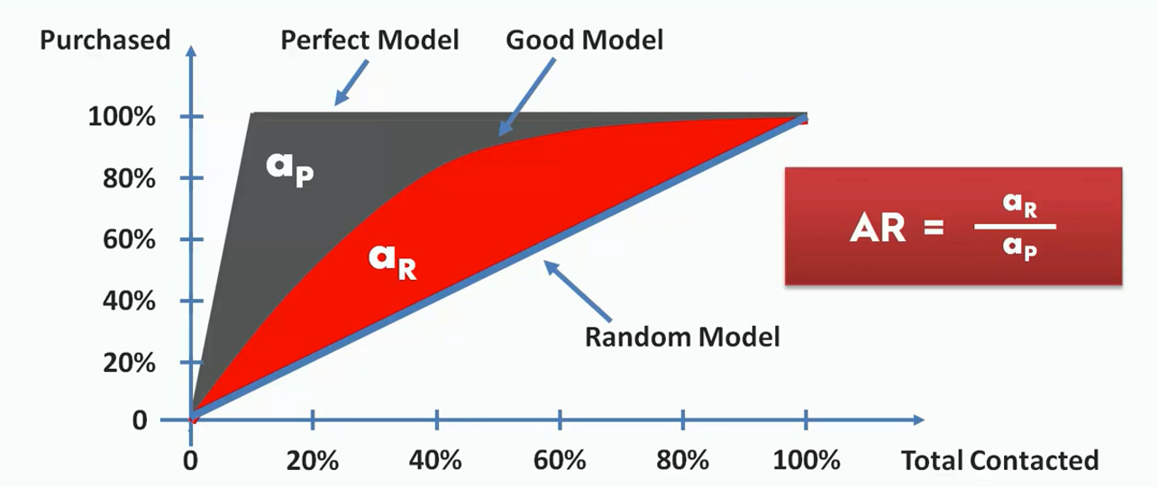

This ratio is between 0 and 1. The more this ratio is closed to one, the better the model is. We can also intuitively decide the goodness of a model just by seeing it. Let's say we take a point on the X-axis(somewhere between 50%). From there we calculate the value on the Y-axis (represented as x).

If the value of x is under 60%, the model is a worse one. If it lies between 60% to 70%, it is a poor model. If the accuracy is between 70% to 80%, it is a good model. Between 80% to 90% will be considered very good. If the model could hit an accuracy between 90% to 100%, you can consider it a too good model.

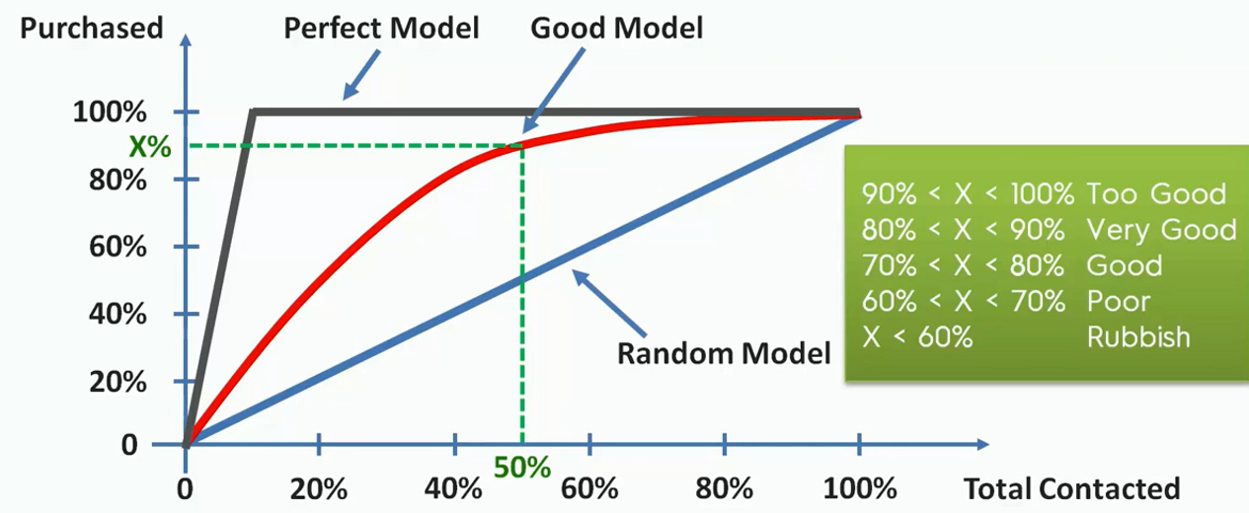

recommended to balance the dataset before fitting the algorithm to the dataset.

# **K-means Clustering | Machine Learning**

**Clustering:** Clustering is an unsupervised learning algorithm. A cluster refers to groups of aggregated data points because of certain similarities among them. Clustering algorithms group the data points without referring to known or labelled outcomes.

There are commonly two types of clustering algorithms, namely **K-means Clustering** and **Hierarchical Clustering**. In this tutorial, we are going to understand and implement the simplest one of them- the K-means clustering.

**K-means Clustering:**This algorithm categorizes data points into a predefined number of groups K, where each data point belongs to the group or cluster with the nearest mean. Data points are clustered based on similarities in their features. The algorithm works iteratively to assign each data point to one of the K groups in such a way that the distance(i.e. Euclidian or Manhattan) between the centroid(i.e. the centre of the cluster) of that group and the data point be small. The algorithm produces exactly K different clusters of the greatest possible distinction.

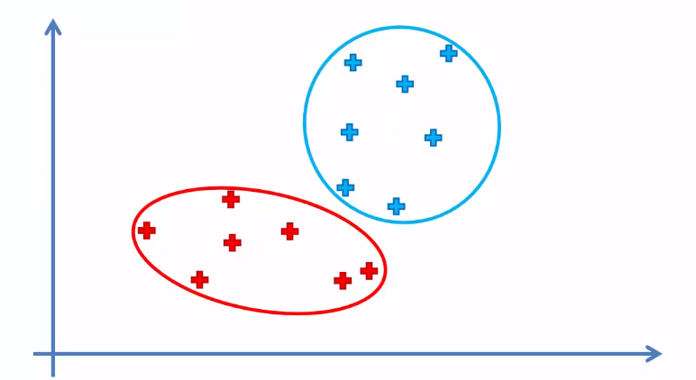

**How The Algorithm Works:**  
K-means Clustering takes an iterative approach to perform the clustering task. The working steps of this algorithm are as follows-

Step 1: Choose the number K of clusters.

Step 2: Select at random K points, the centroids(not necessarily from our dataset).

Step 3: Assign each data point to the closest centroid based on euclidian or manhattan distance. That forms K clusters.

Step 4: Compute and place the new centroid of each cluster.

Step 5. Reassign each data point to the new closest centroid. If any reassignment took place, go to step 4.

It stops creating or optimizing clusters if either the centroids have stabilized meaning no new reassignment of data points takes place or the algorithm reaches the defined number of iterations.

**Choosing The Optimal Number of Clusters:**

The value of k is very crucial for optimal outcomes from the algorithm. There are several techniques to choose the optimal value for k including cross-validation, the silhouette method, G-means algorithm and the elbow method. Here we will implement the elbow method to find the optimal value for k.

As the K-means algorithm works by taking the distance between the centroid and data points, we can intuitively understand that the higher number of clusters will reduce the distances among the points. For that, we plot the number of clusters k and the Within Cluster Sum of Squares(WCSS). The plot would look like an elbow, as with an increasing number of clusters after a certain point, the WCSS starts to stabilize and tends to go parallel with the horizontal axis. So we will take that point after which the plot tends to become similar.

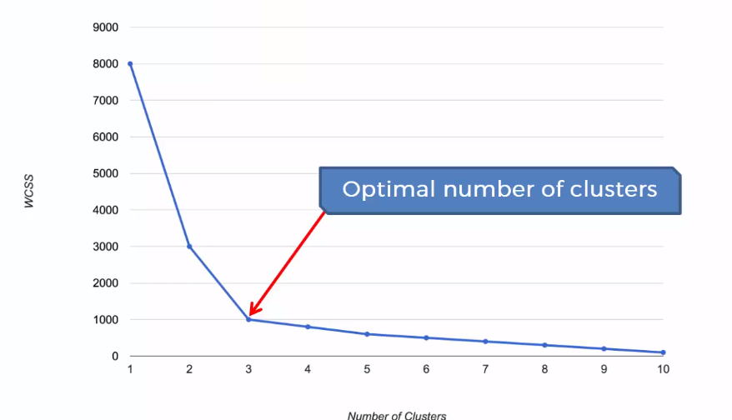

The Within Cluster Sum of Squares (WCSS) is used to calculate the variance in the data points. The goal of the algorithm is to minimize this value.



**K-means clustering in python:**

First of all, we set up the working directory. For this task, e will use the *Mall_Customers.csv*dataset. Let’s have a glimpse of that dataset

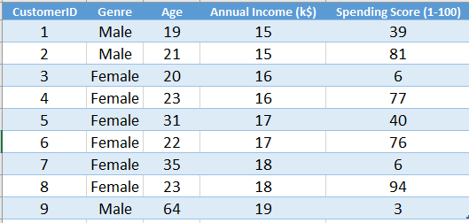

In the dataset, we can see that it contains information about some customers in a supermall categorized by various features. We don't know about any certain outcome or labelled output. So, we will implement K-means clustering to find out some important class about the data points.

You can download the whole dataset form [here.](https://www.dropbox.com/s/s4372co0tkqtof2/Mall_Customers.csv?dl=0)

First of all, we will import essential libraries.

import numpy as np

import matplotlib.pyplot as plt

import pandas as pd

Now, we will import the dataset to our program. Then we will take those features that will effective for our clustering. Here we are intereted in Annual Income and Spending Score. So we will take them to our program.

dataset = pd.read_csv('Mall_Customers.csv')

X = dataset.iloc[:, [3, 4]].values

We need to find the number of cluseter or k. For this we will plot a elbow method graph to find the optimal value for k.

# Using the elbow method to find the optimal number of clusters

from sklearn.cluster import KMeans

wcss = []

for i in range(1, 11):

kmeans = KMeans(n_clusters = i, init = 'k-means++', random_state = 42)

kmeans.fit(X)

wcss.append(kmeans.inertia_)

plt.plot(range(1, 11), wcss)

plt.title('The Elbow Method')

plt.xlabel('Number of clusters')

plt.ylabel('WCSS')

plt.show()

**Note:** Here, the parameter **init**is set to *k-means++* to avoid the random initialization trap.

Let's see the graph

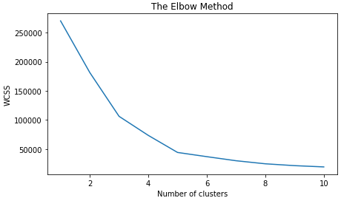

From the above graph, we can see that the optimal value for k is 5(the point where the clustering going parallel with the increasing number of clusters).

# Fitting K-Means to the dataset

kmeans = KMeans(n_clusters = 5, init = 'k-means++', random_state = 42)

y_kmeans = kmeans.fit_predict(X)

Well, we will come to the coolest part of our algorithm. Now we will visualize the outcomes to see what it has done.

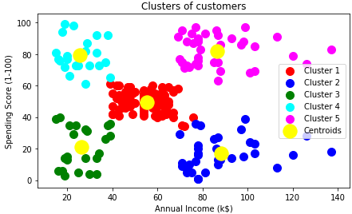

We can see that the data points are grouped in 5 clusters as we defined in the algorithm. This algorithm is one of the simplest clustering algorithms and has various business uses.

# Hierarchical Clustering | Machine Learning

**Clustering:** Clustering is an unsupervised learning algorithm. A cluster refers to groups of aggregated data points because of certain similarities among them. Clustering algorithms group the data points without referring to known or labelled outcomes.

There are commonly two types of clustering algorithms, namely [K-means Clustering](http://www.aionlinecourse.com/tutorial/machine-learning/clustering) and Hierarchical Clustering. In this tutorial, we are going to understand and implement the Hierarchical Clustering.

**Hierarchical Clustering:**

This is an unsupervised clustering algorithm that makes clusters of data points in a top-to-bottom or a bottom-up approach. The working principle of Hierarchical clustering can be intuitively understood by a tree-like hierarchy i.e. how different files are organized in sub-folders where the sub-folders are organized in folders. There are two basic distinctions of this algorithm based on their approach.

1. Agglomerative Hierarchical Clustering- follows a bottom-up approach
2. Divisible Hierarchical Clustering- follows a top to bottom approach

In this tutorial, we will focus on Agglomerative Hierarchical Clustering.

**Agglomerative Hierarchical Clustering:**

In this technique, initially, each data point is taken as an individual cluster. Then the similar clusters are merged together at each iteration based on their proximity with each other. The algorithms run until one cluster or a defined number of clusters are found.

**How does the Algorithm work?**

The working steps of the algorithm are as follows

**Step 1:** Make each data point a single-point cluster. That forms N clusters.

**Step 2:**Take the two closest data points and make them one cluster. That forms N-1 clusters.

**Step 3:** Take the two closest clusters and make them one cluster. That forms N-2 clusters

**Step 4:**Repeat Step 3 until there is only one cluster.

Let’s apply these steps one by on clustering data points

We take six data points here.

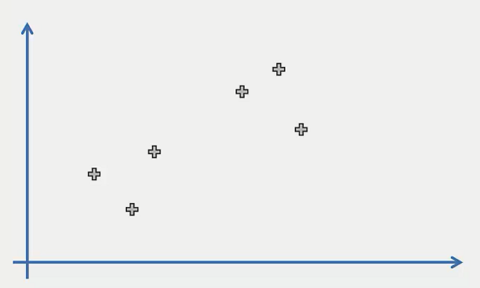

**Step 1:** Make each data point an individual cluster. That makes six clusters here

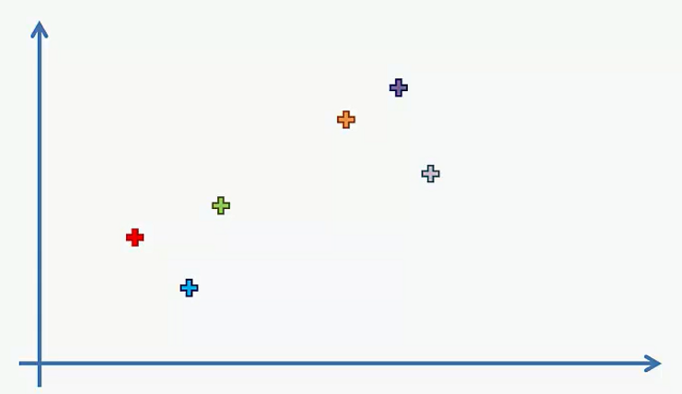

**Step 2:** Make two closest data points and make them one cluster. That forms 5 clusters.

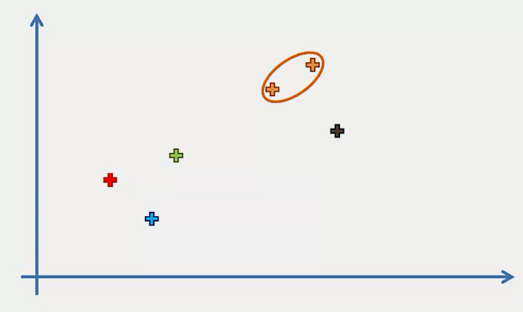

**Step 3:** Take the two closest clusters and make them one cluster. That forms 4 clusters.

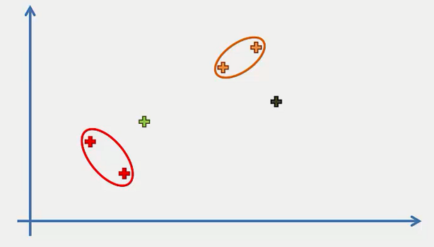

**Step 4:** Repeat step 3 until there is only one cluster.

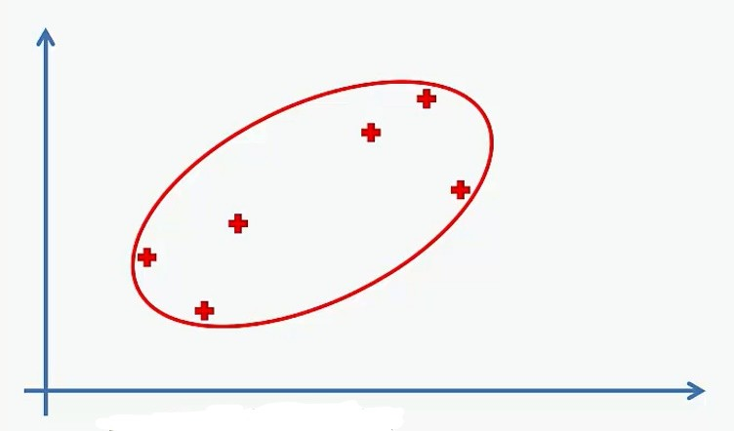

In K-means clustering, we use elbow method for selecting the number of clusters. For Hierarchical Clustering, we use dendrogram to find the number of clusters.

Dendrogram: A dendrogram is a tree-like diagram that records the sequences of merges or splits occurred in the various steps of Hierarchical clustering. Its very helpful to intuitively understand the clustering process and find the number of clusters.

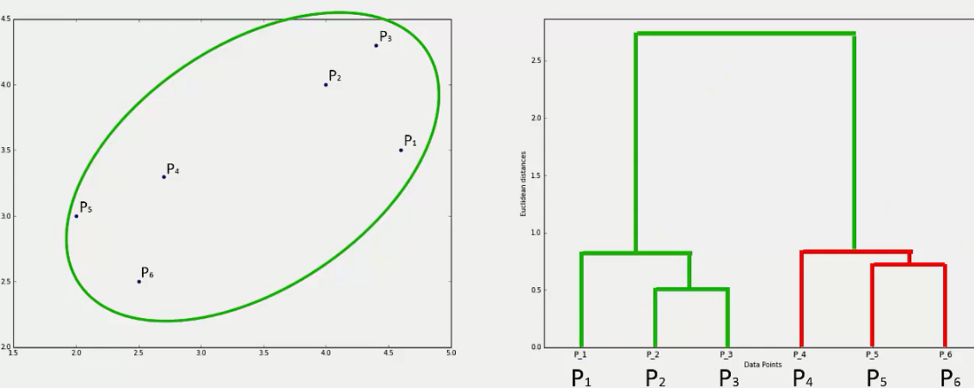

It keeps track of the merges of the clusters in a sequential order like above i.e. the P2 and P3 clusters are merged first, then P5 and P6 and so on. What does is that it calculates the dissimilarity or distance between the clusters and represents it with the vertical lines. The longer the distance the longer the verticals will be.

To find the number of clusters k, we set a threshold value on the vertical axis. Then we count those vertical lines which are the longest and do not intersect with other vertical lines. This count is taken as the number of clusters.

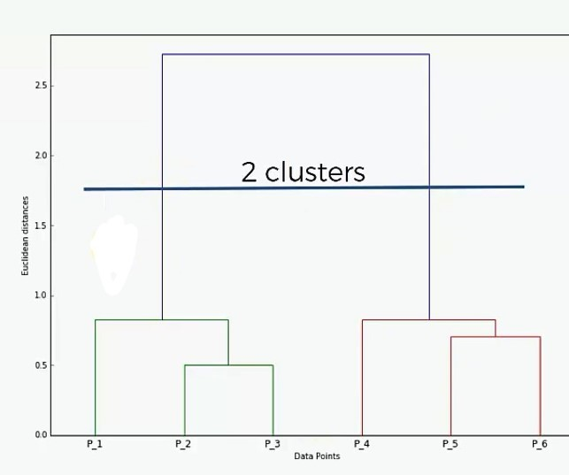

**HC in Python:** Now, we will implement this algorithm in Python. First, we will set the working directory. Here we are using *Mall_Customers.csv*dataset. Let’s have a glimpse of that dataset.



The dataset contains the data of some customers in a mall. Here we do not have any certain outcome or labelled output. So, we will implement Hierarchical Clustering to find some useful class from this dataset.

You can download the whole dataset from [here.](https://www.dropbox.com/s/s4372co0tkqtof2/Mall_Customers.csv?dl=0)

First of all, we will import essential libraries.

import numpy as np

import matplotlib.pyplot as plt

import pandas as pd

Now, we will import the dataset. From the dataset, we will take the *Annual Income*and *Spending Score*in the feature matrix.

dataset = pd.read_csv('Mall_Customers.csv')

X = dataset.iloc[:, [3, 4]].values

We need to find the number of clusters. For this, we will generate a dendrogram.

# Using the dendrogram to find the optimal number of clusters

import scipy.cluster.hierarchy as sch

dendrogram = sch.dendrogram(sch.linkage(X, method = 'ward'))

plt.title('Dendrogram')

plt.xlabel('Customers')

plt.ylabel('Euclidean distances')

plt.show()

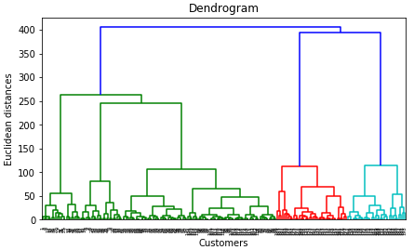

We set the threshold at 200(euclidian distance) and get 5 vertical lines that do not intersect with other lines. So the number of clusters will be 5.

Now, we will fit the Agglomerative HC to our dataset.

# Fitting Hierarchical Clustering to the dataset

from sklearn.cluster import AgglomerativeClustering

hc = AgglomerativeClustering(n_clusters = 5, affinity = 'euclidean', linkage = 'ward')

y_hc = hc.fit_predict(X)

We have come to the final part. Let’s visualize what our model has done!

# Visualising the clusters

plt.scatter(X[y_hc == 0, 0], X[y_hc == 0, 1], s = 100, c = 'red', label = 'Cluster 1')

plt.scatter(X[y_hc == 1, 0], X[y_hc == 1, 1], s = 100, c = 'blue', label = 'Cluster 2')

plt.scatter(X[y_hc == 2, 0], X[y_hc == 2, 1], s = 100, c = 'green', label = 'Cluster 3')

plt.scatter(X[y_hc == 3, 0], X[y_hc == 3, 1], s = 100, c = 'cyan', label = 'Cluster 4')

plt.scatter(X[y_hc == 4, 0], X[y_hc == 4, 1], s = 100, c = 'magenta', label = 'Cluster 5')

plt.title('Clusters of customers')

plt.xlabel('Annual Income (k$)')

plt.ylabel('Spending Score (1-100)')

plt.legend()

plt.show()

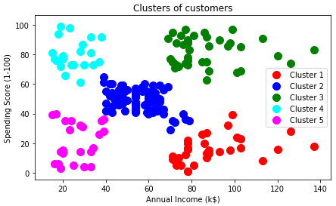

Hierarchical clustering performs well in a small set of data. For a large dataset, this algorithm does not fit well. You should use [K-means clustering](http://www.aionlinecourse.com/tutorial/machine-learning/clustering)instead.

# Association Rule Learning | Apriori | Machine Learning

In this tutorial, we are going to understand the association rule learning and implement the Apriori algorithm in Python.

**Association Rule Learning:** Association rule learning is a machine learning method that uses a set of rules to discover interesting relations between variables in large databases i.e. the transaction database of a store. It identifies frequent associations among variables called association rules that consists of an antecedent  (if) and a consequent (then).

For example, if a person buys a burger, then there is a chance that he will buy some french fries too. This is because there is some relationship between french fries and burger (they are often taken together).

The task of associations rule learning is to discover this kind of relationships and identify the rules of their association.

Association rule learning algorithms are used extensively in data mining for market basket analysis, which is determining dependencies among various products purchased by the customers at different times analyzing the customer transaction databases.

There are two basic types of Association learning algorithms- Apriori and Eclat. In this article, we are going to implement the Apriori algorithm.

**Apriori Intuition:** This is a classic algorithm in data mining. It is used for analyzing frequent itemsets and relevant association rules. It can operate on databases containing a lot of transactions.

Let's take an example of transactions made by customers in a grocery shop.

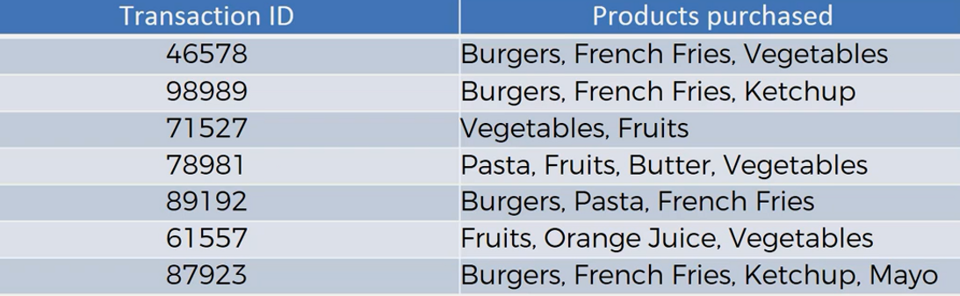

Form the above transactions, the potential association rules can be

If the customer buys Burgers can also buy French fries

If the customer buys Vegetable can also buy Fruits

If the customer buys Pasta can also buy Butter

These associations are measured using three common metrics- Support, Confidence and lift.

**Support:** Support is the rate of the frequency of an item appears in the total number of items. Like the frequency of burger among all the transactions. Mathematically, for an item ***I,***

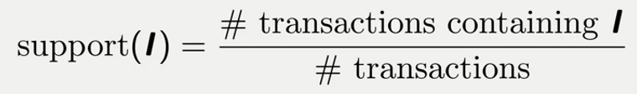**Confidence:** Confidence is the conditional probability of occurrence of a consequent (then) providing the occurrence of an antecedent  (if). It's kind of testing a rule. Like if a customer buys a burger(antecedent), he is supposed to buy french fries(consequent). Mathematically, the confidence of **l2** given **l1** will be

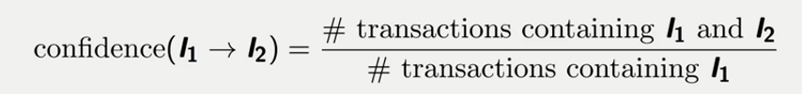  
**Lift:** Lift is the ratio of confidence and support. It tells how likely an item is purchased after another item is purchased. Simply it is the likelihood to buy French fries if a customer buys a burger. Mathematically,                                           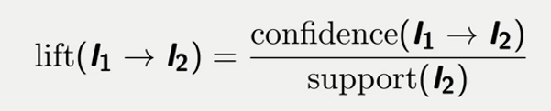

Step 1: Set a minimum support and confidence.

Step 2: Take all the subsets in transactions having support than minimum support.

Step 3: Take all the rules of these subsets having higher confidence than minimum confidence.

Step 4: Sort the rules by decreasing lift.

Let's apply these steps one by one on the above example

First, we will calculate the frequency table for the item set

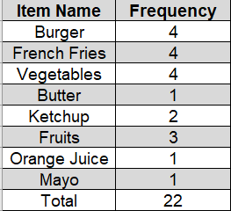

Let's say we need to find the association rule for Burger->French fries

**Step 1:** let's say we have set the minimum support and confidence to 15%. That means no items having support less than 15% will be incurred.

Then we are left with the following items.

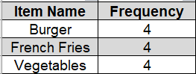

**Step 2:** Now our possible subsets for the above itemsets will be {Burger, French Fries}, {Burger, Vegetables}, {French Fries, Vegetables} etc.

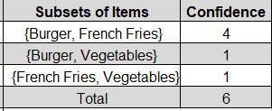

**Step 3:** For our threshold value of confidence, we are left with one pair or one rule. And that is {Burger, French Fries} or Burger --> French Fries

**Step 4:** As we are left with only one rule we calculate the lift for this rule and that is approximately 3.7

**Implementation in Python:** Now, we will implement the Apriori algorithm in Python. For this task, we are using a dataset called *"Market_Basket_Optimization.csv"* that contains the transaction of different products by customers from a grocery store. Now, we need to implement the Apriori algorithm to find out some potential association rules among the products.

You can download the dataset from [here.](https://www.dropbox.com/s/hjl7almer60c8fv/Market_Basket_Optimisation.csv?dl=0)

First of all, we will import the essential libraries.

# Importing the libraries

import numpy as np

import matplotlib.pyplot as plt

import pandas as pd

The next step is to preprocess our data. The dataset preserves the transaction of different products by a single customer in a separate row. So we need to treat the columns as a name of the products, not as a header. For that, we will remove the take no header in the dataset. The Apriori algorithm works with strings, that means we need to make a list of string values from the dataset. To do so, we will implement the **str**function from Python.

# Data Preprocessing

dataset = pd.read_csv('Market_Basket_Optimisation.csv', header = None)

transactions = []

for i in range(0, 7501):

transactions.append([str(dataset.values[i,j]) for j in range(0, 20)])

Now, we reach the part where we will train our dataset with the Apriori algorithm. To use the Apriori class in our program we need to have the *apyori.py*an open-source python module for Apriori algorithm. 

You can find the module[here.](https://www.dropbox.com/sh/pn93ofuxtpo8t2y/AADcQ6Qssejf_dmJegYDj-YOa?dl=0)

In the class, we need to take the list *transactions* as a parameter. The crucial step of performing Apriori is to set the minimum value for the support, confidence and lift. To find the most valuable association rules, we need the perfect combination of these values. Otherwise, the association rules will not be useful.

For our dataset, we have found that the combination of 30% support and 20% confidence as minimum values is perfect. But these values vary across different datasets and business problems. So, you should carefully observe the dataset to set these values.

The minimum length is set to two that means we want associations among at least two products.

# Training Apriori on the dataset

from apyori import apriori

rules = apriori(transactions, min_support = 0.003, min_confidence = 0.2, min_lift = 3, min_length = 2)

Now, we will see how our model performs to find potential association rules. 

# Visualising the results

results = list(rules)

This will generate a list like the following. This is a list of all the potential rules upon the given constraints.                          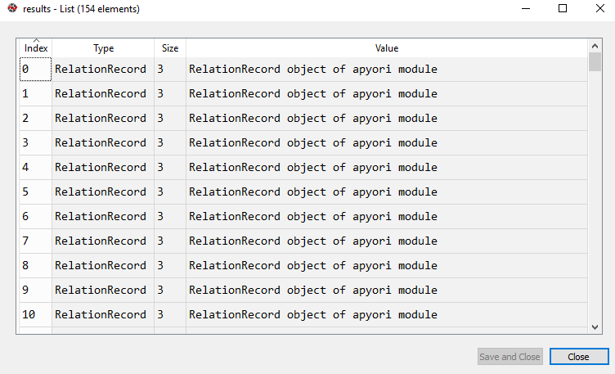

# Eclat Intuition | Machine Learning

**Eclat Intuition:** Today, we are talking about the Eclat model. It is similar to the a priori algorithm. Here, we actually talking about the rules. Because the cloud model is different from the a priori model. In Eclat intuition, the cloud model is just like in the priori model we have the support vector. But we do not have confidence and lift factos. We are only looking for support. It much faster and the steps involved are set a minimum support so we want to set up a support level.

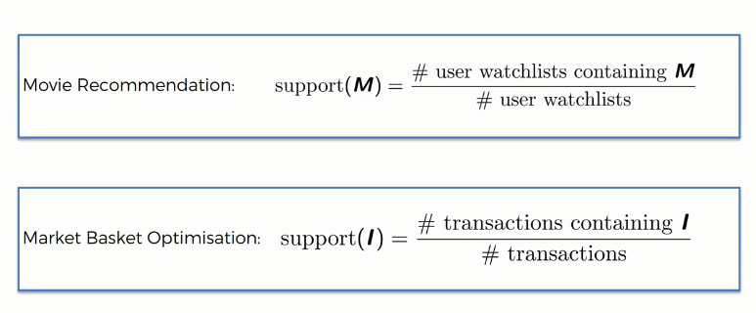

There are several steps:

Step 1: Set a minimum support.

Step 2: Take all the subsets in a transaction having higher support than minimum support.

Step 3: Sort these subsets by decreasing support.

# Reinforcement Learning | Machine Learning

**Reinforcement Learning:** Reinforcement Learning is a branch of Machine Learning, also called Online Learning. It is used to solve interacting problems where the data observed up to time t is considered to decide which action to take at time t + 1. It is also used for Artificial Intelligence when training machines to perform tasks such as walking. Desired outcomes provide the AI with reward, undesired with punishment. Machines learn through trial and error.

Reinforcement Learning is learning how to act in order to maximize a numerical reward.

In this part, you will understand and learn how to implement the following Reinforcement Learning models:

1. Upper Confidence Bound (UCB)
2. Thompson Sampling

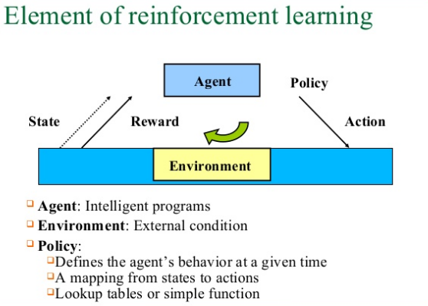

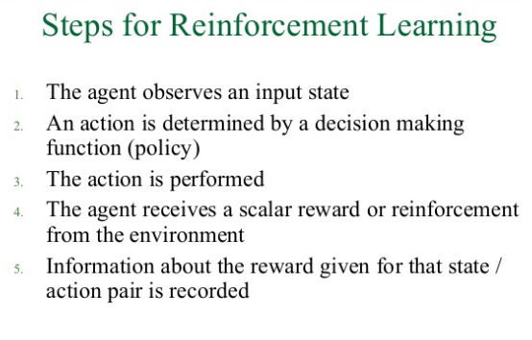

# Upper Confidence Bound (UCB) | Machine Learning

In this tutorial, I will explain to you the application of Upper Confidence Bound(UCB) algorithm to solve the Multi Bandit problem and show you the whole coding process in Python.

**What is the Multi-Armed Bandit Problem?**  
Before going to learn the multi-armed bandit problem, first, take a look at the exploration vs. exploitation dilemma. This dilemma exists in many aspects of our life. Well, say you take your lunch at your favorite restaurant every day as you are confident about what you get from there is good. But you may be missing the chances of discovering even a better option. If you explore all the restaurants in your locality one by one, the probability of tasting the worst food in your life would be pretty high. But then again, there is also a probability that you get an even better option! This dilemma is called exploration vs. exploitation dilemma. Now Let’s go to the classic example of this dilemma- the Multi-Armed Bandit Problem

**Multi-Armed Bandit Problem:**

This is a use case of reinforcement learning, where we are given a slot machine called multi-armed bandit( the slot machines in casinos are called bandit as it turns out all casinos configure these machines in such a way that all gamblers end up losing money!) with each arm having its own rigged probability distribution of success. Pulling any one of these arms gives you a stochastic reward of either 1, for success or 0, for a failure. Now your task is to find such an optimal strategy that will give you the highest rewards in the long run without the prior knowledge of the probability distribution of success of the machines.

This problem can be related to more business examples such as displaying the optimal ads to the viewer.

So in this tutorial, we are going to solve a use case of the multi-armed bandit problem. We take an example of an online advertising campaign dataset where we have 10 different versions of a similar ad. You see the dataset looks similar to that of a multi-armed bandit problem!

Let's have a quick check on our multi-armed bandit problem

                                   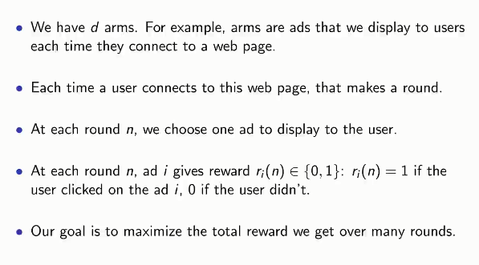

You can download the dataset from [here.](https://www.dropbox.com/s/ovnpvh8y50qain5/Ads_CTR_Optimisation.csv?dl=0)

**UCB Algorithm Intuition:**

You can find the best option by using an A/B test. Where you can show a different ad to a user and take his feedback, that is whether the user clicks or not. And summing up all the feedback, you can find the best ad to display. Bat wait, there is a problem, in A/B test you are incurring more cost and time by doing exploration and exploitation separately. So we need to combine exploration and exploitation and get the result as soon as possible. We do not have enough time and money to actually do this exploitation, so we will do this during the campaign.

The Upper Confidence Bound algorithm the kind of algorithm that helps us to perform exploitation and exploration together.

**How the UCB Algorithm Works?**

At the start of the campaign, we don't know what is the best arm or ad. So we cannot distinguish or discriminate any arm or ad. So the UCB algorithm assumes they all have the same observed average value. Then the algorithm creates confidence bound for each arm or ad. So it randomly picks any of the arms or ads. Then two things can happen- the user clicks the ad or the arm gives reward or does not. Let's say the ad did not have a click or the arm was a failure. So the observed average of the ad or arm will go down. And the confidence bound will also go down. If it had a click, the observed average would go up and the confidence bound also goes up. By exploiting the best one we are decreasing the confidence bound. As we are adding more and more samples, the probability of other arms or ad doing well is also going up. This is the fundamental concept of UCB.

Now let's see what steps are involved to perform this algorithm on our dataset:

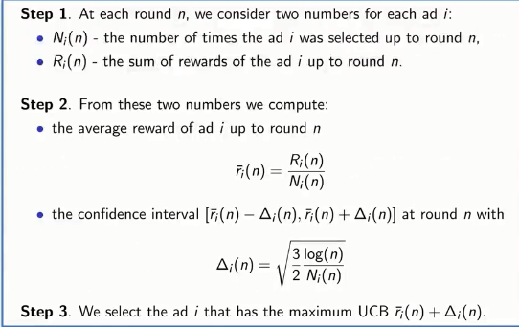

**UCB in Python:**

We will implement the whole algorithm in Python. First of all, we need to import some essential libraries.

# Importing the Essential Libraries

import numpy as np

import matplotlib.pyplot as plt

import pandas as pd

Now, let's import the dataset-

# Importing the Dataset

dataset = pd.read_csv('Ads_CTR_Optimisation.csv')

Now, implement the UCB algorithm:

# Implementing UCB

import math

N = 10000

d = 10

ads_selected = []

numbers_of_selections = [0] * d

sums_of_rewards = [0] * d

total_reward = 0

for n in range(0, N):

ad = 0

max_upper_bound = 0

for i in range(0, d):

if (numbers_of_selections[i] > 0):

average_reward = sums_of_rewards[i] / numbers_of_selections[i]

delta_i = math.sqrt(3/2 * math.log(n + 1) / numbers_of_selections[i])

upper_bound = average_reward + delta_i

else:

upper_bound = 1e400

if upper_bound > max_upper_bound:

max_upper_bound = upper_bound

ad = i

ads_selected.append(ad)

numbers_of_selections[ad] = numbers_of_selections[ad] + 1

reward = dataset.values[n, ad]

sums_of_rewards[ad] = sums_of_rewards[ad] + reward

total_reward = total_reward + reward

**Code Explanation:**Here, three vectors are used.

# ads_selected = [], is used to append the different types of ads selected in each round

# numbers_of_selections = [0] * d, is used to count the number of time an ad was selected

# sums_of_rewards = [0] * d, is used to calculate the cumulative sum of rewards at each round

As we don't have any prior knowledge about the selection of each ad, we will take the first 10 rounds as trial rounds. So, we set the if condition:  *if (numbers_of_selections[i] > 0)* so that the ads are selected at least once before entering into the main algorithm.

Then we implement the second step of the algorithm, computing the average reward of each ad i up to round n and the upper confidence bound for each ad.

Here we applied a trick in else condition by taking the variable *upper_bound* to a huge number. This is because we want the first 10 rounds as trial rounds where the 10 ads are selected at least once. This trick will help us to do so.

After 10 trial rounds, the algorithm will work as the steps explained earlier.

**Visualizing the Result:**  
Now, it's time to see what we get from our model. For this, we will visualize the output.

plt.hist(ads_selected)

plt.title('Histogram of ads selections')

plt.xlabel('Ads')

plt.ylabel('Number of times each ad was selected')

plt.show()

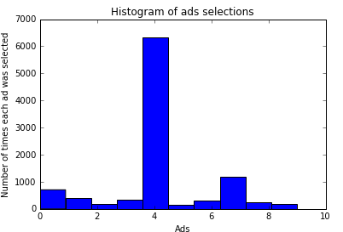

From the above visualization, we can see that the fourth ad got the highest click. So our model advise us to place the fourth version of the ad to the user for getting the highest number of clicks!

# Thompson Sampling Intuition | Machine Learning

In this article, we will talk about the Thompson Sampling Algorithm for solving the multi-armed bandit problem and implement the algorithm in Python.

**Thompson Sampling Algorithm:**Thompson Sampling is one of the oldest heuristics to solve the Multi-Armed Bandit problem. This is a probabilistic algorithm based on Bayesian ideas. It is called sampling because it picks random samples from a probability distribution for each arm. This could be defined as a Beta Bernoulli sampler. Though Thompson sampling can be generalized to sample from any arbitrary distributions. But the Beta Bernoulli version of Thompson sampling is more intuitive and is actually the best options for many problems in practice. In this tutorial, we will use the Beta Benouli sampler.

**Algorithm Comparison: Upper Confidence Bound vs. Thompson Sampling:**  
There is a significant difference between UCB and Thompson sampling. Firstly UCB is a deterministic algorithm whereas Thompson sampling is a probabilistic algorithm. In UCB you must incorporate the value at every round, you cannot proceed to the next round without adjusting the value. In Thompson, you can accommodate delayed feedback. This means you can update the dataset for your multi-armed bandit problem in a batch manner that will save your additional computing resource or cost of updating the dataset each time. This is the main advantage of Thompson sampling over UCB.

Recently, it has generated significant interest after several studies demonstrated it to have better empirical performance compared to the UCB algorithm.

**How this Algorithm Works?**

Let's say we have three multi-armed bandits with the following distributions

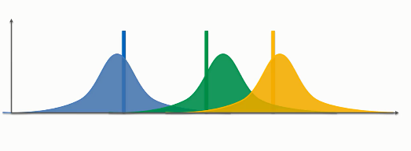  
In the above distribution, our expected value can anywhere in the distribution. Now, this algorithm will choose samples from the above distribution using Bayesian Inference rules. First, it will run some trial rounds before doing the actual computation.                               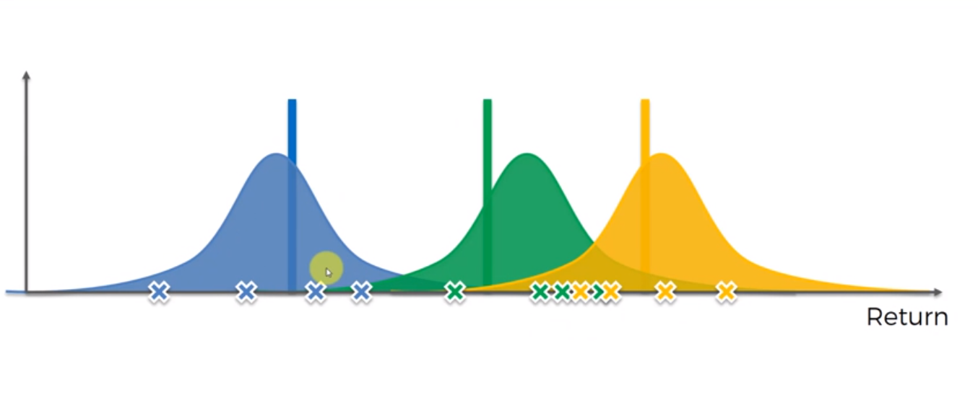

Now, it will pick the samples from each of the distributions that have the highest value of the distribution. This will make an imaginary set of bandits. That means that this algorithm actually makes an auxiliary mechanism to solve the problem, that is, it will not create the machines at every round rather it will create the possible ways these machines could be recreated. With each trial, each takes a sample which has the highest distribution. And with each trial, the distribution will be changed. The distribution will get narrower as we have some information. After a huge number of rounds, we will get the narrowest distribution which we will take as the final outcome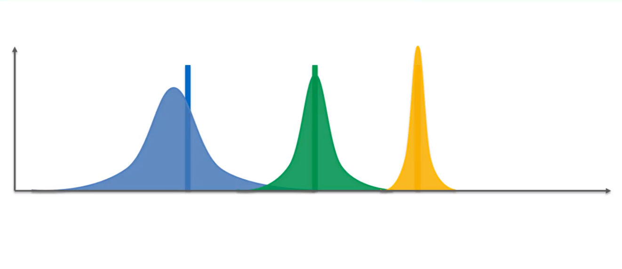

Now let's look at the steps of the algorithm.

Let's implement this algorithm for our own version of a multi-armed bandit problem. Here we will take a dataset of online advertising campaign where an ad has 10 different versions. Now our task is to find the best ad using the Thompson sampling algorithm.

Let's look at the steps we need in Thompson sampling:

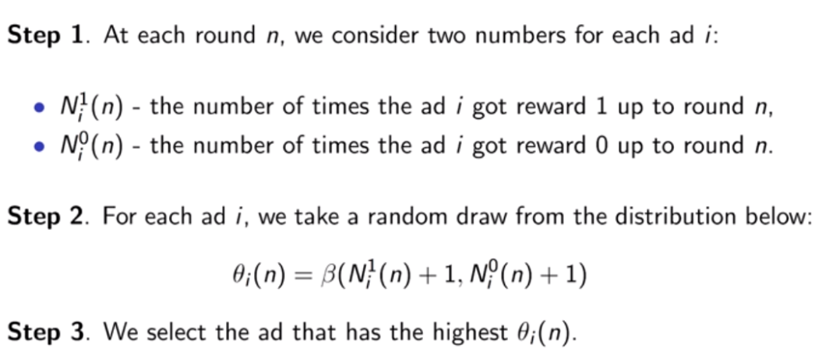

At the first step, the total number of rewards (either 0 or 1) is counted.

To understand the second step, we need to look at the Bayesian inference rules-

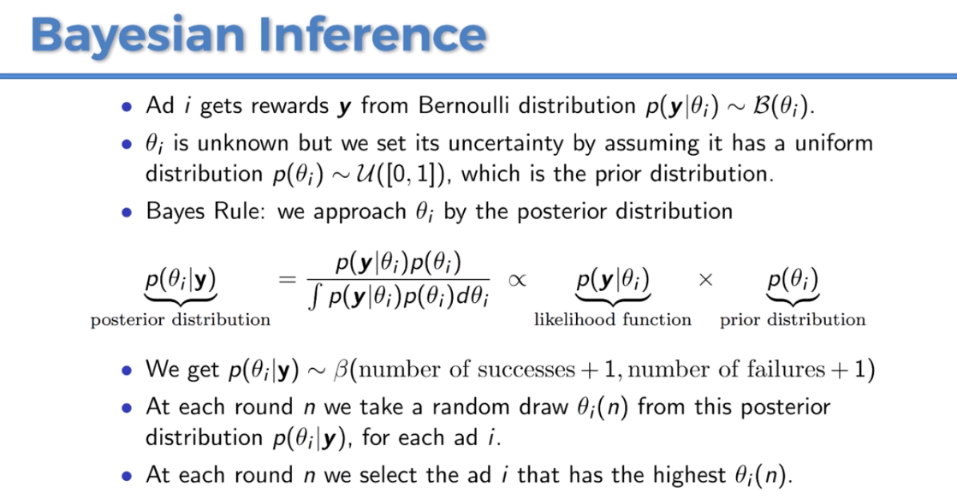

For step 2, we have two assumptions, first, we say that each ad i gets a reward from a Bernoulli distribution which is the probability of success. You can picture this parameter by showing this ad to a million user and the parameter will be interpreted as the number of times the outcomes were ones divided by the number of ads. Basically, it is the probability of getting ones. The second assumption is that we have a uniform distribution which is a prior distribution, then we have the posterior distribution from the Bayes rule that is the probability of success given the rewards after the round n. By doing this Bayes rule we get the beta distribution here. In Thompson sampling, these random draws mean nothing but the probability of success, because the maximum of these random draws approximating the highest probability of success. And this is the idea behind Thompson sampling. By taking the highest of these draws we are maximizing the probability of success for each of the 10 ads. And this highest probability corresponds to each ad at every round.  After performing the algorithm we will take the highest ad having the highest probability of success.

**Thompson sampling in Python:**  
First of all, we need to import essential libraries.

import numpy as np

import matplotlib.pyplot as plt

import pandas as pd

Then we will import our dataset (Ads_CTR_Optimisation.csv)

You can download the dataset from [here.](https://www.dropbox.com/s/ovnpvh8y50qain5/Ads_CTR_Optimisation.csv?dl=0)

# Importing the dataset

dataset = pd.read_csv('Ads_CTR_Optimisation.csv')

Now, let's implement the Thompson Sampling code

# Implementing Thompson Sampling

import random

N = 10000

d = 10

ads_selected = []

numbers_of_rewards_1 = [0] * d

numbers_of_rewards_0 = [0] * d

total_reward = 0

for n in range(0, N):

    ad = 0

    max_random = 0

    for i in range(0, d):

        random_beta = random.betavariate(numbers_of_rewards_1[i] + 1, numbers_of_rewards_0[i] + 1)

        if random_beta > max_random:

            max_random = random_beta

            ad = i

    ads_selected.append(ad)

    reward = dataset.values[n, ad]

    if reward == 1:

        numbers_of_rewards_1[ad] = numbers_of_rewards_1[ad] + 1

    else:

        numbers_of_rewards_0[ad] = numbers_of_rewards_0[ad] + 1

    total_reward = total_reward + reward

Now, we have come to the final part of our program. Let’s visualize what we got-

plt.hist(ads_selected)

plt.title('Histogram of ads selections')

plt.xlabel('Ads')

plt.ylabel('Number of times each ad was selected')

plt.show()

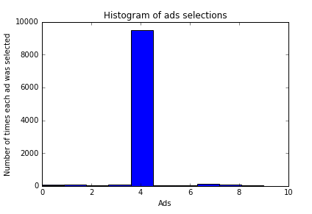

In the above histogram, you can see that ad version five has the highest probability of success. So we will take the fifth version of the ad as output. If you compare this result with our previous [Upper Confidence Bound](http://www.aionlinecourse.com/tutorial/machine-learning/upper-confidence-bound-%28ucb%29) result, you will see a clear difference. Though UCB algorithm found the same ad version as of Thompson sampling, the Thompson sampling showed better empirical evidence than UCB in practice.

# Natural Language Processing | Machine Learning

**Natural Language Processing:** Natural language processing (NLP) is a field of artificial intelligence concerned with the interactions between computers and human(natural) language.

In a simple sense, Natural language Processing is applying machine learning to text and language to teach computers understanding what is said in the spoken and written words. The main focus of NLP is to read, decipher, understand and make sense of the human language in a manner that is useful.

**Examples of NLP in Real Life:** You will find a lot of applications of NLP in your life. Here we name a few-

* Translating one language to another i.e. Google Translator
* Checking grammatical errors i.e. Microsoft word or Grammarly applies NLP to check and correct grammatical errors.
* Sentiment analysis that is identifying the mood or subjective opinions of a text
* Summarizing a text or article
* Predicting the genre of books
* Speech recognition which is used in the virtual assistants such as Apple Siri, Google Assistant, and Amazon Alexa
* Question answering

**How NLP Works?**

Most of NLP algorithms are classification models, and they include Logistic Regression, Naive Bayes,  CART which is a model based on decision trees, Maximum Entropy and other classification algorithms to predict the outcome.

**The working procedure of NLP can be divided into three major steps:**

**Step 1:**Preprocessing of text that includes Cleaning the data, Tokenizing, Stemming, Parts of Speech(POS) Tagging, Lemmatization, Name Entity Recognition (NER)

**Step 2:** This step is for vectorizing data, that is encoding text into integer i.e. numeric form to create feature vector.

**Step 3:** The final step is to fit a suitable classification algorithm to the dataset and make the predictions.

We can implement all these steps using NLP libraries. Some of the popular NLP libraries are-

* Natural Language Toolkit-NLTK
* SpaCy
* Stanford NLP
* OpenNLP

In this article, we are going to implement all these steps using the NLTK library and classification algorithm. From this part, you will learn how to-

* Clean texts to prepare them for the Machine Learning models,
* Create a Bag of Words model,
* Apply Machine Learning models onto this Bag of Worlds model.

**Natural Language Processing in Python:** Now, we will perform the steps of NLP in Python. For this task, we are going to use **Restaurant_Reviews.tsv** dataset. The dataset contains 1000 reviews from customers. These reviews are identified with values 0 and 1 whether they are positive or negative. 0 means the review is positive and 1 means the review is positive. Let's have a glimpse of that dataset.

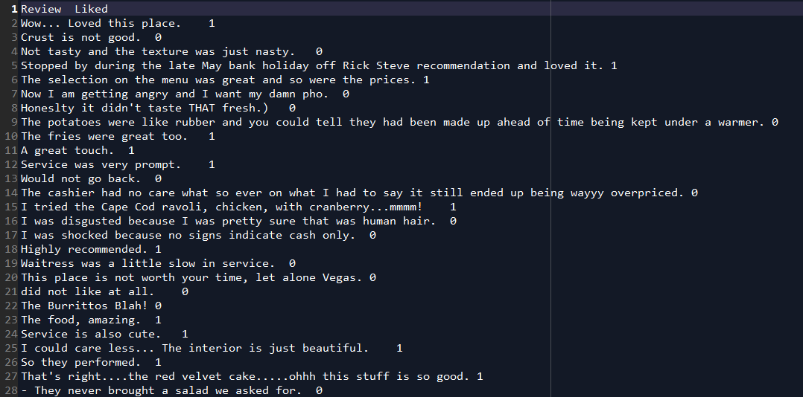

This dataset looks different than other datasets as it is in tsv(tab-separated value) format. For NLP task we cannot use csv(comma-separated value) files. This is because of the strings may contain commas, which will confuse our model.

You can download the whole dataset from [here.](https://www.dropbox.com/s/xnbu67gu78l2zyk/Restaurant_Reviews.tsv?dl=0)

It contains two columns namely *Review* and *Liked.* They are separated by a tab.Now our task is to pre-process this data. Then we will implement any of the classification algorithms to classify the reviews whether it is positive or negative.

Fist of all, we will import some essential libraries.

# Importing the libraries

import numpy as np

import matplotlib.pyplot as plt

import pandas as pd

Now we will import the dataset.

# Importing the dataset

dataset = pd.read_csv('Restaurant_Reviews.tsv', delimiter = '\t', quoting = 3)

As our dataset is in tsv format, we need to clarify that in the delimiter parameter. The reviews contain double quotes, that may cause confusion to the model. So we set the quoting parameter to 3 to avoid this problem.

Now, we will clean the texts using the **NLTK**library from Python. The texts contain a lot of useless words which have no impact on the characteristic of the review, we need to get rid of those words like wow, place, texture, etc. Then we need to perform stemming that is we will take the root of a word like loved, loving, lovely, etc. all can be replaced by the same word love. The texts also contain some common words like was, that, this, it, is, etc. which are known as stopwords and have no use at all. So we will remove those words using the **stopwords** package from the **NLTK**library. We only consider the English words and also take all the words into lowercase.

# Cleaning the texts

import re

import nltk

nltk.download('stopwords')

from nltk.corpus import stopwords

from nltk.stem.porter import PorterStemmer

corpus = []

for i in range(0, 1000):

review = re.sub('[^a-zA-Z]', ' ', dataset['Review'][i])

review = review.lower()

review = review.split()

ps = PorterStemmer()

review = [ps.stem(word) for word in review if not word in set(stopwords.words('english'))]

review = ' '.join(review)

corpus.append(review)

 We proceed to the most important part of NLP, creation of the bag of words model. Bag of words is a multiset of words which will help us to analyze the different reviews and classify them.

# Creating the Bag of Words model

from sklearn.feature_extraction.text import CountVectorizer

cv = CountVectorizer(max_features = 1500)

X = cv.fit_transform(corpus).toarray()

y = dataset.iloc[:, 1].values

After doing all these steps, the corpus will now look like this-

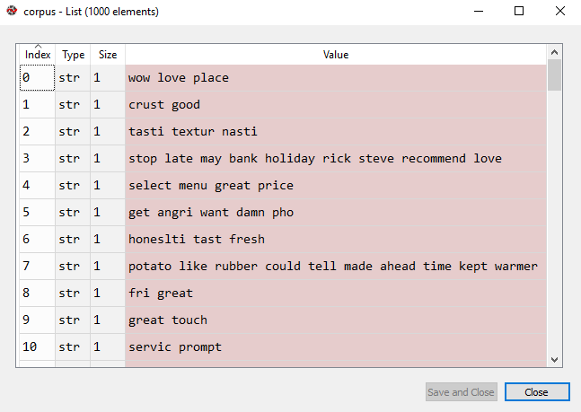

We have completed preprocessing the texts and creating the bag of words model. Now, we split this preprocessed dataset into training and test sets.

# Splitting the dataset into the Training set and Test set

from sklearn.model_selection import train_test_split

X_train, X_test, y_train, y_test = train_test_split(X, y, test_size = 0.20, random_state = 0)

Let's fit a classification algorithm to our training set. Here we will use Naive Bayes which is one of the most popular and most effective classification algorithms for NLP.

# Fitting Naive Bayes to the Training set

from sklearn.naive_bayes import GaussianNB

classifier = GaussianNB()

classifier.fit(X_train, y_train)

Now, we will perform prediction on the test set.

# Predicting the Test set results

y_pred = classifier.predict(X_test)

 Let's see how good is our model in performing predictions using the confusion matrix.

# Making the Confusion Matrix

from sklearn.metrics import confusion_matrix

cm = confusion_matrix(y_test, y_pred)

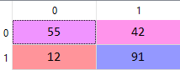

From the above confusion matrix, we can see that the accuracy of our model is 73%.

Deep Learning | Machine Learning

**Deep Learning:** Deep Learning is an artificial intelligence function that imitates the workings of the human brain in processing data and creating patterns for use in decision making. Deep learning is a subset of machine learning in Artificial Intelligence (AI) that has networks capable of learning unsupervised from data that is unstructured or unlabeled. Deep Learning is the most exciting and powerful branch of Machine Learning.

Deep Learning models can be used for a variety of complex tasks:

* Artificial Neural Networks for Regression and Classification
* Convolutional Neural Networks for Computer Vision
* Recurrent Neural Networks for Time Series Analysis
* Self Organizing Maps for Feature Extraction
* Deep Boltzmann Machines for Recommendation Systems
* AutoEncoders for Recommendation Systems

In this part, you will understand and learn how to implement the following Deep Learning models:

1. Artificial Neural Networks for a Business Problem
2. Convolutional Neural Networks for a Computer Vision task

# Artificial Neural Networks | Machine Learning

In this article, we are going to learn and implement an Artificial Neural Network(ANN) in Python.

**Artificial Neural Network:** An artificial neural network (ANN), usually called a neural network" (NN) is a mathematical model or computational model that tries to simulate the structure and functional aspects of biological neural networks. It consists of an interconnected group of artificial neurons and processes information using a connectionist approach to computation.

To get a clear idea, let's take a look at a biological neuron.

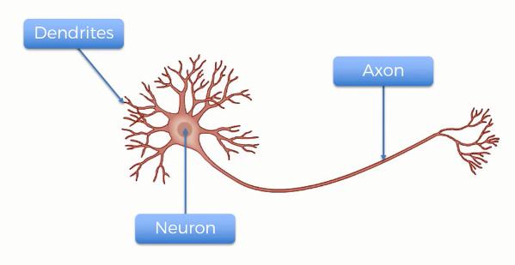

A human neuron has three parts- the main body, the axon, and the dendrites. Though one neuron itself does not have any significance, when millions or probably billions of neurons work together, they can process a task like reading and understanding this article.

Well, you can think of an artificial neuron as a simulation of the human neuron. It tries to mimic the works of a human neuron using mathematics and machine learning algorithms. Here is also, as a biological neuron, a single AN cannot do any significance task. But when we connect a number of neurons in layers, they together can do some tasks like classification or regression.

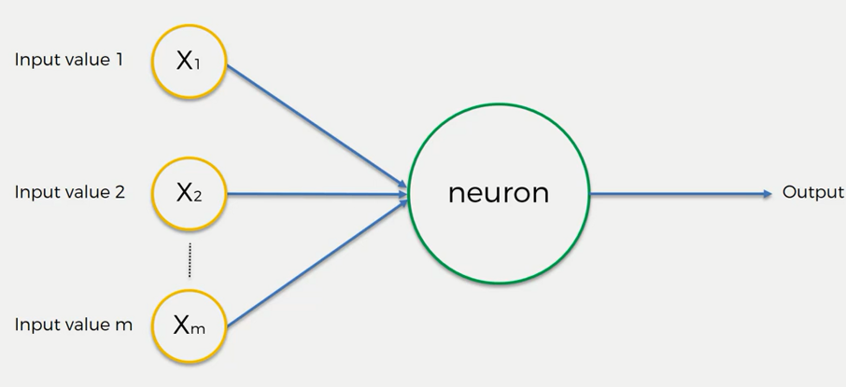

Here you can see a simplified illustration of an artificial neuron. It takes inputs from some neurons i.e. x1, x2, xm, process them using some mathematical functions called activation functions and produce an output. ANN has much more complex structures. It also includes some hidden layers and other structures.

**Activation Functions:** An activation function directs the output of a neuron or node that means after receiving a set of inputs, it chooses what will be the output of that neuron. Depending on the kind of activation function, the output of a neuron varies. There are various types of activation functions. But these four are prominent ones.

1. **Threshold Function:** This is the most basic type of activation function. It simply outputs yes/no type of values. When the weighted sum is(the sum of weighted input from the input layers) less than zero, it simply provides 0, and when the weighted sum is greater or equals to zero, it provides 1.

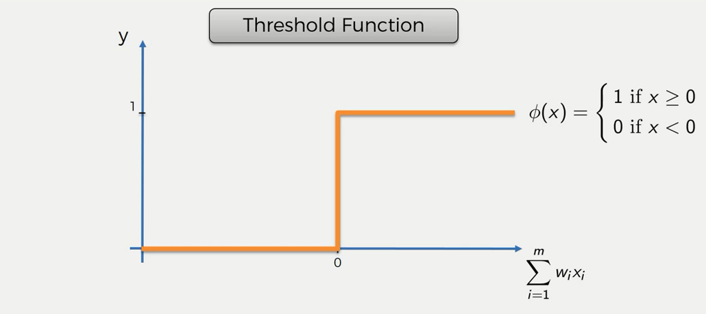

**2. Sigmoid Function:** This is one of the most used activation functions. It provides a continuous output. If the input value is less than zero its output will be a zero. For a value zero or greater than zero it provides a continuous output value ranges between zero and one. It is a useful function for tasks like regressions. It is usually used in the output node.

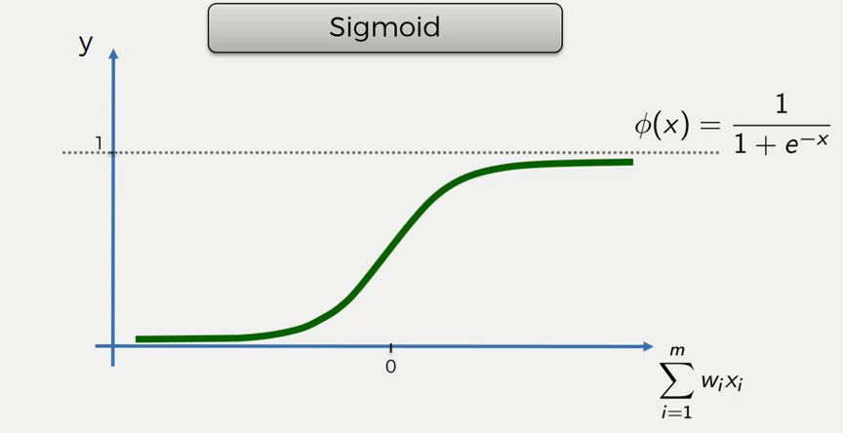

**3. Rectifier Function:** It is one of the most popular activation functions. It provides a zero for a negative value and gradually increases to one for a positive value. It is widely used in the input layer nodes.

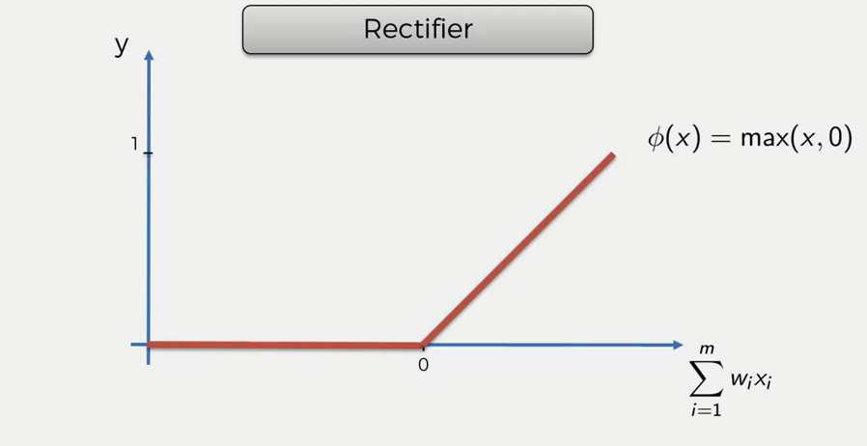

**4. Hyperbolic tangent function:** It provides output for both negative and positive input values.

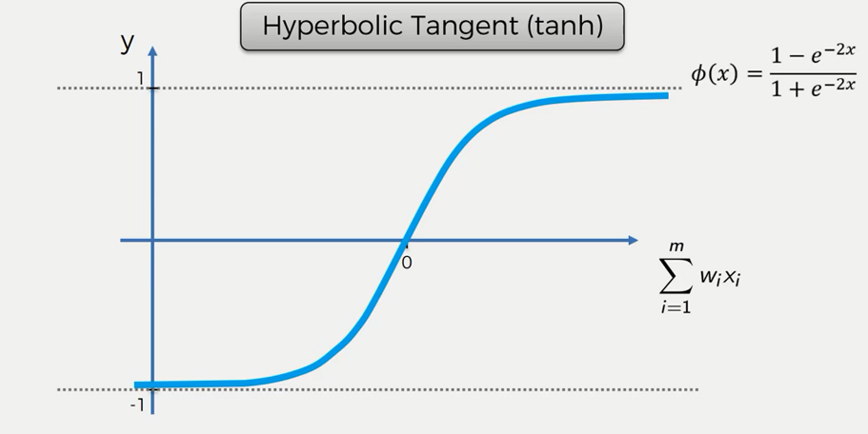

**How Does the Neural Network Work?**

When we connect a number of artificial neurons that forms a neural network. Then the network can carry out some tasks like classification and regression. To understand the whole idea, let's take an example, assume that we need to find the price of an apartment in a particular area, where the input parameters are the area of the apartment, number of bedrooms, how far it is from the city, and the age of the apartment. Now let’s build an ANN model that will predict the price of a particular apartment using this set of input parameters. We are not going into the details, but assume that in the hidden layer we are using an activation function i.e. Rectifier function that calculates the weighted input and pass a value to the output layer where we are using another activation function i.e. Sigmoid function, that upon the input from the hidden layer, calculates the probable value of that apartment. Here we have shown a simplified feedforward network, you may need to use more complex models for other problems.

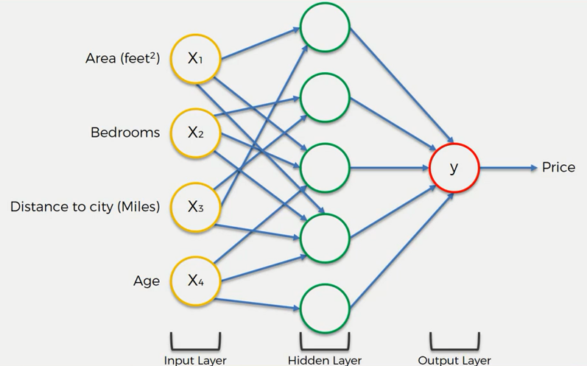

**How do Neural Networks Learn?**

Though the idea of learning of neural networks a bit complex, we can simplify the concept. In a simple sense, we feed in inputs to the input layer nodes(individual neurons), which are connected to some hidden layers nodes. The inputs are processed and fed to the output layer. Then we compare the predicted value with the actual value using a cost function. In ML, a cost function is used to measure how well or bad a model is performing. Here we take a cost function, C which is the squared average difference between the predicted and actual outcomes.

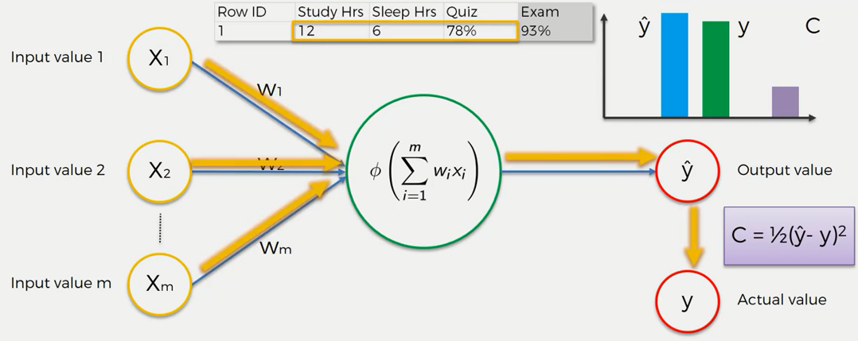

Then we update the weights in the input layer based on the cost functions output. This update is performed by using a gradient descent function. This type of network is called backpropagation network. Because we are providing the input and updating the weights from the output iteratively.

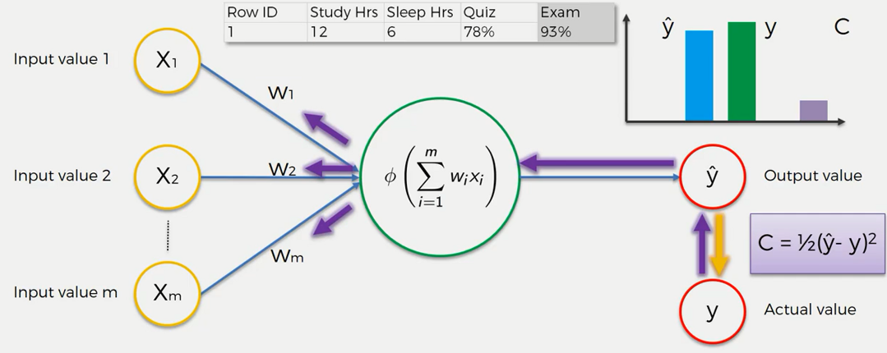

After some iterations (until a satisfactory outcome), we assume that the model has learned successfully.

**Gradient Descent Function:** Gradient descent is an optimization algorithm for updating the weights to the input layer nodes after the comparison done by the cost function. It uses a first-order differential equation that tries to minimize the cost function. That means it tries to find the lowest error value.

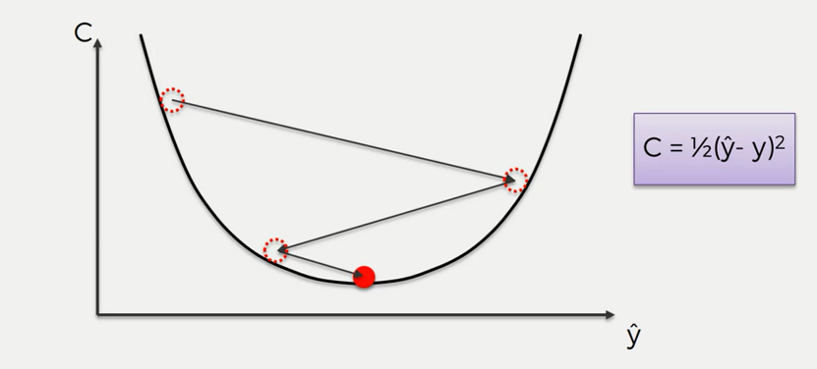

There are various types of various gradient descent functions. Among them, Batch gradient descent function (shown above) and stochastic gradient descent function are most commonly used.

Stochastic gradient descent function is more optimized than Batch gradient function as it can avoid the **local minimum**. **Local minimum** happens when the gradient function finds a minimum error value that seems fine initially. But if the function could go further it would find the best minimum error value.

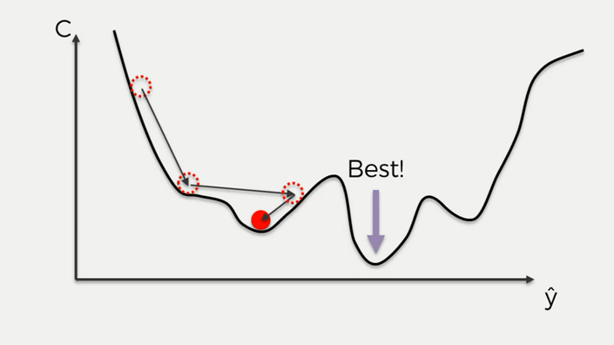

In this article, we will use stochastic gradient descent function.

Let's understand the steps required to train a model with stochastic gradient Descent

**STEP 1:** Randomly initialize the weights to small numbers close to 0 (but not 0).

**STEP 2:** Input the first observation of your dataset in the input layer, each feature in one input node.

**STEP 3:** Forward-propagation: from left to right, the neurons are activated in a way that the impact of each neuron's activation is limited by the weights. Propagate the activations until getting the predicted result y.

**STEP 4:** Compare the predicted result to the actual result. Measure the generated error.

**STEP 5:** Back-propagation: from right to left, the error is back-propagated. Update the weights according to how much they are responsible for the error. The learning rate decides by how much we update the weights.

**STEP 6:** Repeat Steps 1 to 5 and update the weights after each observation (Reinforcement Learning). Or: Repeat Steps 1 to 5 but update the weights only after a batch of observations (Batch Learning).

**STEP 7:** When the whole training set passed through the ANN, that makes an epoch. Redo more epochs.

**ANN in Python:** In this tutorial, we are going to implement an artificial neural network in Python.

We have a dataset of a bank containing the transaction data of customers. Let's have a look at the dataset-

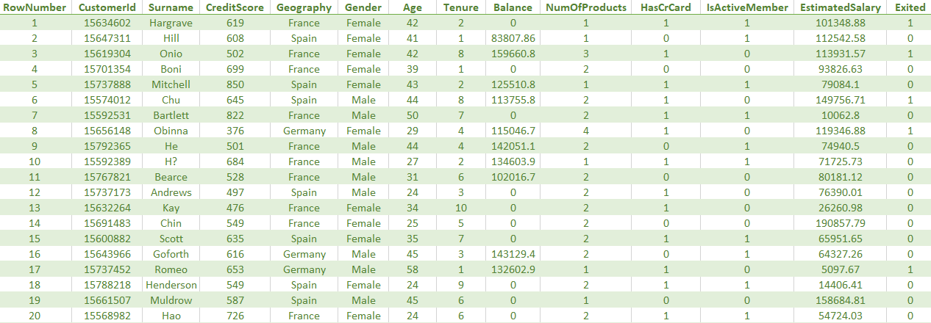

You can download the whole dataset from [here.](https://www.dropbox.com/s/oklux19m1i821dk/Churn_Modelling.csv?dl=0)

The dataset contains a number of different features. Now, using these features of the dataset, our task is to classify whether a customer stays or departs from the bank. So this is a classification problem.

For building neural networks we need libraries and modules like Keras, Theona, and TensorFlow. Ensure that you have properly installed them in your anaconda environment. You can find the guideline for installing these[here.](https://keras.io/#installation)

First of all, we will import some essential libraries.

# Importing the libraries

import numpy as np

import matplotlib.pyplot as plt

import pandas as pd

In the dataset, the last column *Exited*that represents the state of a customer(stays or leaves) is the only dependent variable. So we will take this column in the dependent variable vector. Rest of the columns are independent, so we will take all except the first three columns into the feature matrix.

# Importing the dataset

dataset = pd.read_csv('Churn_Modelling.csv')

X = dataset.iloc[:, 3:13].values

y = dataset.iloc[:, 13].values

Here some of the features are categorical variables. So we will encode them.

# Encoding categorical data

from sklearn.preprocessing import LabelEncoder, OneHotEncoder

labelencoder_X_1 = LabelEncoder()

X[:, 1] = labelencoder_X_1.fit_transform(X[:, 1])

labelencoder_X_2 = LabelEncoder()

X[:, 2] = labelencoder_X_2.fit_transform(X[:, 2])

onehotencoder = OneHotEncoder(categorical_features = [1])

X = onehotencoder.fit_transform(X).toarray()

X = X[:, 1:]

Now we split the dataset into training and test sets.

# Splitting the dataset into the Training set and Test set

from sklearn.model_selection import train_test_split

X_train, X_test, y_train, y_test = train_test_split(X, y, test_size = 0.2, random_state = 0)

We need to scale our dataset. For this, we will use the StandardScaler library.

# Feature Scaling

from sklearn.preprocessing import StandardScaler

sc = StandardScaler()

X_train = sc.fit_transform(X_train)

X_test = sc.transform(X_test)

Now, we have come to the main part of our program. We will build a neural network using the Keras library.

# Importing the Keras libraries and packages

import keras

from keras.models import Sequential

from keras.layers import Dense

We will initialize the ANN using the *Sequential*class from Keras.

# Initialising the ANN

classifier = Sequential()

Now, we will add the hidden layer. The dataset contains eleven independent variables. It is a rule of thumb that we take half of the dependent variable in the hidden layer. So the **output_dim**parameter is set to 6. Here we used the rectifier functions as the activation function.

# Adding the input layer and the first hidden layer

classifier.add(Dense(output_dim = 6, init = 'uniform', activation = 'relu', input_dim = 11))

 We can add more than one hidden layer to our network.

# Adding the second hidden layer

classifier.add(Dense(output_dim = 6, init = 'uniform', activation = 'relu'))

Now, we will add the output layer. Here, we have only one dependent variable. So our output layer only contains one node. We used the sigmoid function as the activation function.

# Adding the output layer

classifier.add(Dense(output_dim = 1, init = 'uniform', activation = 'sigmoid'))

 Let's compile the whole ANN before start running. Here we use the stochastic gradient descent function as the optimizer. **adam**is one of the most used stochastic gradient descent function. We choose **binary_crossentropy**as the loss function as this is a binary classification problem.

# Compiling the ANN

classifier.compile(optimizer = 'adam', loss = 'binary_crossentropy', metrics = ['accuracy'])

It's time to fit the classifier algorithm to our dataset. we take the number of iteration, nb_epoch to 100 that means the whole network will run a hundred times.

# Fitting the ANN to the Training set

classifier.fit(X_train, y_train, batch_size = 10, nb_epoch = 100)

Now, we will predict the outcome of the ANN.

# Predicting the Test set results

y_pred = classifier.predict(X_test)

y_pred = (y_pred > 0.5)

Let's see how good our model is for making the prediction.

# Making the Confusion Matrix

from sklearn.metrics import confusion_matrix

cm = confusion_matrix(y_test, y_pred)

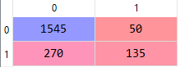

From the above confusion matrix, we can see the accuracy of the model is 84%

# Principal Component Analysis | Machine Learning

**Principal Component Analysis (PCA):**Principle Component Analysis or PCA is a popular dimensionality reduction technique that reduces the number of features or independent variable by extracting those features with the highest variance. That means it finds the correlation between the independent variables and calculates their variance, then it selects those features that have the highest variance.

If the dataset contains n variables, the PCA will extract m<=n number of independent variables which explains the most variance of the dataset. It is an unsupervised algorithm as it can extract features regardless of the dependent variable.

**PCA in Python:** PCA is a very simple and popular algorithm in practice. In this tutorial, we will implement this algorithm alongside with a[Logistic Regression](http://www.aionlinecourse.com/tutorial/machine-learning/logistic-regression) algorithm. For this task, we will use the famous *"****Wine.csv"***dataset from the UCI machine learning repository. Our version of dataset contains thirteen independent variables that represent various aspects of wines and one dependent variable that represents the three types of buyers of the wine based on specific features. Now, we will implement PCA to reduce the number of independent variables to a defined value(i.e. two).

You can download the whole dataset from [here.](https://www.dropbox.com/s/8139t6qk69wt10d/Wine.csv?dl=0)

First of all, we import essential libraries.

#Importing the libraries  
import numpy as np  
import matplotlib.pyplot as plt  
import pandas as pd

Now, let's import the dataset and make a feature matrix X and dependent variable y

#Importing the dataset  
dataset = pd.read_csv('Wine.csv')  
X = dataset.iloc[:, 0:13].values  
y = dataset.iloc[:, 13].values

Then we will split the dataset and apply feature scaling.

# Splitting the dataset into the Training set and Test set  
from sklearn.model_selection import train_test_split  
X_train, X_test, y_train, y_test = train_test_split(X, y, test_size = 0.2, random_state = 0)  
   
# Feature Scaling  
from sklearn.preprocessing import StandardScaler  
sc = StandardScaler()  
X_train = sc.fit_transform(X_train)  
X_test = sc.transform(X_test)

Now, we have come to the most important part of the tutorial. Let's implement the PCA algorithm to our dataset.

# Applying PCA  
from sklearn.decomposition import PCA  
pca = PCA(n_components = 2)  
X_train = pca.fit_transform(X_train)  
X_test = pca.transform(X_test)  
explained_variance = pca.explained_variance_ratio_

Here, the parameter **n_components** represents the number of independent variables we want in our datasets(here we take 2). The algorithm will take those two variables with the highest variance. You can see their variance from the **explained_variannce**vector.

Now we will fit logistic regression to our dataset and predict the result.

#Fitting Logistic Regression to the Training set  
from sklearn.linear_model import LogisticRegression  
classifier = LogisticRegression(random_state = 0)  
classifier.fit(X_train, y_train)  
   
#Predicting the Test set results  
y_pred = classifier.predict(X_test)

Let's see how good our model is for making predictions using the confusion matrix.

# Making the Confusion Matrix  
from sklearn.metrics import confusion_matrix  
cm = confusion_matrix(y_test, y_pred)  
The confusion matrix will look like following

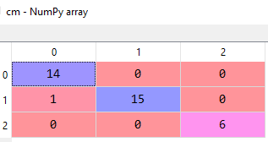

From the above matrix, we can calculate the accuracy of the model and that comes out to be 97%, quite impressive!

Now, let's visualize both our training and test sets.

# Visualising the Training set results  
from matplotlib.colors import ListedColormap  
X_set, y_set = X_train, y_train  
X1, X2 = np.meshgrid(np.arange(start = X_set[:, 0].min() - 1, stop = X_set[:, 0].max() + 1, step = 0.01),  
                     np.arange(start = X_set[:, 1].min() - 1, stop = X_set[:, 1].max() + 1, step = 0.01))  
plt.contourf(X1, X2, classifier.predict(np.array([X1.ravel(), X2.ravel()]).T).reshape(X1.shape),  
             alpha = 0.75, cmap = ListedColormap(('red', 'green', 'blue')))  
plt.xlim(X1.min(), X1.max())  
plt.ylim(X2.min(), X2.max())  
for i, j in enumerate(np.unique(y_set)):  
    plt.scatter(X_set[y_set == j, 0], X_set[y_set == j, 1],  
                c = ListedColormap(('red', 'green', 'blue'))(i), label = j)  
plt.title('Logistic Regression (Training set)')  
plt.xlabel('PC1')  
plt.ylabel('PC2')  
plt.legend()  
plt.show()

  The graph will look like the following illustration:

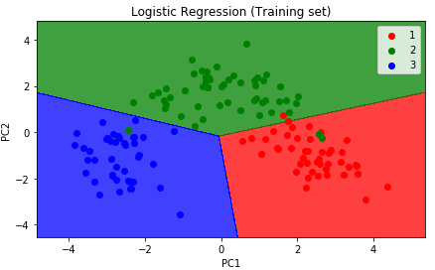

# Visualising the Test set results  
from matplotlib.colors import ListedColormap  
X_set, y_set = X_test, y_test  
X1, X2 = np.meshgrid(np.arange(start = X_set[:, 0].min() - 1, stop = X_set[:, 0].max() + 1, step = 0.01),  
                     np.arange(start = X_set[:, 1].min() - 1, stop = X_set[:, 1].max() + 1, step = 0.01))  
plt.contourf(X1, X2, classifier.predict(np.array([X1.ravel(), X2.ravel()]).T).reshape(X1.shape),  
             alpha = 0.75, cmap = ListedColormap(('red', 'green', 'blue')))  
plt.xlim(X1.min(), X1.max())  
plt.ylim(X2.min(), X2.max())  
for i, j in enumerate(np.unique(y_set)):  
    plt.scatter(X_set[y_set == j, 0], X_set[y_set == j, 1],  
                c = ListedColormap(('red', 'green', 'blue'))(i), label = j)  
plt.title('Logistic Regression (Test set)')  
plt.xlabel('PC1')  
plt.ylabel('PC2')  
plt.legend()  
plt.show()

The graph will look like the following:

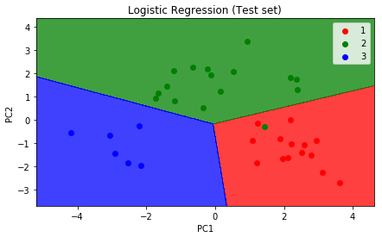

# Linear Discriminant Analysis (LDA) | Machine Learning

**Linear Discriminant Analysis (LDA):**Linear Discriminant Analysis(LDA) is a dimensionality reduction technique, that separates the best classes that are related to the dependent variable. Which makes it a supervised algorithm. In PCA, we do not consider the dependent variable. So this is the basic difference between the PCA and LDA algorithms.

If there are n number of independent variables, the LDA algorithm will extract p<=n new independent variables that separate most of the classes of the dependent variable.

**LDA in Python:**LDA is a very simple and popular algorithm in practice. In this tutorial, we will implement this algorithm alongside with [Logistic Regression](http://www.aionlinecourse.com/tutorial/machine-learning/logistic-regression)algorithm. For this task, we will use the famous **"Wine.csv"**dataset from the UCI machine learning repository. Our version of dataset contains thirteen independent variables that represent various aspects of wines and one dependent variable that represent the three types of buyers of the wine based on specific features. Now, we will implement LDA to reduce the number of independent variables to a predefined value (i.e. two).

You can download the whole dataset from [here.](https://www.dropbox.com/s/8139t6qk69wt10d/Wine.csv?dl=0)

First of all, we will import some essential libraries.

# Importing the libraries

import numpy as np

import matplotlib.pyplot as plt

import pandas as pd

Then we will import our dataset and make the feature matrix and dependent variable vector.

# Importing the dataset

dataset = pd.read_csv('Wine.csv')

X = dataset.iloc[:, 0:13].values

y = dataset.iloc[:, 13].values

Now, we will split the dataset into training and test sets.

# Splitting the dataset into the Training set and Test set

from sklearn.model_selection import train_test_split

X_train, X_test, y_train, y_test = train_test_split(X, y, test_size = 0.2, random_state = 0)

Let's apply feature scaling onto the dataset.

# Feature Scaling

from sklearn.preprocessing import StandardScaler

sc = StandardScaler()

X_train = sc.fit_transform(X_train)

X_test = sc.transform(X_test)

We have come to the main part of our program. Now, we will implement the LDA algorithm to the dataset.

# Applying LDA

from sklearn.discriminant_analysis import LinearDiscriminantAnalysis as LDA

lda = LDA(n_components = 2)

X_train = lda.fit_transform(X_train, y_train)

X_test = lda.transform(X_test)

**Note:** **n_component** is the parameter that represents the number of independent variables we want in our model. Here we take it to 2, so our model will contain two independent variables.

Let's fit a linear regression algorithm to our model.

# Fitting Logistic Regression to the Training set

from sklearn.linear_model import LogisticRegression

classifier = LogisticRegression(random_state = 0)

classifier.fit(X_train, y_train)

# Predicting the Test set results

y_pred = classifier.predict(X_test)

Now, let's see how well our model is to make predictions using the confusion matrix.

# Making the Confusion Matrix

from sklearn.metrics import confusion_matrix

cm = confusion_matrix(y_test, y_pred)

The confusion matrix will look like the following

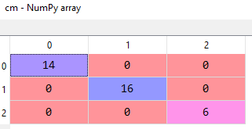

From the above confusion matrix, we can calculate the accuracy of our model and that comes out to be 100%!

Let's visualize the prediction of our model for both training and test sets.

# Visualising the Training set results

from matplotlib.colors import ListedColormap

X_set, y_set = X_train, y_train

X1, X2 = np.meshgrid(np.arange(start = X_set[:, 0].min() - 1, stop = X_set[:, 0].max() + 1, step = 0.01),

np.arange(start = X_set[:, 1].min() - 1, stop = X_set[:, 1].max() + 1, step = 0.01))

plt.contourf(X1, X2, classifier.predict(np.array([X1.ravel(), X2.ravel()]).T).reshape(X1.shape),

alpha = 0.75, cmap = ListedColormap(('red', 'green', 'blue')))

plt.xlim(X1.min(), X1.max())

plt.ylim(X2.min(), X2.max())

for i, j in enumerate(np.unique(y_set)):

plt.scatter(X_set[y_set == j, 0], X_set[y_set == j, 1],

c = ListedColormap(('red', 'green', 'blue'))(i), label = j)

plt.title('Logistic Regression (Training set)')

plt.xlabel('LD1')

plt.ylabel('LD2')

plt.legend()

plt.show()

The graph will look like the following illustration

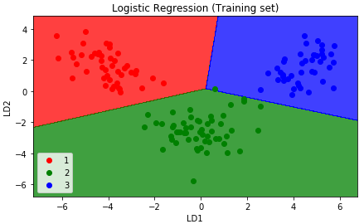

# Visualising the Test set results

from matplotlib.colors import ListedColormap

X_set, y_set = X_test, y_test

X1, X2 = np.meshgrid(np.arange(start = X_set[:, 0].min() - 1, stop = X_set[:, 0].max() + 1, step = 0.01),

np.arange(start = X_set[:, 1].min() - 1, stop = X_set[:, 1].max() + 1, step = 0.01))

plt.contourf(X1, X2, classifier.predict(np.array([X1.ravel(), X2.ravel()]).T).reshape(X1.shape),

alpha = 0.75, cmap = ListedColormap(('red', 'green', 'blue')))

plt.xlim(X1.min(), X1.max())

plt.ylim(X2.min(), X2.max())

for i, j in enumerate(np.unique(y_set)):

plt.scatter(X_set[y_set == j, 0], X_set[y_set == j, 1],

c = ListedColormap(('red', 'green', 'blue'))(i), label = j)

plt.title('Logistic Regression (Test set)')

plt.xlabel('LD1')

plt.ylabel('LD2')

plt.legend()

plt.show()

The output graph will be-

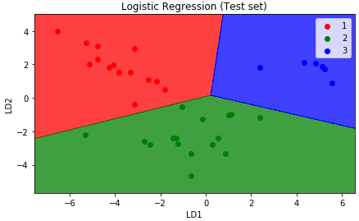

# **Kernel PCA | Machine Learning**

**Kernel Principal Component Analysis (Kernel PCA):** Principal component analysis (PCA) is a popular tool for dimensionality reduction and feature extraction for a linearly separable dataset. But if the dataset is not linearly separable, we need to apply the Kernel PCA algorithm. It is similar to PCA except that it uses one of the kernel tricks to first map the non-linear features to a higher dimension, then it extracts the principal components as same as PCA.

**Kernel PCA in Python:** In this tutorial, we are going to implement the Kernel PCA alongside with a Logistic Regression algorithm on a nonlinear dataset. For this task, we will use the *"Social_Network_Ads.csv"* dataset. In the dataset, the features have a non-linear correlation with the dependent variable. So, we have to apply Kernel PCA to extract the independent variables. Let's have a glimpse of that dataset.

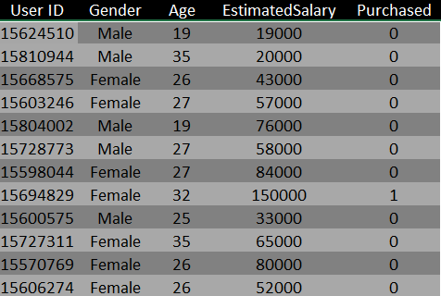  
You can download the whole dataset from [here.](https://www.dropbox.com/s/sj2r3og9br7z08j/Social_Network_Ads.csv?dl=0)

First of all, Let's import the essential libraries

import numpy as np

import matplotlib.pyplot as plt

import pandas as pd

Importing the dataset

dataset = pd.read_csv('Social_Network_Ads.csv')  
X = dataset.iloc[:, [2, 3]].values  
y = dataset.iloc[:, 4].values  
Splitting the dataset into the Training set and Test set

from sklearn.model_selection import train_test_split  
X_train, X_test, y_train, y_test = train_test_split(X, y, test_size = 0.25, random_state = 0)

 Feature Scaling

from sklearn.preprocessing import StandardScaler  
sc = StandardScaler()  
X_train = sc.fit_transform(X_train)  
X_test = sc.transform(X_test)

Applying Kernel PCA

from sklearn.decomposition import KernelPCA  
kpca = KernelPCA(n_components = 2, kernel = 'rbf')  
X_train = kpca.fit_transform(X_train)  
X_test = kpca.transform(X_test)

**Note:**Here, **n_components**parameter defines the number of independent variables we want in our model (here, it is two) and we choose RBF(Radial Basis Function) kernel as our kernel function.

 Fitting Logistic Regression to the Training set

from sklearn.linear_model import LogisticRegression  
classifier = LogisticRegression(random_state = 0)  
classifier.fit(X_train, y_train)

Predicting the Test set results

y_pred = classifier.predict(X_test)

Making the Confusion Matrix

from sklearn.metrics import confusion_matrix  
cm = confusion_matrix(y_test, y_pred)

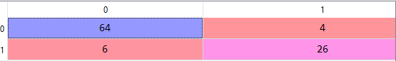

From the above confusion matrix, we can see that the model has an accuracy of 80%

Now, let's visualize both the training and test set results.

Visualising the Training set results

from matplotlib.colors import ListedColormap  
X_set, y_set = X_train, y_train  
X1, X2 = np.meshgrid(np.arange(start = X_set[:, 0].min() - 1, stop = X_set[:, 0].max() + 1, step = 0.01),  
                    np.arange(start = X_set[:, 1].min() - 1, stop = X_set[:, 1].max() + 1, step = 0.01))  
plt.contourf(X1, X2, classifier.predict(np.array([X1.ravel(), X2.ravel()]).T).reshape(X1.shape),  
            alpha = 0.75, cmap = ListedColormap(('red', 'green')))  
plt.xlim(X1.min(), X1.max())  
plt.ylim(X2.min(), X2.max())  
for i, j in enumerate(np.unique(y_set)):  
   plt.scatter(X_set[y_set == j, 0], X_set[y_set == j, 1],  
               c = ListedColormap(('red', 'green'))(i), label = j)  
plt.title('Logistic Regression (Training set)')  
plt.xlabel('Age')  
plt.ylabel('Estimated Salary')  
plt.legend()  
plt.show()

The graph will look like the following:

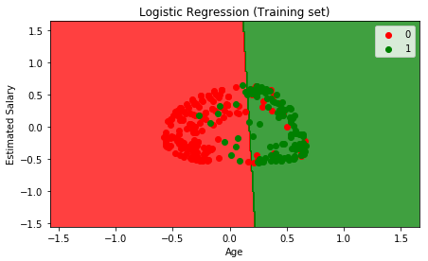

 Visualising the Test set results

from matplotlib.colors import ListedColormap  
X_set, y_set = X_test, y_test  
X1, X2 = np.meshgrid(np.arange(start = X_set[:, 0].min() - 1, stop = X_set[:, 0].max() + 1, step = 0.01),  
                    np.arange(start = X_set[:, 1].min() - 1, stop = X_set[:, 1].max() + 1, step = 0.01))  
plt.contourf(X1, X2, classifier.predict(np.array([X1.ravel(), X2.ravel()]).T).reshape(X1.shape),  
            alpha = 0.75, cmap = ListedColormap(('red', 'green')))  
plt.xlim(X1.min(), X1.max())  
plt.ylim(X2.min(), X2.max())  
for i, j in enumerate(np.unique(y_set)):  
   plt.scatter(X_set[y_set == j, 0], X_set[y_set == j, 1],  
               c = ListedColormap(('red', 'green'))(i), label = j)  
plt.title('Logistic Regression (Test set)')  
plt.xlabel('Age')  
plt.ylabel('Estimated Salary')  
plt.legend()  
plt.show()

The graph will look like the following:

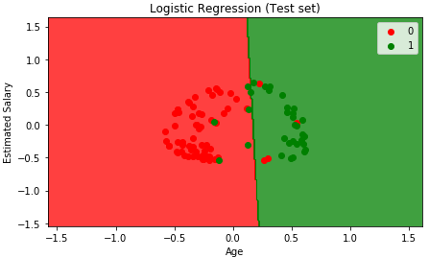

# **Model Selection & Boosting | Machine Learning**

**Model Selection & Boosting:** Model Selection is the undertaking of choosing a statistical model from an arrangement of candidate models, given information. In the least difficult cases, a prior arrangement of information is considered.

Boosting is a machine learning ensemble meta-algorithm for essentially lessening inclination, and furthermore changes in supervised learning, and a group of machine learning algorithms which change over weak learners to strong ones.

**Types of Boosting Algorithms are:**

1.    AdaBoost (Adaptive Boosting)

2.    Gradient Tree Boosting

3.    XGBoost

# K-fold Cross Validation | Machine Learning

In this tutorial, we are going to learn the K-fold cross-validation technique and implement it in Python.  
  
While building machine learning models, we randomly split the dataset into training and test sets where a maximum percentage of the data is taken into the training set. Though the test dataset is small, there is still some chance that we left some important data in there that might have improved the model. And there is a problem of high variance in the training set. To solve this, problems we use the idea of K-fold cross-validation.  
  
Cross-validation is a technique that is used to evaluate machine learning models by resampling the training data for improving performance.  
  
In K-fold Cross-Validation, the training set is randomly split into K(usually between 5 to 10) subsets known as folds. Where K-1 folds are used to train the model and the other fold is used to test the model. This technique improves the high variance problem in a dataset as we are randomly selecting the training and test folds.  
  
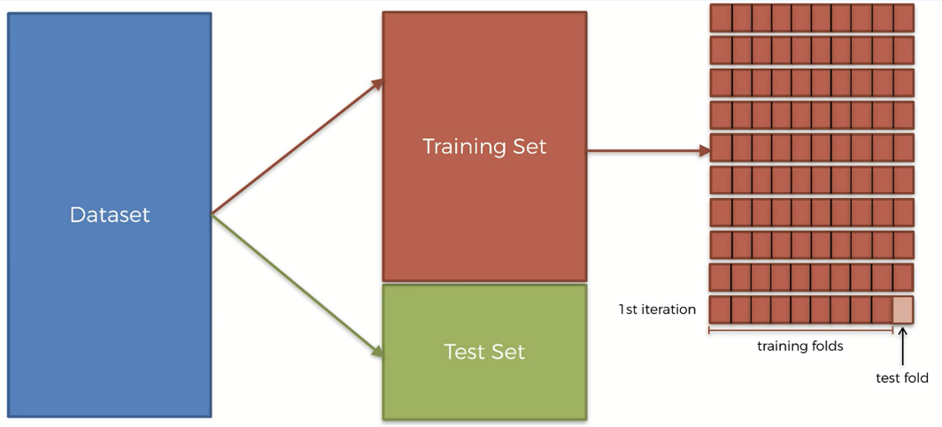  
  
The steps required to perform K-fold cross-validation are given below-  
Step 1: Split the entire data randomly in k folds(usually between 5 to 10). The higher number of splits leads to less biased model.  
Step 2: Then fit the model with k-1 folds and test it with the remaining Kth fold. Record the performance metric.  
Step 3: Repeat step 2 until every k-fold serves as the test set.  
Step 4: Take the average of all the recorded scores. This will serve as the final performance metric of your model.  
**K-fold cross-validation in Python:** Now, we will implement this technique to validate our machine learning model. For this task, we will use *"Social_Network_Ads.csv"* dataset. We will implement the K-fold cross-validation technique to improve our Kernel SVM classification model.  
  
 You can download the dataset from [here.](https://www.dropbox.com/s/sj2r3og9br7z08j/Social_Network_Ads.csv?dl=0)

First of all, we need to import some essential libraries.

# Importing the libraries

import numpy as np

import matplotlib.pyplot as plt

import pandas as pd

Now, we will import the dataset and make the feature matrix X and the dependent variable vector y.

# Importing the dataset

dataset = pd.read_csv('Social_Network_Ads.csv')

X = dataset.iloc[:, [2, 3]].values

y = dataset.iloc[:, 4].values

Now, we will split the dataset into training and test sets.

# Splitting the dataset into the Training set and Test set

from sklearn.model_selection import train_test_split

X_train, X_test, y_train, y_test = train_test_split(X, y, test_size = 0.25, random_state = 0)

We, need to feature scale our training and test sets for an improved result.

# Feature Scaling

from sklearn.preprocessing import StandardScaler

sc = StandardScaler()

X_train = sc.fit_transform(X_train)

X_test = sc.transform(X_test)

Now, we will fit Kernel SVM to our training set and predict how it performs on the test set.

# Fitting Kernel SVM to the Training set

from sklearn.svm import SVC

classifier = SVC(kernel = 'rbf', random_state = 0)

classifier.fit(X_train, y_train)

# Predicting the Test set results

y_pred = classifier.predict(X_test)

To calculate the accuracy of our Kernel SVM model we will build the confusion matrix.

# Making the Confusion Matrix

from sklearn.metrics import confusion_matrix

cm = confusion_matrix(y_test, y_pred)

 Let's see how accurate our model is        
                                          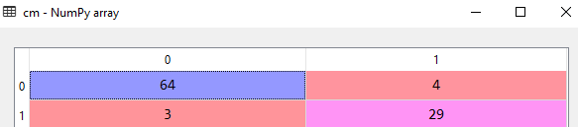  
From the above matrix, we can see that the accuracy of our Kernel SVM model is 93%  
Now, let's see how we can improve the performance metric of our model using K-fold cross-validation with k = 10 folds.

# Applying k-Fold Cross Validation

from sklearn.model_selection import cross_val_score

accuracies = cross_val_score(estimator = classifier, X = X_train, y = y_train, cv = 10)

accuracies.mean()

accuracies.std()

Let's see the accuracies for all the folds.  
                                                                                                           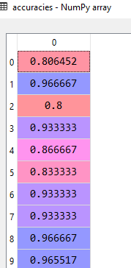  
  
The mean value for the accuracies is 90% with a mean deviation of 6%. That means our model is accurate for 96% or 84% time.

# XGBoost | Machine Learning

**XGBoost in Python Step 1**: First of all, we have to install the XGBoost. Now, we need to implement the classification problem. In this problem, we classify the customer in two class and who will leave the bank and who will not leave the bank. Now, we import the library and we import the dataset churn Modeling csv file. So, we just want to preprocess the data for this churn modeling problem associated to this churn modeling CSV file. Here, XGboost is a great and boosting model with decision trees according to the feature skilling. After building the model, we can understand, XGBoost is so popular its because three qualities, first quality is high performance and second quality is fast execution speed. Now, we spliting the dataset into the training set and testing set.

import numpy as np  
import matplotlib.pyplot as plt  
import pandas as pd

# importing the dataset

dataset = pd.read_csv('Churn_Modelling.csv')  
X = dataset.iloc[:, 3:13].values  
y = dataset.iloc[:, 13].values

# encoding categorical data

from sklearn.preprocessing import LabelEncoder, OneHotEncoder  
labelencoder_X_1 = LabelEncoder()  
X[:, 1] = labelencoder_X_1.fit_transform(X[:, 1])  
labelencoder_X_2 = LabelEncoder()  
X[:, 2] = labelencoder_X_2.fit_transform(X[:, 2])  
onehotencoder = OneHotEncoder(categorical_features = [1])  
X = onehotencoder.fit_transform(X).toarray()  
X = X[:, 1:]

# splitting the dataset into the Training set and Test set

from sklearn.model_selection import train_test_split  
X_train, X_test, y_train, y_test = train_test_split(X, y, test_size = 0.2, random_state = 0)

**XGBoost in Python Step 2:** In this tutorial, we gonna fit the XSBoost to the training set. Now, we apply the xgboost library and import the XGBClassifier.Now, we apply the classifier object. And we call the XGBClassifier class. Now, we apply the fit method. Now, we execute this code. Now, we apply the confusion matrix. And we also predict the test set result. And we applying the k fold cross validation code. Now, we execute this code. After executing this code, we get the dataset. Then we get the confusion matrix, where we get the 1521+208 correct prediction and 197+74 incorrect prediction. And we get this accuracy 86%. After executing the mean function, we get 86%.

from xgboost import XGBClassifier  
classifier = XGBClassifier()  
classifier.fit(X_train, y_train)

# Predicting the Test set results

y_pred = classifier.predict(X_test)

# Making the Confusion Matrix

from sklearn.metrics import confusion_matrix  
cm = confusion_matrix(y_test, y_pred)

# Applying k-Fold Cross Validation

from sklearn.model_selection import cross_val_score  
accuracies = cross_val_score(estimator = classifier, X = X_train, y = y_train, cv = 10)  
accuracies.mean()  
accuracies.std()

# Convolution Neural Network | Machine Learning

**Convolution Neural Network:** A Convolutional neural network (CNN, or ConvNet) is a class of deep, feed-forward artificial neural networks, most commonly applied to analysing visual imagery.

CNN's use a variation of multilayer perceptron designed to require minimal pre-processing. They are also known as shift invariant or space invariant artificial neural networks (SIANN), based on their shared-weights architecture and translation invariance characteristics.

Convolutional networks were inspired by biological processes in that the connectivity pattern between neurons resembles the organization of the animal visual cortex. Individual cortical neurons respond to stimuli only in a restricted region of the visual field known as the receptive field. The receptive fields of different neurons partially overlap such that they cover the entire visual field.

CNN's use relatively little pre-processing compared to other image classification algorithms. This means that the network learns the filters that in traditional algorithms were hand-engineered. This independence from prior knowledge and human effort in feature design is a major advantage.

Here, we have an image, convolution neural network and having output label image.

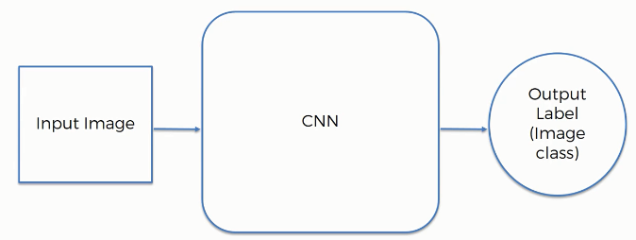

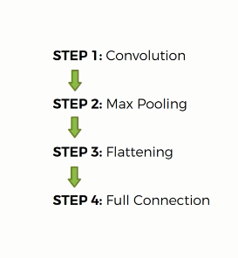

**Convolution Operation:** In this tutorial, we are going to talk about the convolution. Here, we describe the convolution function:

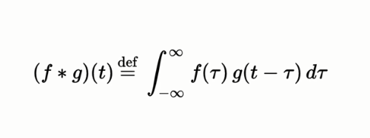

Convolution is a combined integration of the two functions and it shows you how one function modifies the other or modifies the shape of other.

Convolution is a mathematical operation to merge two sets of information. In our case, the convolution is applied to the input data using a convolution filter to produce a feature map. There are a lot of terms being used so let's visualize them one by one.

On the left side is the input to the convolution layer, for example, the input image. On the right is the convolution filter, also called the kernel, we will use these terms interchangeably. This is called a 3x3 convolution due to the shape of the filter.

We perform the convolution operation by sliding this filter over the input. At every location, we do element-wise matrix multiplication and sum the result. This sum goes into the feature map. Now, we have some input message and we create a feature map. We create multiple feature map because we use different filters.

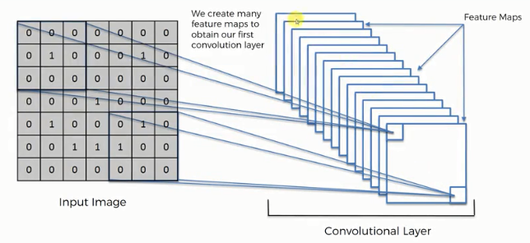

**ReLU  Layer:** In this tutorial, we are going to talk about the ReLU layer. Here, we are applying the rectifier because we want to increase non-linearity in our image. They propose different types of rectified function.

**Pooling:** In this tutorial, we are going to talk about the max pooling.

Max pooling is a sample-based discretization process. The objective is to down-sample an input representation (image, hidden-layer output matrix, etc.), reducing its dimensionality and allowing for assumptions to be made about features contained in the sub-regions binned.

This is done so in part to help over-fitting by providing an abstracted form of the representation. As well, it reduces the computational cost by reducing the number of parameters to learn and provides basic translation invariance to the internal representation.

Max pooling is done by applying a max filter to (usually) non-overlapping subregions of the initial representation.

We are taking the maximum of the pixel that we or the values that we have. This helping with preventing overfitting. We applied the convolution operation and now we apply the pooling.

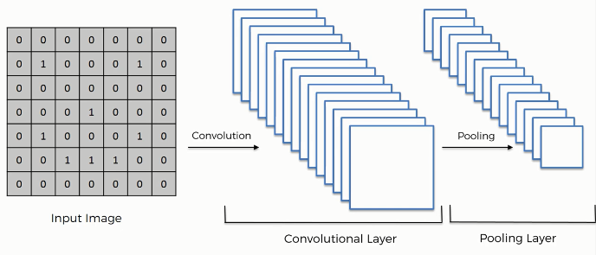

**Flattening:** Here, we have the pooled featured map. After that, we apply the convolution operation to our image and then we apply the pooling to the result of the collision. So, we are going to flatten it into the column. Here, we see many pooling layers. We put them into one log column sequentially. In the input image, we apply the convolution. And also apply the rectifier function.

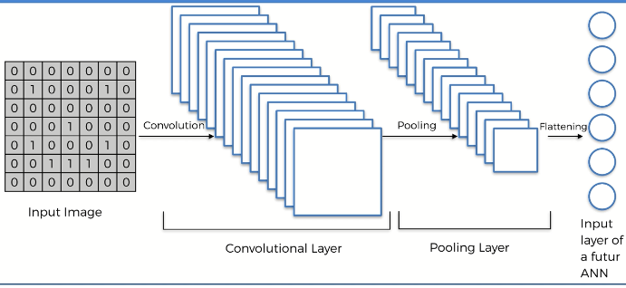

**Full Connection:**Today, we are talking about the full connection. In this step, we are adding a whole artificial neural network to our convolutional neural network. Here, we are calling them fully connected which are the hidden layer. The main purpose of the artificial neural network to combine our feature into more attributes. Here, we used to call a cost function in an artificial neural network and we used mean square error there in common illusional neural network. It is called a loss function and we use across entropy function for that. We are trying to optimize it to minimize that function to optimize our network. We had an artificial neural network is back propagated and some things are adjusted t help optimize. It all done through a gradient descent of backpropagation. The dog neuron knows that the answer it is actually a dog because at the end we are comparing to the picture or to the label on the picture.

**CNN in Python 1:** In this tutorial, we are going to implement the CNN in python. Here, we build our convolutional neural network model, we will simply need to change the image of

Then, we will be able to train a convolutional neural network to predict if some new brain image contains the tumor is yes or no. Now, we have to input these image in our convolution neural that work.

Here, in the working directory, we have a dataset which are all our images of cats and dogs. In each folder the training set and the test set we would get for example 5000 image.

The first pillar of the structure is to separate our images into two separate folders. A training set folder and testing set folder. Here, we see different dog pictures. Now, we can take some pictures of our friends and replace these dogs picture by that picture. Then, we will able to train an algorithm that will predict. And, there are images of a cat. Here, the training set contained 8000 customers and the test set contained 2000 customer. Here, also,4000 images for dogs and 4000 images of cats. So, there are 80 percent and 20 percent split. We already import this dataset.we do not need to encode the dataset because the independent variable is some way of a pixel and the three channel. We need to split the dataset into the training set and test set. Now, we need to apply the feature scaling.

import numpy as np  
import matplotlib.pyplot as plt  
import pandas as pd

# Importing the dataset

dataset = pd.read_csv('Churn_Modelling.csv')  
X = dataset.iloc[:, 3:13].values  
y = dataset.iloc[:, 13].values

from sklearn.model_selection import train_test_split  
X_train, X_test, y_train, y_test = train_test_split(X, y, test_size = 0.2, random_state = 0)

# Feature Scaling

from sklearn.preprocessing import StandardScaler  
sc = StandardScaler()  
X_train = sc.fit_transform(X_train)  
X_test = sc.transform(X_test)

**CNN in Python 2:** In this tutorial, we are going to talk about the convolution neural network. In the first step is to import all the keras packages that we will need to make our CNN model. Here, the first package is sequential. We use sequential packages to initialize our neural network. Now, we import convolution layers and we are working on images and since images are in two dimensions. We use the 2D packages to deal with images. And we also add our pooling layers. And next is flatten. Here, we also use the last dense packages. We use to add the fully connected layers and a classic artificial neural network. Now, I execute the code.

Now, we are going to create an object of this sequential class. We are going to call this object classifier and we call the sequential method.

from keras.models import Sequential  
from keras.layers import Convolution2D  
from keras.layers import MaxPooling2D  
from keras.layers import Flatten  
from keras.layers import Dense

**CNN in Python 4:** In this tutorial, we are going to take care of the first state of convolutions. Here, we take the classifier object and also include the method add. Here, we include convolution2D. Here, we use the 32 feature detectors three by three-dimension for feature detector. We need to specify what the expected format of our input images are. The input image converted into a 3D array if the image is a color image and into a 2D array if it is a black and white image. The 3D means three channel. We need to start with the 2D array dimension. We need to import here for our input shape argument. Therefore, 64 to 64 and then the number of channel 3 that is we are using tensor flow. We have one last argument to input which the activation function is exactly as we did for our fully connected layers. We used this activation function to activate the neurons in the neural network. Here, we are using the rectifier function.

# Initialising the CNN

classifier = Sequential()

# Step 1 - Convolution

classifier.add(Convolution2D(32, 3, 3, input_shape = (64, 64, 3), activation = 'relu'))

**CNN in Python 5:** Today, we will take care of the second step pulling. We call the classifier. For the classifier object, we use the add method. And we add the new parenthesis max pooling. We use the max pool size 2 and 2.This line will reduce the size of our maps and it's well divided by two. The size of the feature map is divided by two. For flattening, we use the classifier object and use the add method. We use the parenthesis Flatten().

In the same way, For Full connection, we use the classifier object and use the add method. We use the parenthesis Dense (). Also has a parenthesis output_dim is equal to 128. We need to choose a number that is not too small to make the classifier a good model and also not too big. Here, we will go with this 128 hidden nodes in the hidden layer. And another activation function is a rectifier. Now, we copy paste the code. And, add the sigmoid function. now, we add 128 to 1. Then, we get the final layer, which predicts the output.

# Step 2 - Pooling

classifier.add(MaxPooling2D(pool_size = (2, 2)))

# Adding a second convolutional layer

classifier.add(Convolution2D(32, 3, 3, activation = 'relu'))  
classifier.add(MaxPooling2D(pool_size = (2, 2)))

# Step 3 - Flattening

classifier.add(Flatten())

# Step 4 - Full connection

classifier.add(Dense(output_dim = 128, activation = 'relu'))  
classifier.add(Dense(output_dim = 1, activation = 'sigmoid'))

**CNN in Python 8:** In this tutorial, we need to compile the whole thing by choosing to cast a grade. To compile this, we add the compile method and also add the parameter in the optimizer. The optimizer is equal to the Adam. Ans we use loss is equal to bunary_cross entropy. And, the metrics is equal to the accuracy.

# Compiling the CNN

classifier.compile(optimizer = 'adam', loss = 'binary_crossentropy', metrics = ['accuracy'])

**CNN in Python 9:** In this tutorial, we are going to fit the CNN image. We actually need a lot of images to find and generalize some correlations. The amount of our training images is augmented because the transformation is random transformation. Image augmentation is a technique that allows you to enrich our dataset our train set. Now, image augmentation is applied to the training set. Here, we create ImageDataGenerator class. We will rescale all our pixel values between 0 and 1. By rescaling them using this rescale equals one over 255 then all our pixels will be between 0 and 1. She arranged that to apply random transaction and we will keep this open to value zoom range. So this 0.2 values here are just some parameters of how much we want to apply these random transformations. We call it the test set because this code section will create the test set. We have 8000 images in our training set. we need to replace 2000 by 8000 right. Now, we generate a fit method onto our classifier. Now, we execute it. And we create another object. Here, 8000 and 2000 images belonging to two classes.2000 image of our test set. After execution, we get 75% accuracy. We get three predictions out of four..there is a difference between the accuracy in the training set and accuracy in the test set.

from keras.preprocessing.image import ImageDataGeneratortrain_datagen = ImageDataGenerator(rescale = 1./255,  
                                  shear_range = 0.2,  
                                  zoom_range = 0.2,  
                                  horizontal_flip = True)test_datagen = ImageDataGenerator(rescale = 1./255)training_set = train_datagen.flow_from_directory('dataset/training_set',  
                                                target_size = (64, 64),  
                                                batch_size = 32,  
                                                class_mode = 'binary')test_set = test_datagen.flow_from_directory('dataset/test_set',  
                                           target_size = (64, 64),  
                                           batch_size = 32,  
                                           class_mode = 'binary')classifier.fit_generator(training_set,  
                        samples_per_epoch = 8000,  
                        nb_epoch = 25,  
                        validation_data = test_set,  
                        nb_val_samples = 2000)

**CNN in Python 10:** In this tutorial, we are going to talk about if we achieve our goal to get an accuracy of more than 80 percent on the test. Only adding a convolutional layer, we will see how it will definitely improve our performance results. Now, we add another convolution layer. Here, we going to keep the same parameter. Now, we execute the whole code. The accuracy of the training set is about 85.The accuracy of stains on the test that began at 55 percent almost 56 percent. We got indeed 64 percent and 68 percent on the test set. We get an accuracy of 85 percent for the training set and 82 percent for the test. We get a difference of 3 percent as opposed to this 10 percent difference that we got in.

**Softmax and Cross-Entropy:** In softmax function in order to help us out of the situation.

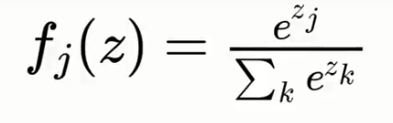

The softmax function or the normalized exponential function is a generalization of the logistic function. It takes the exponent and put the power of zed and adds it up so that one's two across all. Here we use a function called mean squared which we used as the cost function for assessing our natural performance. Our goal is to minimize the MSE in order to optimize our network performance.

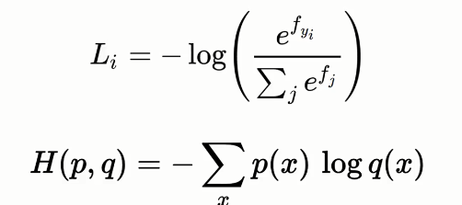

# Dimensionality Reduction | Machine Learning

Think of working with a dataset with hundreds of features. Intuitively you can understand the hardship you must deal with while visualizing the dataset or training your model with it. This is because of the dimensions it would take as a higher number of features will lead to higher dimensions. And higher dimensions are not suitable for visualizing the dataset for a more intuitive understanding of the problem.

Overfitting will be another issue related to high dimensionality. This is because many of the features are somehow correlated to some fashion. Hence most of the features are redundant. For example, if you have to predict the weather where rainfall and humidity are two of the features, you can see two of them are somehow correlated. To avoid overfitting you need to reduce the features for the sake of getting better prediction accuracy.

This is where dimensionality reduction techniques come into play. This is simply reducing the dimension of your feature set. This technique allows you to find a small set of most impactful features among a large number of features. With this small set of principal features, you can run your prediction algorithms easily with better accuracy.

##### Why Do We Need Dimensionality Reduction Techniques?

* With less number of dimensions the space required to store the data is reduced
* Training time also accelerated due to lower dimensions
* Some algorithms such as Decision Tree and SVM do not perform well with higher dimensions. So, we need fewer dimensions for better accuracy with these models.
* It removes the multi-collinearity problem that happens due to highly correlated features in the dataset.
* It reduces the complexity of visualizing the data. As you can understand that a plot is more intuitive in 2D than in a 3D form.

There are two different dimensionality reduction techniques:

1. Feature Selection Methods
2. Feature Extraction Methods

##### Feature Selection Methods

Feature selection methods use the statistical relationship of input variables to the output variable. The methods mainly find the correlations among the features and try to select the most independent features that have no collinearity. It selects the features with the highest importance.

Some of the common feature selection techniques are-

* Filter Methods
* Wrapper Methods
* Embedded Methods

**Filter Methods:**In this method, each feature is ranked based on some univariate metrics. Then it selects the highest-ranking features. Some of the common filtering methods are-

* variance
* chi-square
* correlation coefficients
* information gain or mutual information

**Wrapper Methods:**Wrapper methods selects the features based on specific classifier performance. With a greedy approach, it evaluates all the possible combinations of features against the evaluation criterion. Some of the popular wrapper methods are-

* recursive feature elimination
* sequential feature selection algorithms
* genetic algorithms

**Embedded Methods:**These methods perform feature selection during the model training period. This is the reason why they are called embedded methods. Here the model can perform both feature selection and training at the same time.

Some of the popular methods are-

* L1 (LASSO) regularization
* L2(Ridge) regularization
* decision tree based feature selection

##### Feature Extraction Methods

This technique tries to reduce the number of features by creating new features from the existing ones. Then it discards the original features. The newly built set of features contain most of the crucial information of the dataset.

Some of the popular feature extraction methods are-

* [Principal Component Analysis (PCA)](https://www.aionlinecourse.com/tutorial/machine-learning/principal-component-analysis)
* [Linear Discriminant Analysis (LDA)](https://www.aionlinecourse.com/tutorial/machine-learning/linear-discriminant-analysis-%28lda%29)
* [Kernel PCA](https://www.aionlinecourse.com/tutorial/machine-learning/kernel-pca-in-python)
* Quadratic Discriminant Analysis (QDA)